**Java program to find the given number is even or odd**

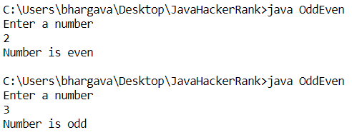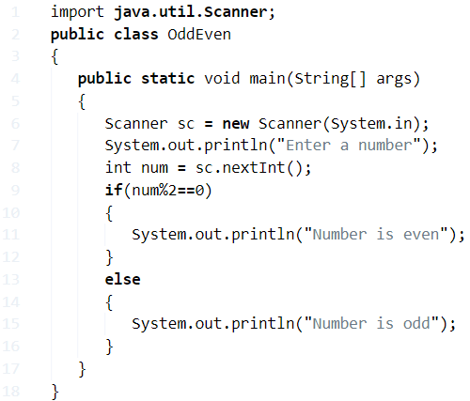

**Java Program Sum Of N Numbers**

Here is the sample program with output sum of two numbers program or three numbers. check it out

How this program works: we are using arrays to store the values first. From a user input point of view, let’s assume you need to sum five numbers. Say 5: Now the next step is to enter those numbers in a series order. Once it was done, the program automatically adds all your two numbers or three numbers like up to N numbers.

**check out the sample output so that you will get an Idea:**

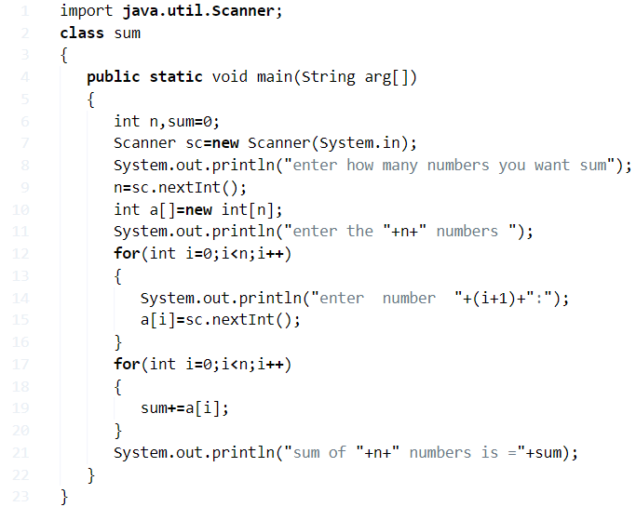

Output:

|  |  |
| --- | --- |
| 1  2  3  4  5  6  7  8  9  10  11  12  13  14 | enter how many numbers you want sum  5  enter the 5 numbers  enter  number  1:  32  enter  number  2:  12  enter  number  3:  43  enter  number  4:  212  enter  number  5:  23  sum of 5 numbers is =322 |

### 2. Using Recursion

Here is another method using recursion: A recursion is a function call itself. Here is the sample program to print the sum of N numbers in Java.

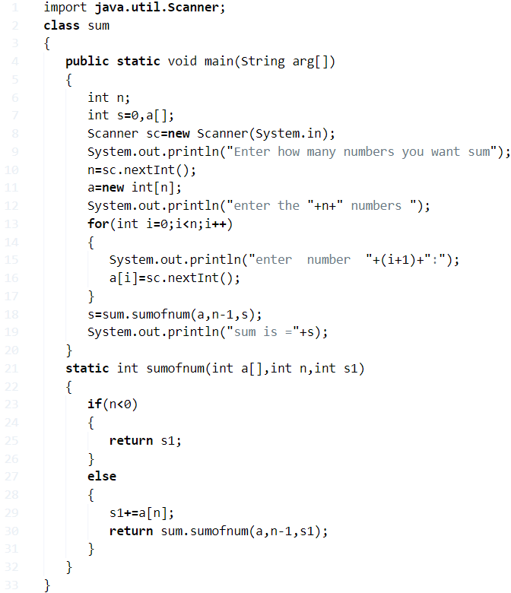

Output:

|  |  |
| --- | --- |
| 1  2  3  4  5  6  7  8  9  10  11  12 | Enter how many numbers you want sum  4  enter the 4 numbers  enter  number  1:  100  enter  number  2:  200  enter  number  3:  300  enter  number  4:  400  sum is =1000 |

3. Using Static Method

Another example program using the static method

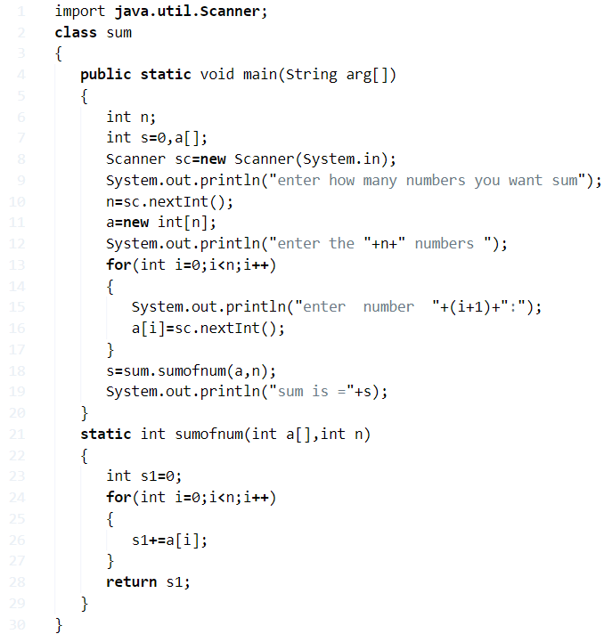

Output:

|  |  |
| --- | --- |
| 1  2  3  4  5  6  7  8  9  10  11  12 | enter how many numbers you want sum  4  enter the 4 numbers  enter  number  1:  12345  enter  number  2:  02468  enter  number  3:  13579  enter  number  4:  235711  sum is =264103 |

#### 4. Calculate Sum Of N Numbers Using While Loop

While Loop: The Loop is used to execute a set of statements as long as the condition is true.

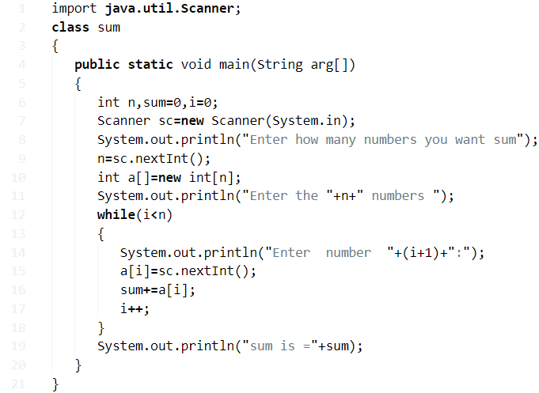

**Output:**

output:

Java

|  |  |
| --- | --- |
| 1  2  3  4  5  6  7  8  9  10  11  12 | Enter how many numbers you want sum  4  Enter the 4 numbers  Enter  number  1:  12  Enter  number  2:  12  Enter  number  3:  13  Enter  number  4:  13  sum is =50 |

**Java Program Sum Of digits Of A Number**

## Using For Loop

**1)** Here we are using the for loop to calculate the sum of digits of a number.

**2)** Read the entered long value using scanner class object sc.nextLong().

**3)** The for loop iterates up to n!=0, here sum=0, and n=n/10,add the remainder of n/10 to the sum until n!=0 is false. If n=0 then for loop will be terminated, and prints the sum value.

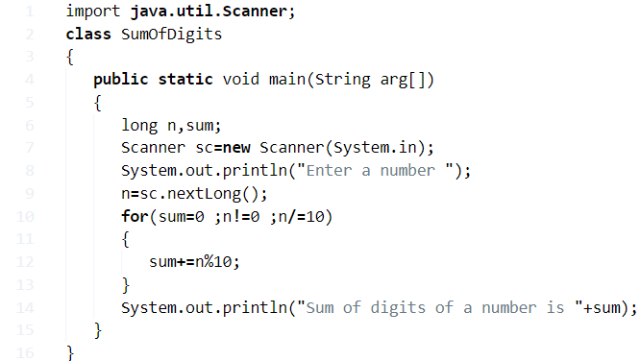

**Output:**

|  |  |
| --- | --- |
| 1  2  3 | Enter a number  12345678910  Sum of digits of a number is 46 |

### Using Static Method

**1)** Static method sum(long num), will calculate the sum of digits of a number.

**2)** Read entered value. Call the static method sum(n) in the main method then the static method will be executed. This method adds the remainder to sum and n=n/10, these 2 steps will repeat until num!=0. If num=0 then it returns the sum value.

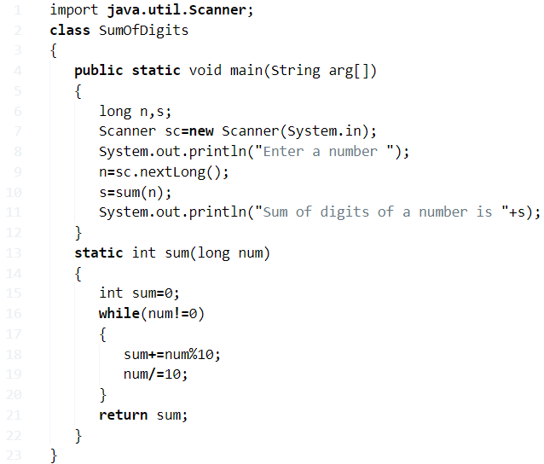

**Output:**

|  |  |
| --- | --- |
| 1  2  3 | Enter a number  5299  Sum of digits of a number is 25 |

#### **Using Command Line Arguments**

**1)** The[command line arguments](https://javatutoring.com/command-line-arguments-java-with-examples/) will be passed to “String args[]” of the main method.

**2)** Using Long.parseLong(arg[0]), we are converting the value at index 0 as long, here Long is the wrapper class.

**3)** Repeat these two steps sum=sum+n%10; n/=10; until n!=0, if n=0 then while terminated and print the sum value.

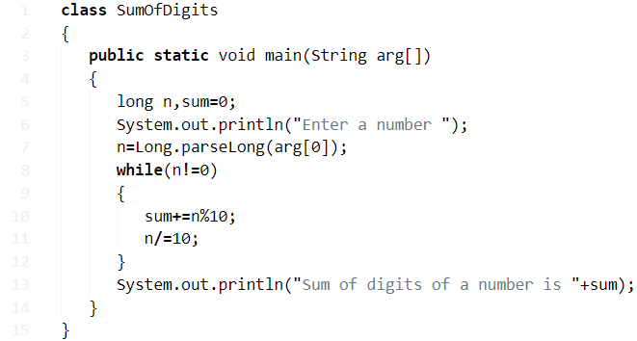

**Output:**

|  |  |
| --- | --- |
| 1  2  3 | >java SumOfDigits 9871  Enter a number  Sum of digits of a number is 25 |

##### **Using Recursion**

**1)** We are calling the method using the class SumOfDigits to object “s” as s.sum(n) then sum() starts the execution.

**2)** Sum method calls itself as sum(num), it repeats until num!=0. If num=0 then it returns the sum value.

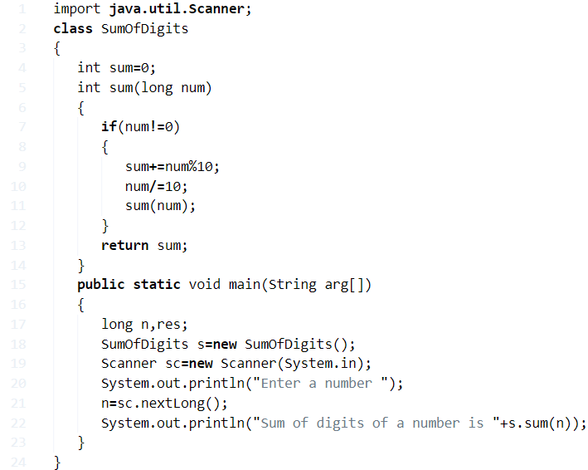

**Output:**

Output

|  |  |
| --- | --- |
| 1  2  3 | Enter a number  4012017  Sum of digits of a number is 15 |

**17) Factorial of a number**

**Q) So, basically what is factorial?**

**Def:**A factorial is a function that multiplies number by every number. For example 4!= 4*3*2*1=24. The function is used, among other things, to find the number of ways “n” objects can be arranged.

In mathematics, there are n! ( Factorial ways to arrange N Objects ) in sequence.

**Q) How to calculate?**

**For example :**

Consider :

* 2! = 2 x 1 = 2

The possibility of 2! is two ways like {2,1}, { 1,2 }.

Same as like :

4! = 4 x 3 x 2 x 1 = 24.

* 24 = the arrangement of 4! is {1,2,3,4}, {2,1,3,4}, {2,3,1,4}, {2,3,4,1}, {1,3,2,4}, etc.

Same as like 5! , 10! , N!.

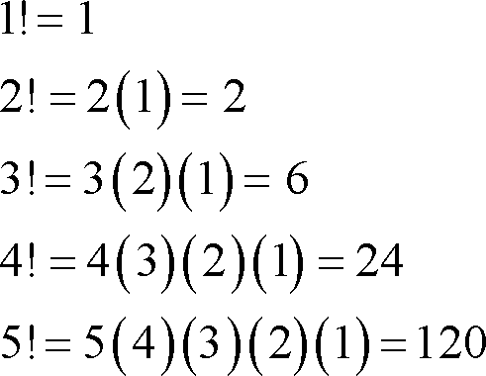

The following program has been written in 5 different ways, using while loop, for loop, do while loop, using method.

Now, let’s get into the programming part.

**Method – 1 Using standard values with outputs**

Standard values – consider the following code is universally applicable- with sample outputs.

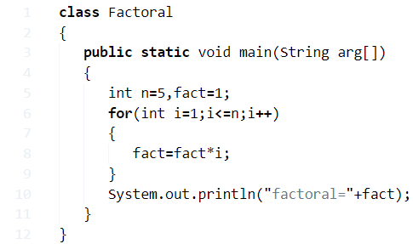

**Output:**

|  |  |
| --- | --- |
| 1 | factorial =120 |

**Method – 2 Using For Loop**

* Using for loop: Here is the program using for loop with sample outputs #example.

Among all three loops, for loop is probably the most used loop. For loop are two types mainly:

1. for each style of for loop
2. normal for loop

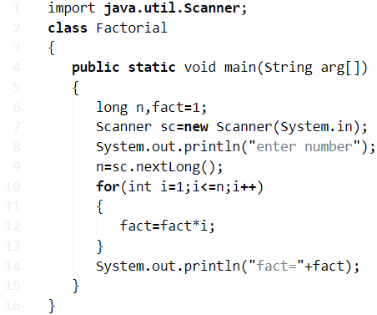

**output:**

|  |  |
| --- | --- |
| 1  2 | enter number  7=5040 |

**Method – 3 Using Command Line Arguments**

Using command line arguments: Here is the complete guide about [command line arguments in Java with examples](https://javatutoring.com/command-line-arguments-java-with-examples/).

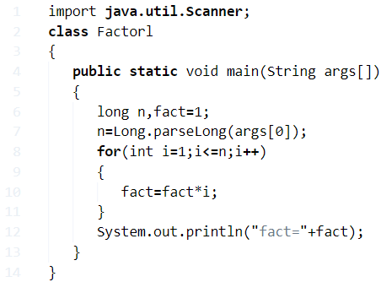

**output:**

|  |  |
| --- | --- |
| 1  2  3  4  5 | C:\Users\goutham\Desktop\E>javac.java    C:\Users\goutham\Desktop\E>java Factorl 9    factorl=362880 |

**Method – 4 Using Function**

Java code for calculating Factorial using a user-defined method(using function).

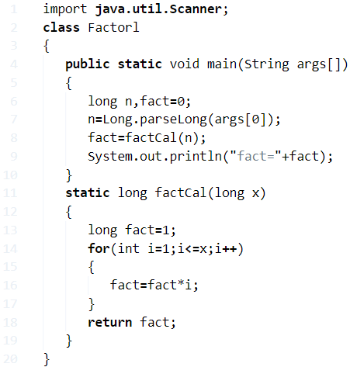

**output:**

|  |  |
| --- | --- |
| 1  2  3  4  5 | C:\Users\goutham\Desktop\E>javac.java    C:\Users\goutham\Desktop\E>java Factorl 10    factorl=3628800 |

**Method – 5 Using Recursion**

**Recursion:** A Recursion is a function call itself – you can check out more information about what is recursion in java here?

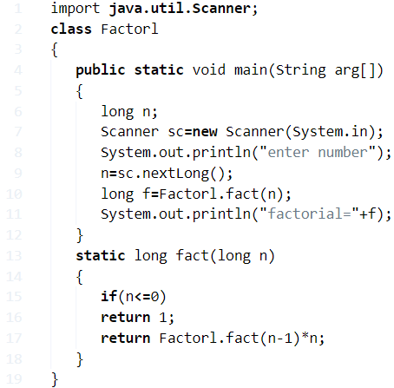

**output:**

|  |  |
| --- | --- |
| 1  2  3  4  5 | enter number    30    Factorl=8764578968847253504 |

**Method – 6 Using while loop**

Here is the code using the while loop: The definition of while loop is to execute the set of statements as long as the condition is true. Here we share the complete guide on what is while loop in java with sample examples and syntax – do check it out. If you have any doubts related to the following program using while loop, do let us know here.

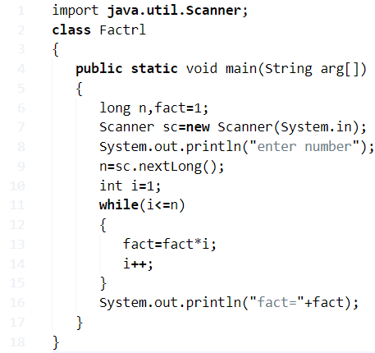

**output:**

|  |  |
| --- | --- |
| 1  2  3 | enter number  10  fact=3628800 |

**Method – 7 Using Do While Loop**

The difference between while loop and do while loop is, wherein do while the condition is checked in each iteration, whereas in while loop the condition is checked at the beginning of each iteration. Here is the complete guide on [Java do while with examples and syntax](https://javatutoring.com/do-while-java-examples/).

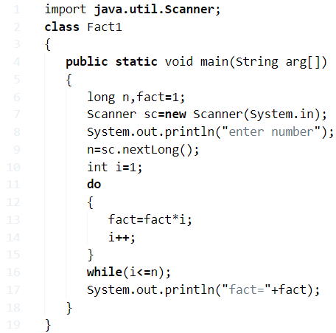

**output:**

output:

|  |  |
| --- | --- |
| 1  2  3  4 | output:  enter number  7  fact=5040 |

**Java program to find factorial of a given number**

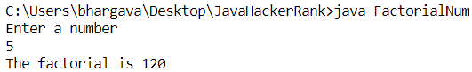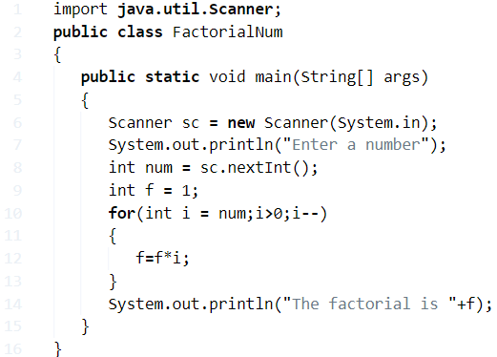

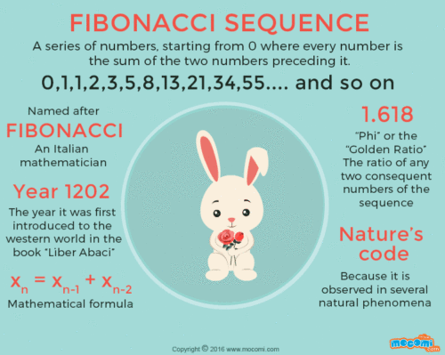

**16) Fibonacci Series**

* Coined by Leonardo Fibonacci(c.1175 – c.1250) is the collection of numbers in a sequence known as the Fibonacci Series where each number after the first two numbers is the sum of the previous two numbers. The series generally goes like 1, 1, 2, 3, 5, 8, 13, 21 and so on.
* Earlier, 0 was also mentioned making the series 0, 1, 1, 2, 3, 5… The sequence can start with either 1, 1 or 0, 1 irrespective. The Fibonacci Sequence follows the very popular Golden Ratio closely.

## Fibonacci Series In Java – Using For Loop

**1)** In Fibonacci series each number is addition of its two previous numbers.

**2)** Read the n value using Scanner object sc.nextInt(), and store it in the variable n.

**3)**For loop iterates from c=0 to c=n-1.

**a)** For c=0 nextterm=0, for c=1 nexterm =1

**b)** For c=2, nextterm=i+j=1(to get next value we are adding previous  two numbers), and “i” initialized to “j” (i.e i=1),”j” initialized to “nextterm” (i.e j=1), for c=3  nextterm =2, for c=4 nextterm=5 .

**Method – 1 using loop**

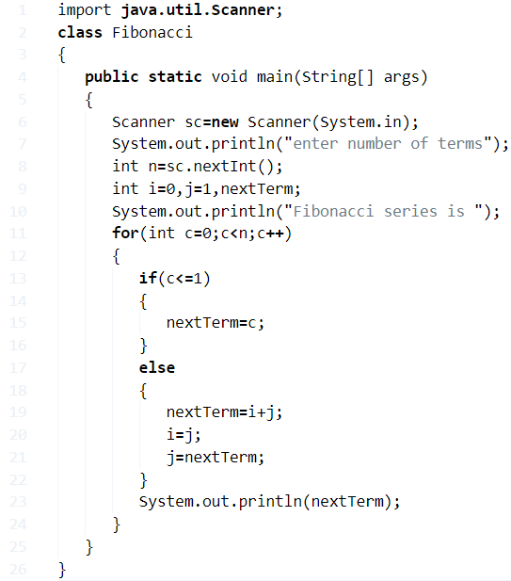

**Output:**

|  |  |
| --- | --- |
| 1  2  3  4  5  6  7  8 | enter number of terms  5  Fibonacci series is  0  1  1  2  3 |

**Method – 2 Using While Loop**

**1)** Read the n value using Scanner object sc.nextInt(), and store it in the variable n.

**2)** Here  first value=0,second value=1, while loop iterates until i<n is false.

**3)** For i=0 next=0, for i=1 next=1, for 1=2 next=first+second, and first=second,second=next.

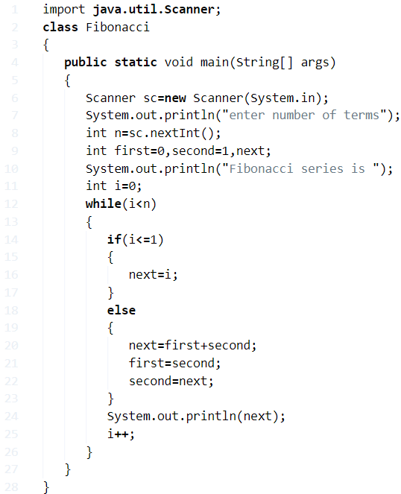

**Output:**

|  |  |
| --- | --- |
| 1  2  3  4  5  6  7  8 | enter number of terms  5  Fibonacci series is  0  1  1  2  3 |

**Method – 3 Using Static Method**

**1)** We can call the static method using the class name.

**2)** Call the series method which is static in the main method.

**3)** The series method executes the code and prints the series.

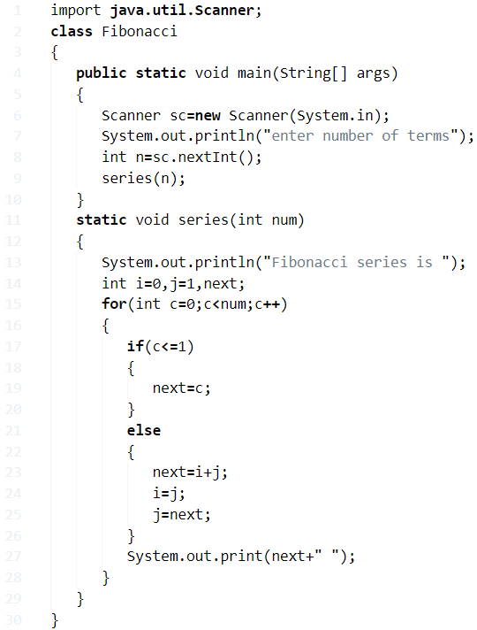

**Output:**

|  |  |
| --- | --- |
| 1  2  3  4 | enter number of terms  20  Fibonacci series is  0 1 1 2 3 5 8 13 21 34 55 89 144 233 377 610 987 1597 2584 4181 |

**Method – 4 Using Recursion**

**1)** In our program fib(int n) method calls itself as fib(–n). Here fib(int n) is the recursive function.

**2)** After creating an  object to the class “Fibonacci”, call the method using  object as “f.fib(num)”, then fib(int n) will start the execution with n=5 and calls itself with n=n-1, then again method execution started, repeats until the condition “if(n>0)” is false.

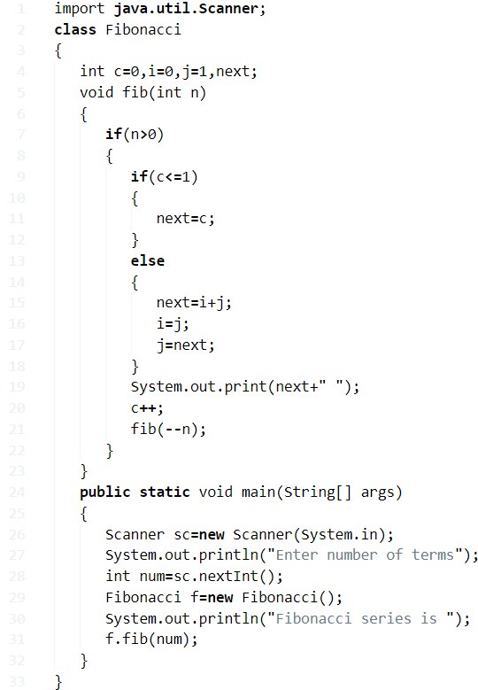

**Output:**

|  |  |
| --- | --- |
| 1  2  3  4 | Enter number of terms  5  Fibonacci series is  0 1 1 2 3 |

**Prime Number Java Program – 1 to 100 & 1 to N**

**A PRIME NUMBER**  is any number that is divisible by 1 and itself only. Certain examples of prime numbers are 2, 3, 5, 7, 11 etc. However, 1 is neither a prime nor composite number.

## Using Static Method

**1)** A prime number is a number which has no positive divisors other than 1 and itself.

**2)** We are finding the given number is prime or not using the static method primeCal(int num). For loop iterates from i=0 to i=given number, if the remainder of number/i =0 then increases the count by 1. After all the iterations, if count=2, then that number is a prime number.

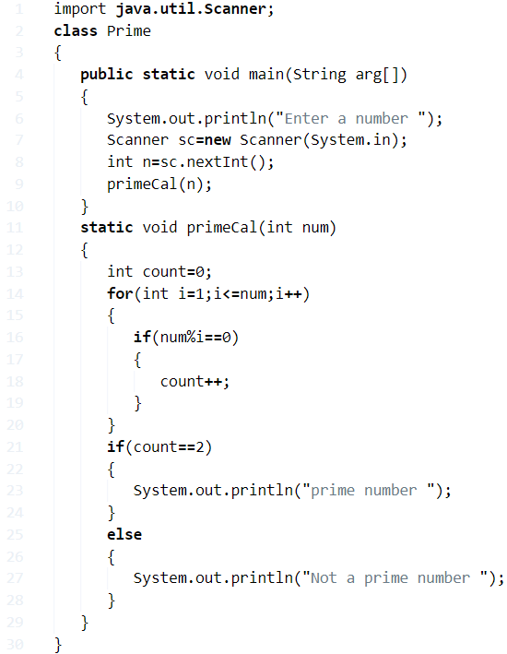

**Output:**

|  |  |
| --- | --- |
| 1  2  3 | Enter a number  7  prime number |

### **Find Prime Numbers Between 1 to n**

**1)** We are finding the prime numbers within the limit.

**2)** Read the “n” value using scanner object  sc.nextInt()and store it in the variable n.

**3)** The for loop iterates from j=2 to j=given number. then count assigned to 0, the inner loop finds the divisors of each j value, count value represents no.of divisors. If count=2, then that number is a prime number.

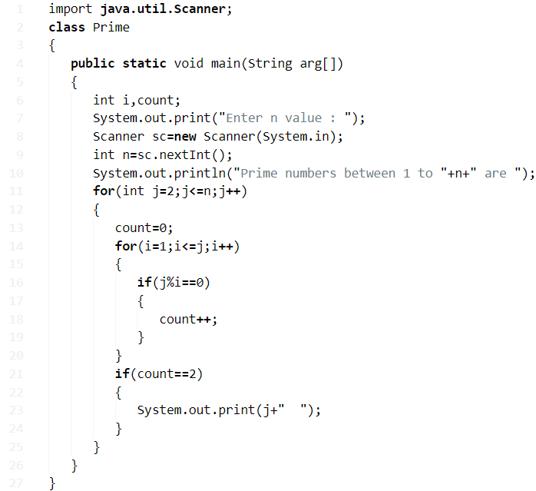

**Output:**

|  |  |  |
| --- | --- | --- |
| 1  2  3  4 | Enter n value : 100  Prime numbers between 1 to 100 are  2  3  5  7  11  13  17  19  23  29  31  37  41  43  47  53  59  61  67  71  73  79  83  89  97 | |
| 1  2  3 | Enter n value : 25  Prime numbers between 1 to 25 are  2  3  5  7  11  13  17  19  23 |

|  |  |
| --- | --- |
| 1  2  3 | Enter n value : 50  Prime numbers between 1 to 25 are  2  3  5  7  11  13  17  19  23  29  31  37  41  43  47 |

#### Prime Number Java Program – Using While Loop

**1)** In this program, the while loop is present in the constructor. If we instantiate the class then automatically constructor will be executed.

**2)** Read the “n” value using scanner class object sc.nextInt(). FindPrime class is initiated in the class Prime as new FindPrime(n); then the constructor of FindPrime will be executed.

The while loop iterates until i<=num is false. The remainder of number/i=0 then count will be increased by 1, “i” value increased by 1. If count=2, then print “number is a prime number”.

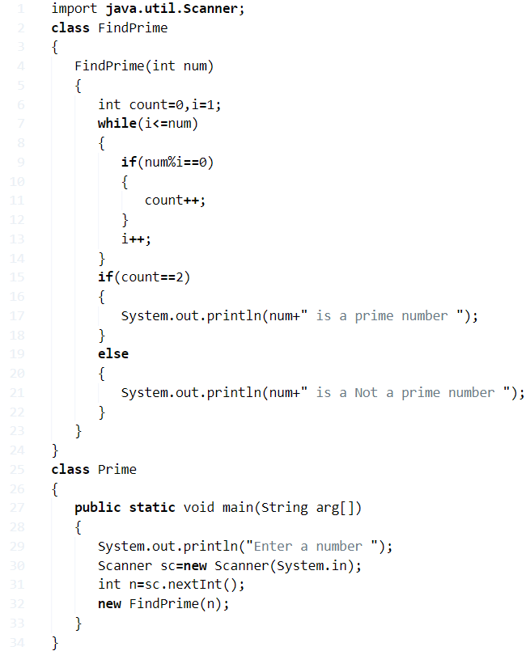

**Output:**

|  |  |
| --- | --- |
| 1  2  3 | Enter a number  97  97 is a prime number |
| 1  2  3 | Enter a number  93  93 is a Not a prime number |

##### **Using For Loop**

**1)** To find  divisors of the  given number

* for loop iterates from i=1 to n.
* If remainder of n,i is 0 then count value increased by 1. Count represents  total no of divisors.
* if count=2 then the given number is prime.

**2)** Example n=53, i=1, 53%1=0,count=1: i=2,53%2=1!=0, count=1:i=3, 53%3=2!=0: repeat until i=53 ,53%53=0,count=2. Count=2 so 53 is prime number.

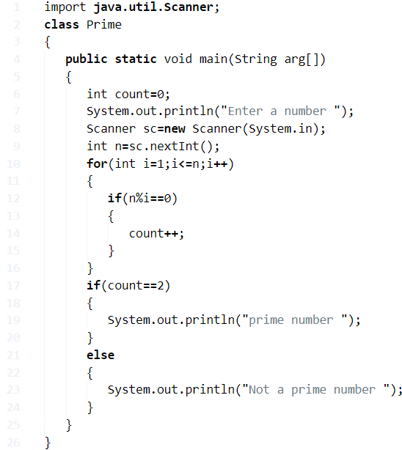

**Output:**

|  |  |
| --- | --- |
| 1  2  3 | Enter a number  57  Not a prime number |

###### Using Recursion

**1)** Read the entered number n.

**2)** The object for Prime class will be created in the main method. Call the method primeOrNot(n) using the object as  p.primeOrNot(n);

**3)** The method primeOrNot(int num) will be executed and calls itself as primeOrNot(num); until the condition if(i<=num) is false. If the condition is false then this method returns the count and assigned to the variable c. If  count=2, then print “prime number” otherwise print “not a prime number”.

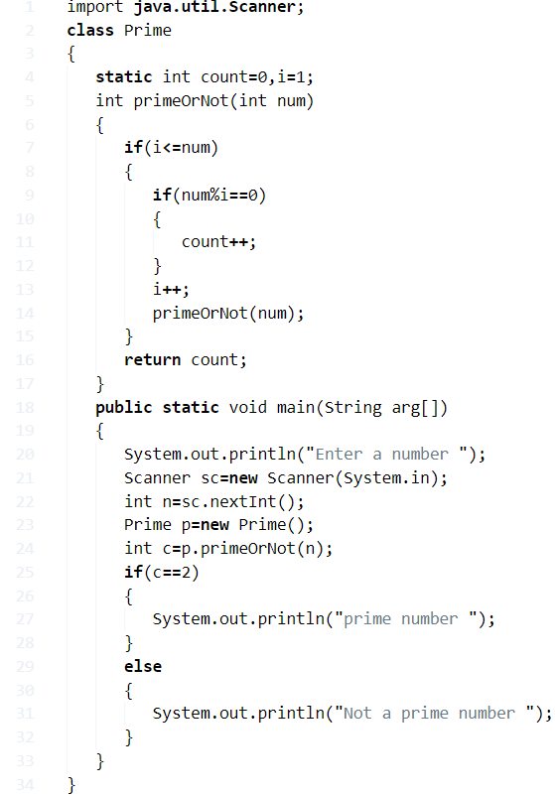

**Output:**

Output

|  |  |
| --- | --- |
| 1  2  3 | Enter a number  9  Not a prime number |

**Java program to find the given string is palindrome or not**

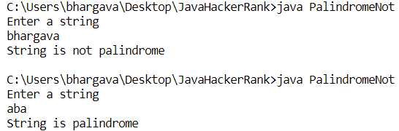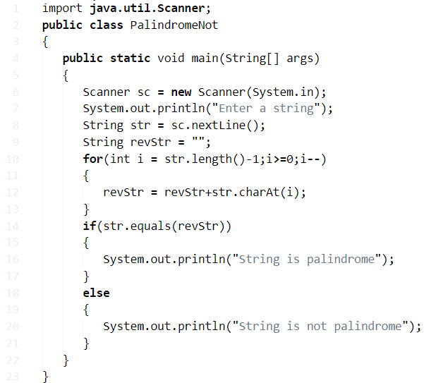

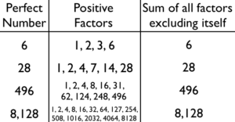**Perfect Number In Java Program – 3 Ways**

**A** **Perfect number**is a positive integer that is equal to the sum of its proper divisors except itself.

Let’s take an easy example, such as 6.

1, 2, 3 and 6 are the divisors of 6. If we add up all the numbers except 6, we end with the sum of 6 itself.

1 + 2 + 3 = 6 = Perfect Number.

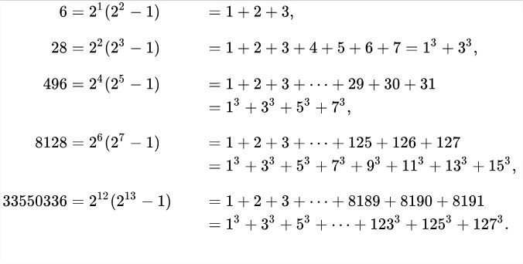Here are a few more examples of perfect numbers:

As you can see, these are regarded as even perfect numbers. An even perfect number is a perfect number that is even,i.e.,an even number n whose sum of divisors (including n itself) equals n.

All known perfect numbers are even. Ochem and Rao (2012) have demonstrated that any odd perfect number must be larger than 10^1500.

## Perfect Number – Using While Loop

**1)** The number which is equal to the sum of its divisors is called a perfect number.

**2)** Read the entered long number, assigned to the long variable n.

**3)** while loop iterates until the condition (i<=n/2) is false. If the remainder of n/i=0 then add i value to sum and increase the i value. After all the iterations compare the number with the sum, if both are equal then prints the number is a perfect number.

**4)** Example n=6,i=1 condition at while is 1<=3 is true, here 6%i=0 is true so sum=1,

i=2, 2<3 is true, 6%2=0 is true so sum=1+2=3,

i=3, 3<=3 is true ,6%3=0 is true so sum=3+3=6, for i=4 the while loop terminate and compare the sum value with n, both are equal, so it prints 6 is a perfect number.

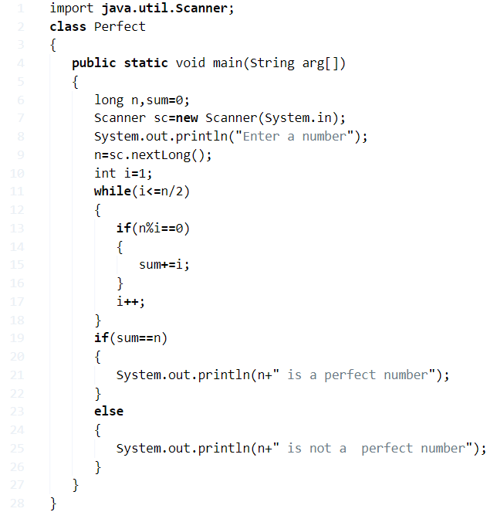

**Output:**

|  |  |
| --- | --- |
| 1  2  3 | Enter a number  6  6 is a perfect number |

### Using Static Method

**1)** In this program we have a static method long perfectOrNot(long num), it calculates the sum of proper divisors of the given number.

**2)** Call the method long perfectOrNot(long num) in the main method as perfectOrNot(n). Then that method executes the code and returns the sum value, the sum will be assigned to the variable p. Now compare the p with the given number n, if both are equal then it prints a number is a perfect number.

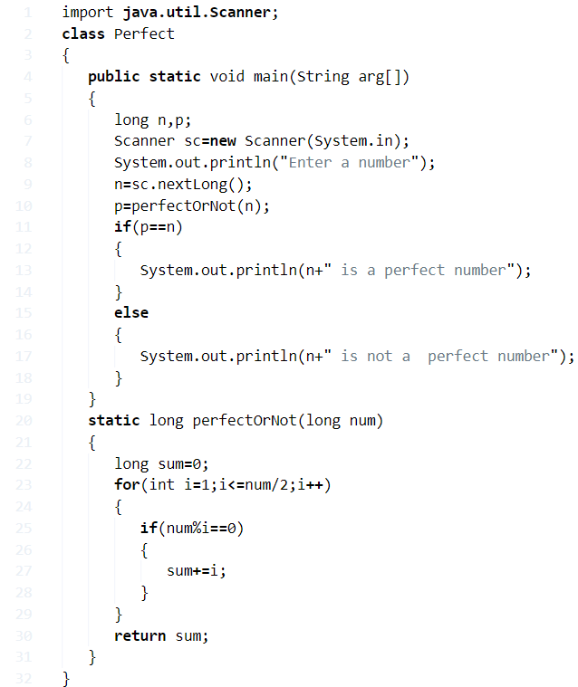

**Output:**

|  |  |
| --- | --- |
| 1  2  3 | Enter a number  50  50 is not a  perfect number |

**Perfect Number – Using Recursion**

**1)** Call the method  perfectOrNot() using the Perfect class object as p.perfectOrNot(n,i), then perfectOrNot(n,i) method starts the execution and calls itself as perfectOrNot(num,i); it repeats until the condition i<=num/2 is false.

**2)**This method returns the sum value and compares the sum with the original number, if both are equal then that number is called a perfect number.

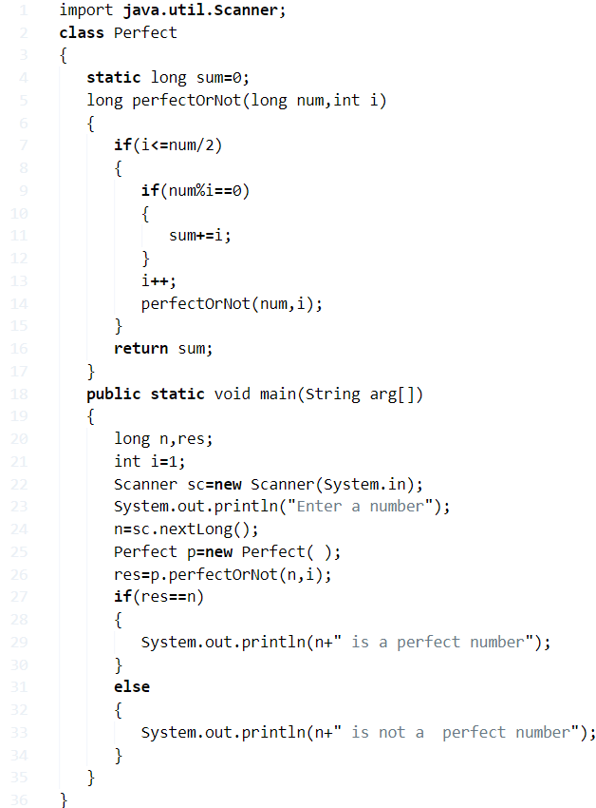

**Output:**

Output

|  |  |
| --- | --- |
| 1  2  3 | Enter a number  55  55 is not a  perfect number |

**Armstrong Number In Java Program**

**A:** An Armstrong number of three digits is an integer, where the sum of the cubes of its digits is equal to the number itself.

[table id=16 /]

Here is the example for you :

Consider the example: **371**

**A: 3^3 + 7^3 + 1^3 = 371 ( If you add those all numbers, the final digit should be same as given number ).**

Here is the list of Java programs with different methods in different ways. Do check out the table of contents so that you will get an idea.

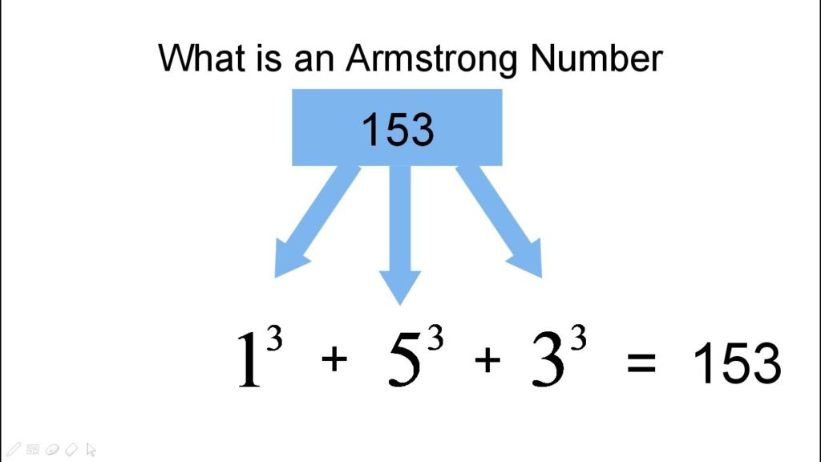

**1. Using static method Between 100 and 999**

[wp_ad_camp_3]

Here is the first sample program using the static method with sample output as well. Here we used the method ‘ Static  ‘ and taken numbers between 100 to 999. Once you are done with the execution, it automatically displays the Armstrong numbers between 100 and 999. Check out the sample output.

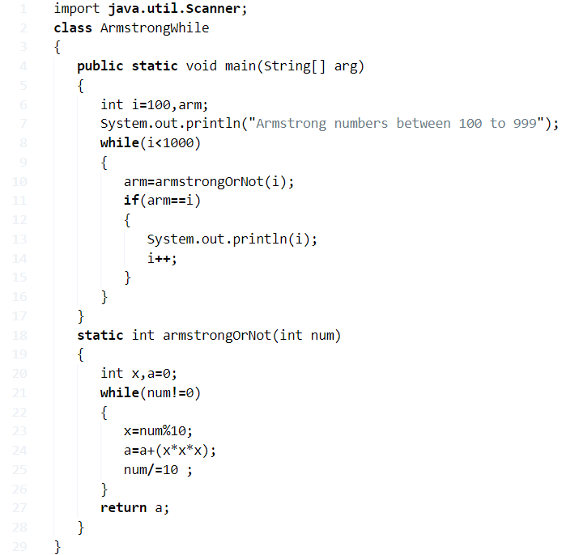

Output:

|  |  |
| --- | --- |
| 1  2  3  4  5 | Armstrong numbers between 100 to 999  153  370  371  407 |

2. Using while Loop ( 1 to 500 )

[wp_ad_camp_2]

There you go another method using while loop. Java, while loop is nothing but executing a set of statements repeatedly as long as condition, is true – here is the complete guide on while loop in Java with examples. In this case, we have taken the example of numbers from 1 to 500. Upon execution, you will get to know what are Armstrong numbers. Check out the output below so that you will get an idea.

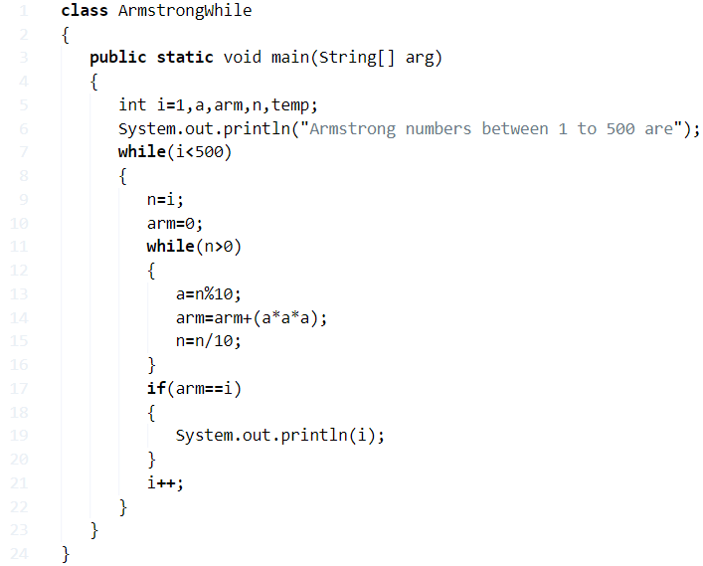

Output:

|  |  |
| --- | --- |
| 1  2  3  4  5  6 | Armstrong numbers between 1 to 500 are  1  153  370  371  407 |

3. Using Recursion ( Between 1 to 1000 )

Another method using recursion: A function that calls itself is called recursion. Here is the complete code with the sample program and the output of the program. Here we have taken the example of numbers from 1 to 1000. Check it out.

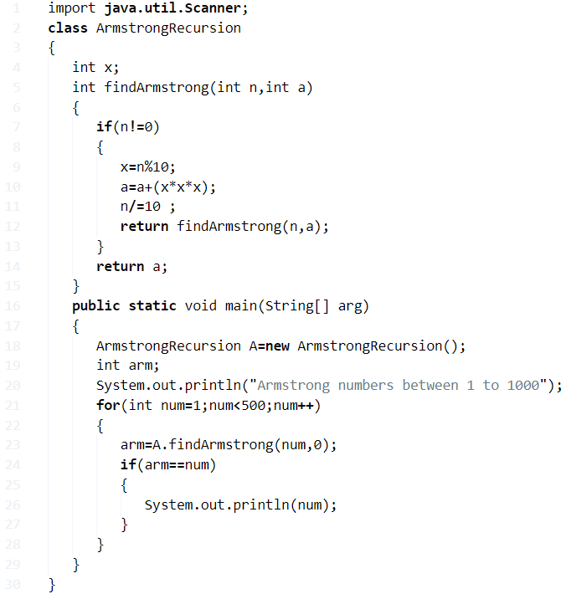

Output:

|  |  |
| --- | --- |
| 1  2  3  4  5  6 | Armstrong numbers between 1 to 1000  1  153  370  371  407 |

4. Using BufferedReader

There you another method using bufferedreader. Do check it out.

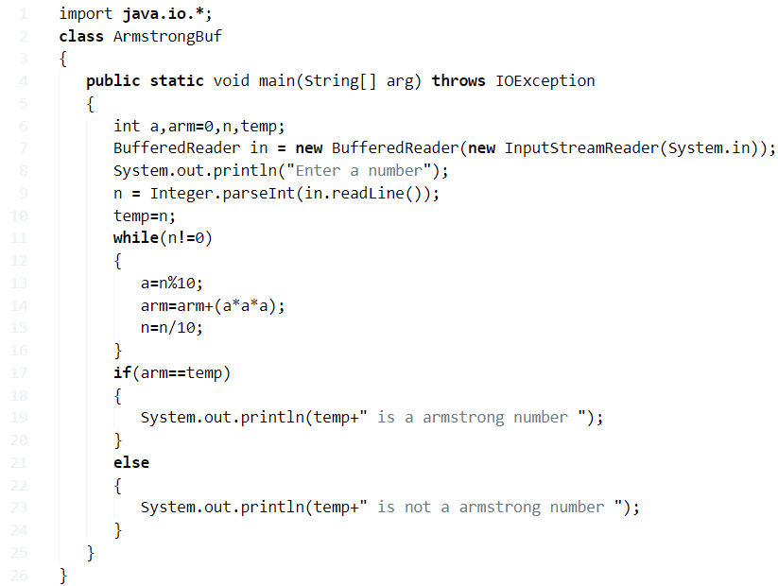

Output:

|  |  |
| --- | --- |
| 1  2  3 | Enter a number  153  153 is a armstrong number |

5. Using for loop ( 100 to 500 )

Another sample program to print Armstrong number using for loop. Check out the program along with the sample output.

Armstrong Number In Java using for loop

Java

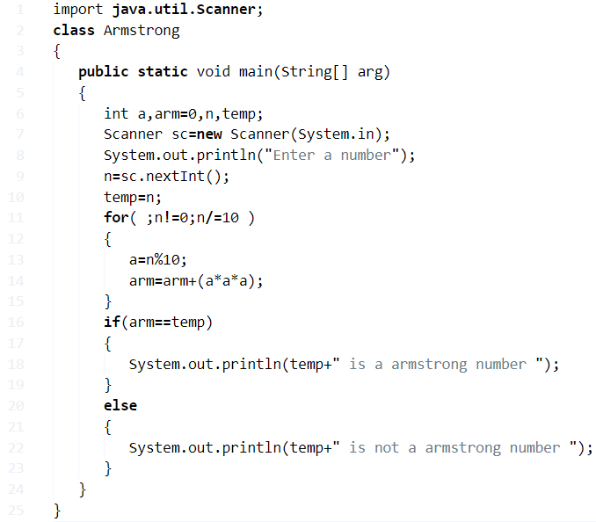

**Java Program To Check Leap Year Or Not – 4 Ways**

**A LEAP YEAR**, also known as an intercalary year or a bissextile year is a calendar year containing 366 days, as compared to the regular 365 days a year.

The extra day is added to balance out the drift between an astronomical year and a seasonal year. The Earth’s revolution generally takes 365.25 days approx to complete. The extra day is added every four years to bridge that extra time period. Here’s an interesting link that explains why years 1800, 1900, 2100 are not Leap years, even though they are divisible by 4.

## Using Ternary Operator

**1)** The ternary operator syntax is  “if (condition)? value1:value2;”, if the condition is true then it returns value1, otherwise it returns value2.

**2)** We are calculating the given year is a leap year or not. A year divisible by 400 (or) a year divisible by 4 and not divisible by 100 is a leap year.

**3)** Read the year value using scanner object sc.nextLong and store it in the variable y.

In given example y=1948, y!=0, it is divisible by 400 so c=1 return to a, a is initialized as a=1. Then it prints 1948 is a leap year.

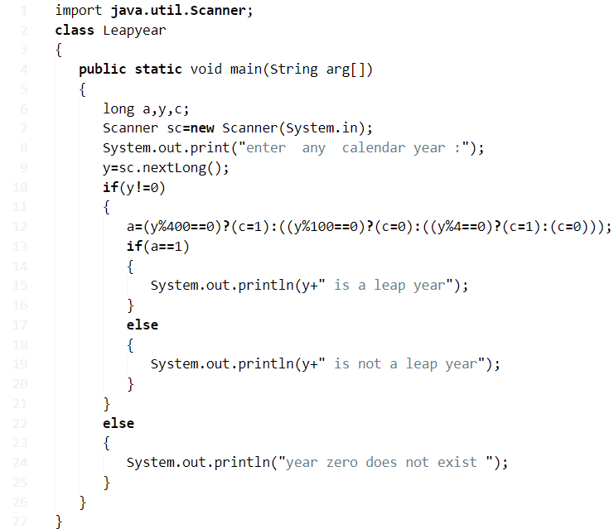

**Output:**

|  |  |
| --- | --- |
| 1  2 | enter  any  calendar year :1950  1950 is not a leap year |
| 1  2 | enter  any  calendar year :1948  1948 is a leap year |

### Using Static Method

**1)** In this program leapOrNot(long year) is the static method which finds the given year is a leap year or not. leapOrNot(long year) method calls at the main method of the class Leapyear. Then that static method starts the execution.

**a)**If the year divisible by 400 then it prints the given year is leap(or)If the given year divisible by 4 and not divisible by 100 then it prints the given year is a leap.

**b)**Otherwise, it prints “year is not a leap year”.

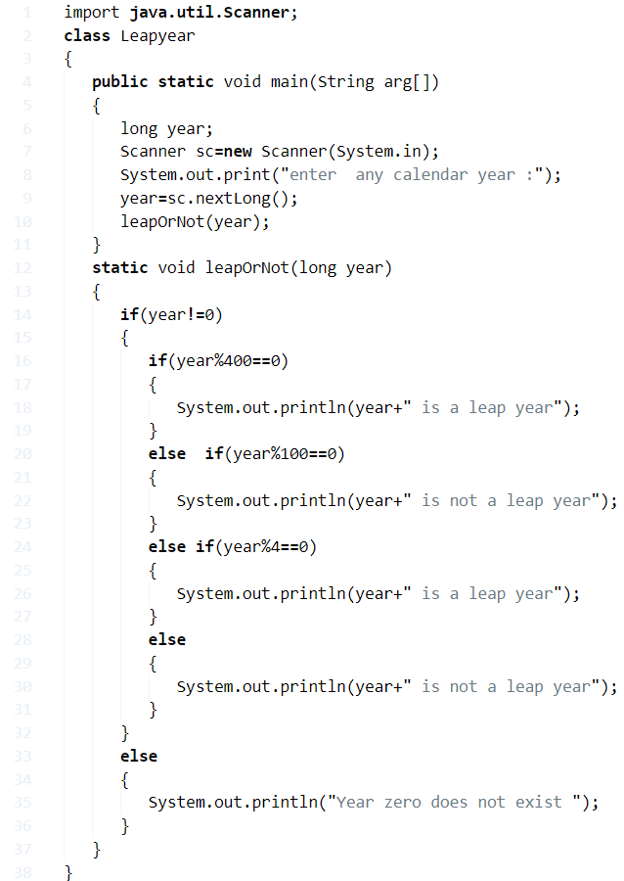

**Output:**

|  |  |
| --- | --- |
| 1  2 | enter  any calendar year :2016  2016 is a leap year |

#### Using Command Line Arguments

**1)** We[can read command line arguments from](https://javatutoring.com/command-line-arguments-java-with-examples/) “String args[]” of the main method.

**2)** Convert the year which is in the string format at arg[0], in to int using year=Integer.parseInt(arg[0]);. Integer is the wrapper class which converts the string into int data type.

**a)** If the year divisible by 400 then it prints the given year is leap or if the given year divisible by 4 and not divisible by 100 then it prints the given year is a leap.

**b)**Otherwise, it prints “year is not a leap year”.

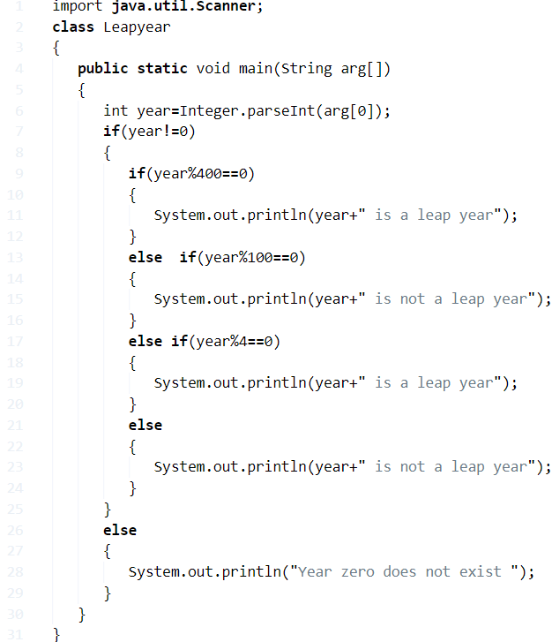

**Output:**

|  |  |
| --- | --- |
| 1  2 | >java Leapyear 2050  2050 is not a leap year |

##### **Java Leap Year Or Not – Using Function**

**1)** The leap(int year) function returns c=1 if the given year is a)divisible by 400 or b) divisible by 4 and not divisible by 100.

**2)** The function calls at the main method if year!=0, then it returns the c value and c value initialized to the variable “a” if a=1 then prints  “is a leap year” otherwise prints “not a leap year”.

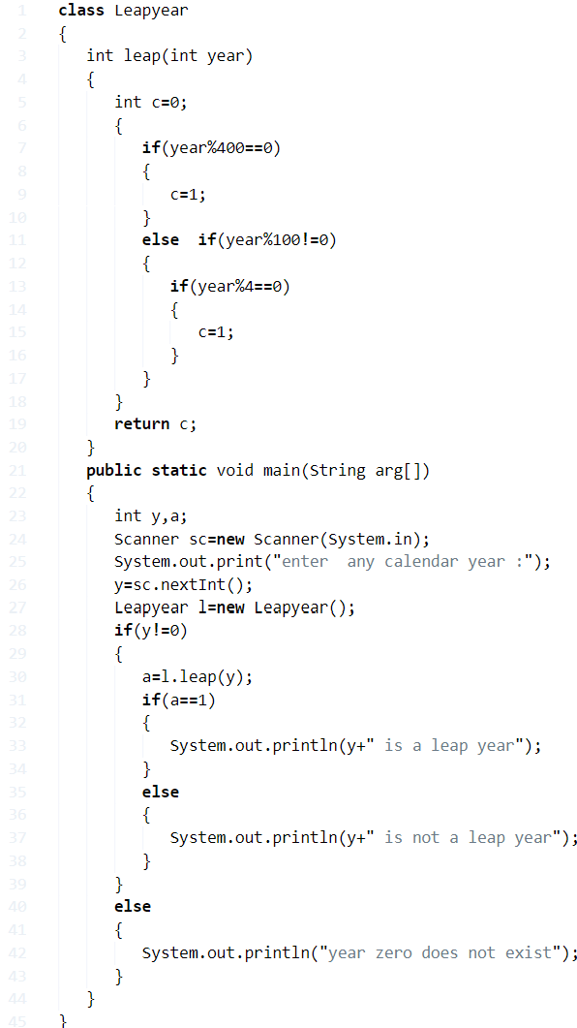

**Output:**

|  |  |
| --- | --- |
| 1  2 | enter  any calendar year :2016  2016 is a leap year |

##### **Using If-Else**

**1)** We are using if else condition to find the given year is a leap year or not.

**2)** The 1st if condition checks the given year is equal to zero or not, if not

**a)** If given year divisible by 400 it prints  “is a leap year”, if condition false then come to else part.

**b)**If given year divisible by 100, then inner if condition checks the year is divisible by 4 or not if true then prints “is a leap year” otherwise prints “is not a leap year. If condition if(year%100!=0) is false then it prints “is not a leap year”.

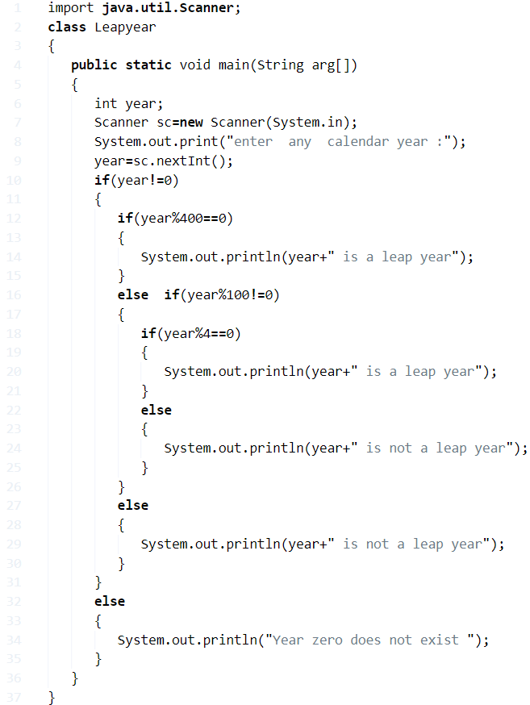

**Output:**

Output

|  |  |
| --- | --- |
| 1  2 | enter  any  calendar year :1999  1999 is not a leap year |

# Java program to Print ASCII Value in Java

# ****ASCII**** acronym for American Standard Code for Information Interchange. It is a 7-bit character set contains ****128**** (0 to 127) characters. It represents the numerical value of a character. For example, the ****ASCII value**** of ****A**** is ****65****.

In this section, we will learn **how to print ASCII value** or **code** through a **Java** program.There are **two** ways to print ASCII value in [Java](https://www.javatpoint.com/java-tutorial):

* **Assigning a Variable to the int Variable**
* **Using Type-Casting**

## Assigning a Variable to the int Variable

To print the [ASCII](https://www.javatpoint.com/ascii) value of a character, we need not use any method or class. Java internally converts the character value to an ASCII value.

Let's find the [ASCII](https://www.javatpoint.com/ascii-full-form) value of a character through a [Java program](https://www.javatpoint.com/java-programs).

In the following program, we have assigned two characters **a** and **b** in the **ch1** and **ch2** variables, respectively. To find the ASCII value of **a** and **b,** we have assigned ch1 and ch2 variables to the integer variables **asciivalue1** and **asciivalue2,** respectively. Finally, we have printed the variable **asciivalue1** and **asciivalue2** in which ASCII values of the characters are stored.

**PrintAsciiValueExample1.java**

1. **public** **class** PrintAsciiValueExample1
2. {
3. **public** **static** **void** main(String[] args)
4. {
5. // character whose ASCII value to be found
6. **char** ch1 = 'a';
7. **char** ch2 = 'b';
8. // variable that stores the integer value of the character
9. **int** asciivalue1 = ch1;
10. **int** asciivalue2 = ch2;
11. System.out.println("The ASCII value of " + ch1 + " is: " + asciivalue1);
12. System.out.println("The ASCII value of " + ch2 + " is: " + asciivalue2);
13. }
14. }

**Output:**

The ASCII value of a is: 97

The ASCII value of b is: 98

Another way to write the above program is:

**PrintAsciiValueExample2.java**

1. **public** **class** PrintAsciiValueExample2
2. {
3. **public** **static** **void** main(String[] String)
4. {
5. **int** ch1 = 'a';
6. **int** ch2 = 'b';
7. System.out.println("The ASCII value of a is: "+ch1);
8. System.out.println("The ASCII value of b is: "+ch2);
9. }
10. }

**Output:**

The ASCII value of a is: 97

The ASCII value of b is: 98

Similarly, we can print the ASCII value of other characters (A, B, C, …., Z) and symbols (!, @, $, *, etc.).

## Using Type-Casting

Type-casting is a way to cast a variable into another datatype.

In the following program, we have declared two variables **ch1** and **ch2** of type **char** having the character **a** and **b,** respectively. In the next two lines, we have cast char type to int type using **(int)**. After executing these two lines, the variable **ch1** and **ch2** are converted to an int variable **ascii1** and **ascii2**, respectively.

Finally, we have printed the variable **ascii1** and **ascii2** in which ASCII values of the characters are stored.

**PrintAsciiValueExample3.java**

1. **public** **class** PrintAsciiValueExample3
2. {
3. **public** **static** **void** main(String[] args)
4. {
5. //characters whose ASCII value to be found
6. **char** ch1 = 'a';
7. **char** ch2 = 'b';
8. //casting or converting a charter into int type
9. **int** ascii1 = (**int**) ch1;
10. **int** ascii2 = (**int**) ch2;
11. System.out.println("The ASCII value of " + ch1 + " is: " + ascii1);
12. System.out.println("The ASCII value of " + ch1 + " is: " + ascii2);
13. }
14. }

**Output:**

The ASCII value of a is: 97

The ASCII value of b is: 98

If we do not want to assign character, we can also take a character from the user.

**PrintAsciiValueExample4.java**

1. **import** java.util.Scanner;
2. **public** **class** PrintAsciiValueExample4
3. {
4. **public** **static** **void** main(String args[])
5. {
6. System.out.print("Enter a character: ");
7. Scanner sc = **new** Scanner(System.in);
8. **char** chr = sc.next().charAt(0);
9. **int** asciiValue = chr;
10. System.out.println("ASCII value of " +chr+ " is: "+asciiValue);
11. }
12. }

**Output 1:**

Enter a character: P

ASCII value of P is: 80

**Output 2:**

Enter a character: G

ASCII value of G is: 71

The following program prints the ASCII value (0 to 255) of all the characters. In the output, we have shown a few values.

**AsciiValueOfAllChracters.java**

1. **public** **class** AsciiValueOfAllChracters
2. {
3. **public** **static** **void** main(String[] args)
4. {
5. **for**(**int** i = 0; i <= 255; i++)
6. {
7. System.out.println(" The ASCII value of " + (**char**)i + "  =  " + i);
8. }
9. }
10. }

**Output:**

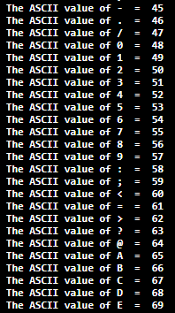

If we want to print the ASCII value of all the alphabets (A to Z), we can set the values in the loop and print them.

**AsciiValueAtoZ.java**

1. **public** **class** AsciiValueAtoZ
2. {
3. **public** **static** **void** main(String[] args)
4. {
5. **for**(**int** i = 65; i <= 90; i++)
6. {
7. System.out.println(" The ASCII value of " + (**char**)i + "  =  " + i);
8. }
9. }
10. }

**Output:**

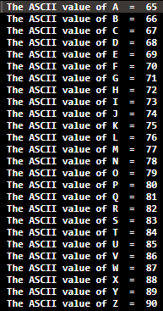

Similarly, we can print the ASCII value of **a to z** by changing the loop in the above code.

1. **for**(**int** i = 97; i <= 122; i++)

**Reverse A Number In Java – 4 Simple Ways**

## Using While Loop

**1)** Entered value will be assigned to n and res=0.

**2)** While loop iterates until n!=0, if n=0 then the loop terminated and prints the res  value.

* example n=153, the condition is true ,a=3, res=(0*10)+3=3, n=15
* n=15 condition true, a=5,res=30+5=35,n=1
* n=1,condition true, a=1, res=35*10+1=351,n=0, so while loop terminated and prints reverse number.

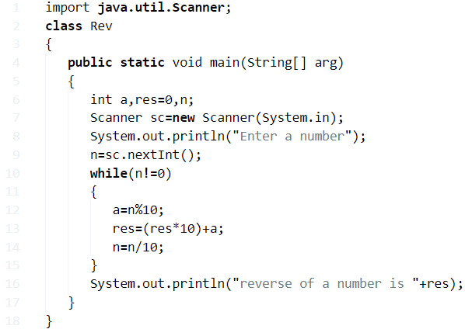

**Output:**

|  |  |
| --- | --- |
| 1  2  3 | Enter a number  153  reverse of a number is 351 |

### Using Static Method

**1)** Here we have a static method reverse(int num), which calculates the reverse number.

**2)** The reverse method is called at the main method then reverse method executed and returns the reverse number, then prints the reverse number.

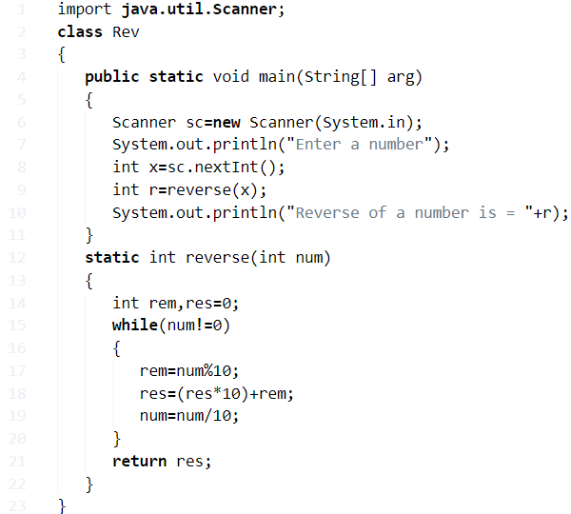

**Output:**

|  |  |
| --- | --- |
| 1  2  3 | Enter a number  159  Reverse of a number is = 951 |

#### Reverse A Number In Java – Using Function

**1)** We are calculating the reverse of a number using for loop.

**2)** For loop iterates until n!=0, here the structure of for loop doesn’t contains the initialization ,increment / decrement.

**3)** For loop repeats these steps a=n%10; res=(res*10)+a; n=n/10; until the condition is false. if n=0 then it prints reverse of the number.

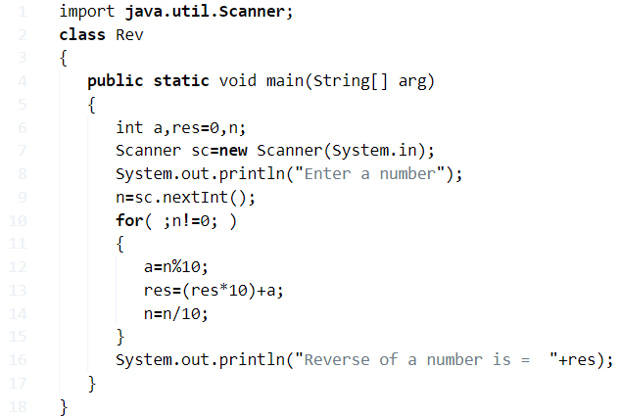

**Output:**

|  |  |
| --- | --- |
| 1  2  3 | Enter a number  909  Reverse of a number is =  909 |

##### Using Recursion

**1)** In this program reverse(int num) is recursive, it calls itself until the condition is false.

**2)** Using Rev  class object r, call the method reverse(x ) as  r.reverse(x), then reverse(x) method starts the execution and calls itself as reverse(num)  until num!=0.

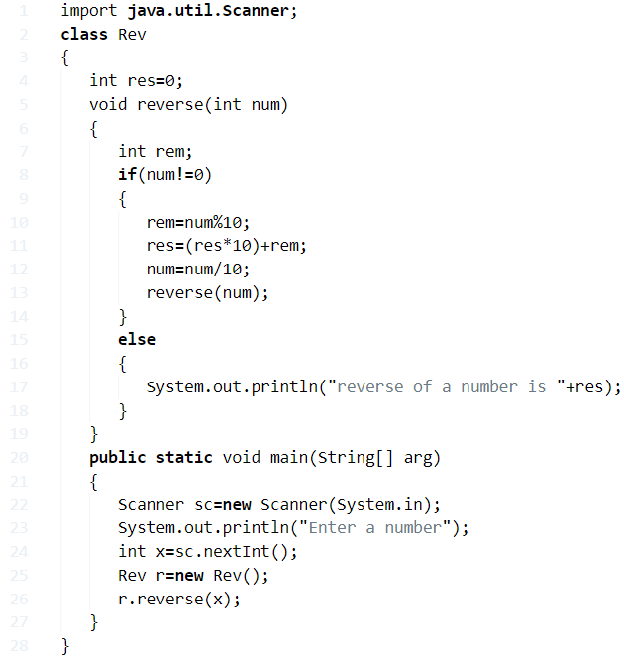

**Output:**

Output

|  |  |
| --- | --- |
| 1  2  3 | Enter a number  9582  reverse of a number is 2859 |

**Reverse An Array**

## Standard Array Reversal

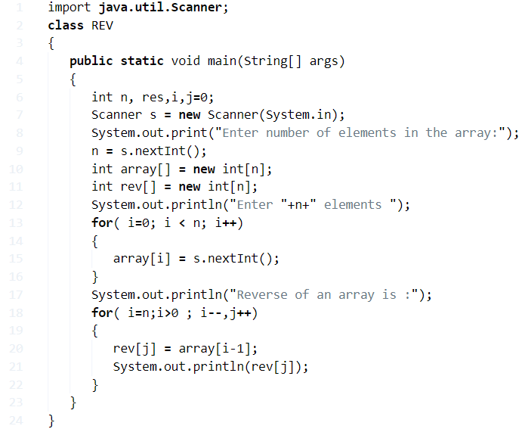

**Output:**

|  |  |
| --- | --- |
| 1  2  3  4  5  6  7  8  9  10  11  12  13 | Enter number of elements in the array:5  Enter 5 elements  1  2  3  4  5  Reverse of an array is :  5  4  3  2  1 |

### Without Using Another Array

**1)** Insert the elements in to the array “array[]” using scanner class method s.nextInt().

**2)**To reverse the array we are interchanging the n-1 element with the i’th element by increasing i value and decreasing the n value until i<n.

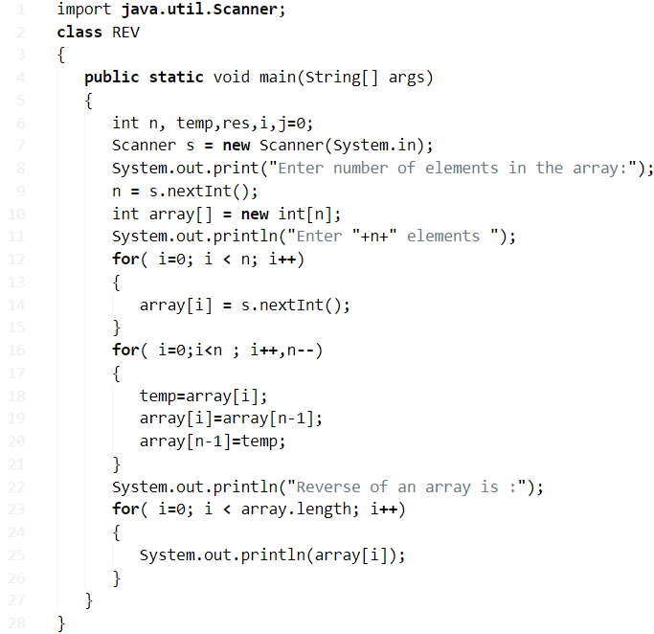

**Output:**

|  |  |
| --- | --- |
| 1  2  3  4  5  6  7  8  9  10  11  12  13  14  15 | Enter number of elements in the array:6  Enter 6 elements  10  20  30  40  50  60  Reverse of an array is :  60  50  40  30  20  10 |

#### Using Class

**1)** The class “Reverse” will reverse the given array.

**2)** Reverse res=new Reverse(array,n), creating the Reverse class object res by passing the array, number of elements in the array. Then Reverse class constructor Reverse(int[] a,int n) will be executed.

* for i=length of the array to i>0 and  j=0 to j<length of the array
* rev[j] = a[i-1]

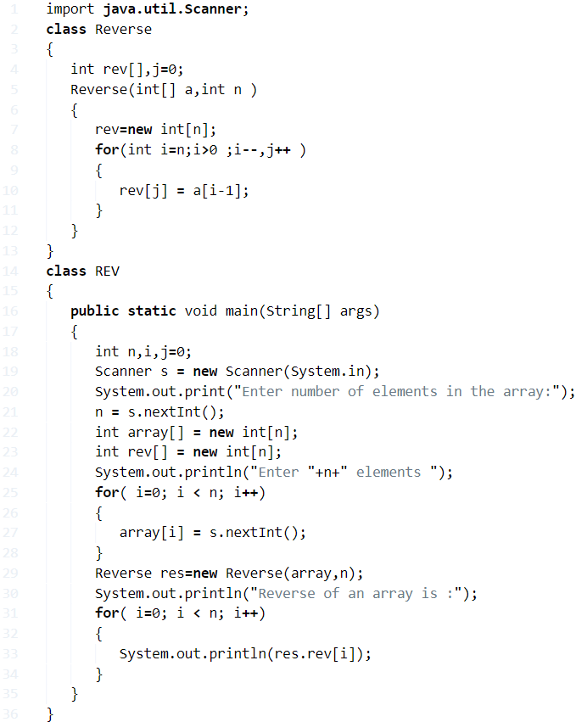

**Output:**

Output

|  |  |
| --- | --- |
| 1  2  3  4  5  6  7  8  9  10  11 | Enter number of elements in the array:4  Enter 4 elements  5  9  15  30  Reverse of an array is :  30  15  9  5 |

**Reverse A String In Java – 4 Ways**

## Reverse A String – Using Static Method

**1)**String reverse(String s) is the static method This method contains the **logic to reverse the string.**

**2)** Create the object for the class ReverseofaString and call the static method with the object as rev.reverse(str)) by passing the given string.

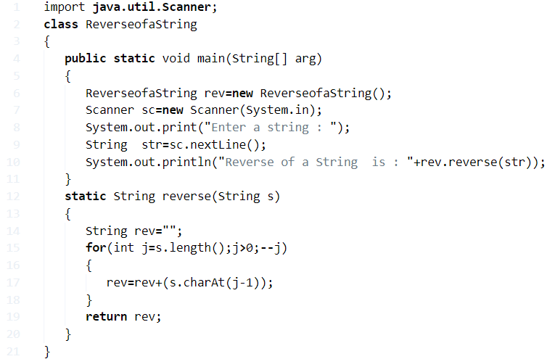

**Output:**

|  |  |
| --- | --- |
| 1  2 | Enter a string : String  Reverse of a String  is : gnirtS |

### Java Code Reverse A String – Using Array

**1)** We are using a character array to reverse the given string.

**2)** Read the entered string using scanner object scan.nextLine() and store it in the variable str. We are converting the string an to character array the string class method toCharArray() and initialized to char[] ch.

**3)** j=length of the array, for loop iterates from i=length of the array to i>0. The loop prints the character which is at the index i-1 of the array “ch” i.e. it prints the characters from the last index of the char array.

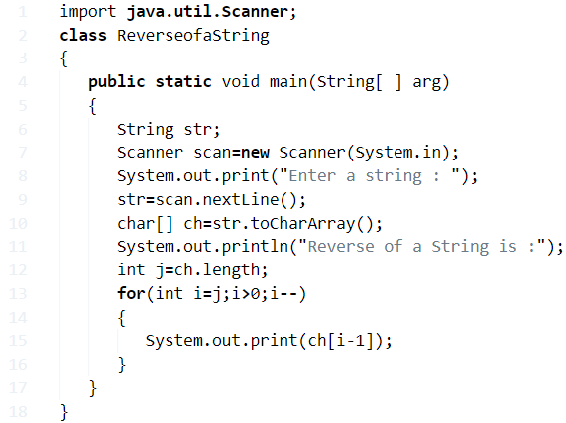

**Output:**

|  |  |
| --- | --- |
| 1  2  3 | Enter a string : computer science  Reverse of a String is :  ecneics retupmoc |

#### Using Recursion

**1)** A method [which calls itself is recursive](https://javatutoring.com/recursion-in-java/). In this program reverse(String s) is recursive.

**2)**Create the object for the class ReverseofaString rev. Read the entered string using sc.nextLine() and store it in the string variable str. Call the reverse method as rev.reverse(str).

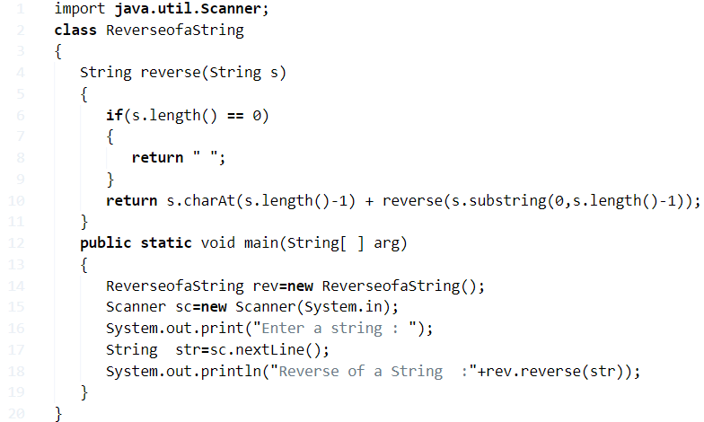

**Output:**

|  |  |
| --- | --- |
| 1  2 | Enter a string : enter  Reverse of a String  :retne |

##### Using While Loop

**1)** Here i=length of the given string. While loop iterates until the condition i>0 is false, i.e. if the length of the string is zero then cursor terminates the loop.

**2)** While loop prints the character of the string which is at the index (i-1) until i>0. Then we will get the reverse of a string.

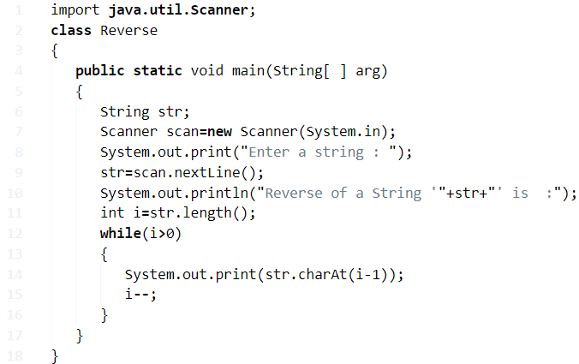

**Output:**

|  |  |
| --- | --- |
| 1  2  3 | Enter a string : kankesh  Reverse of a String 'kanakesh' is  :  hsekanak |

###### Using For Loop

**1)** For loop iterates from j=length of the string to j>0.

**2)** It prints the character of the string which is at the index (i-1), then we will get reverse of a string.

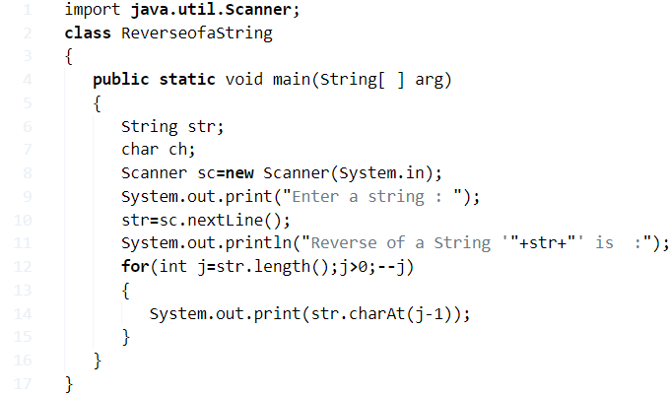**x**

**Output:**

|  |  |
| --- | --- |
| 1  2  3 | Enter a string : java  Reverse of a String 'java' is  :  avaj |

##### Word by Word

**1)** Read the string using scanner object scan.nextLine() and store it in the variable str. We are converting the string into the char array using the string class method toChatArray(), and initialized to char[] ch.

**2)** The 1st for loop iterates from i=0 to i< length of the array.

**a)** If ch[i]!=’ ‘ then adding ch[0] to the string word. If block adds the characters to the string word until we will get space i.e. word contains the 1st word.

**b)** If we get space then the else block to reverse the word which is read using else block.

**3)** 2nd for loop reverse the last word which is read by else block.

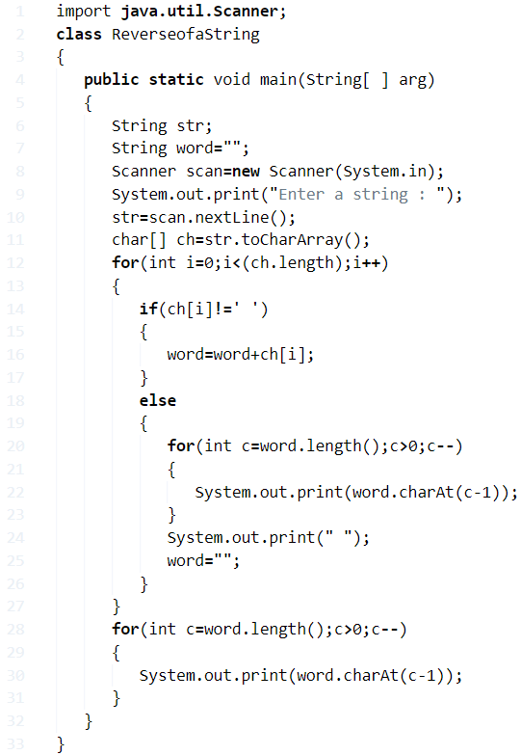

**Output:**

Output:

|  |  |
| --- | --- |
| 1  2 | Enter a string : reverse programme  esrever emmargorp |

### Java program to reverse a list

To reverse an ArrayList, we can use reverse() method of Collections class. Consider the following example.

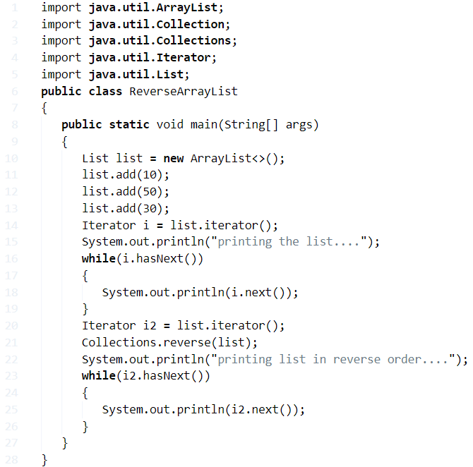

**Output**

printing the list....

10

50

30

printing list in reverse order....

30

50

10

## Java Program to find the number of the words in the given text file

In this program, we need to find the most repeated word present in given text file. This can be done by opening a file in read mode using file pointer. Read the file line by line. Split a line at a time and store in an array. Iterate through the array and count the word. The content of data.txt file used in the program is shown below.

data.txt

A computer program is a collection of instructions that performs specific task when executed by a computer.

Computer requires programs to function.

Computer program is usually written by a computer programmer in programming language.

A collection of computer programs, libraries, and related data are referred to as software.

Computer programs may be categorized along functional lines, such as application software and system software.

### Algorithm

* **STEP 1:** START
* **STEP 2:** DEFINE String line
* **STEP 3:** SET count =0
* **STEP 4:** USE File Reader to open file in read mode.
* **STEP 5:** READ line from file
* **STEP 6:** REPEAT STEP 7 to STEP 8 UNTIL reach the end of file
* **STEP 7:** SPLIT lines into words and STORE in array string words[].
* **STEP 8:** count = count + words.length
* **STEP 9:** PRINT count.
* **STEP 10:** END

### Program:

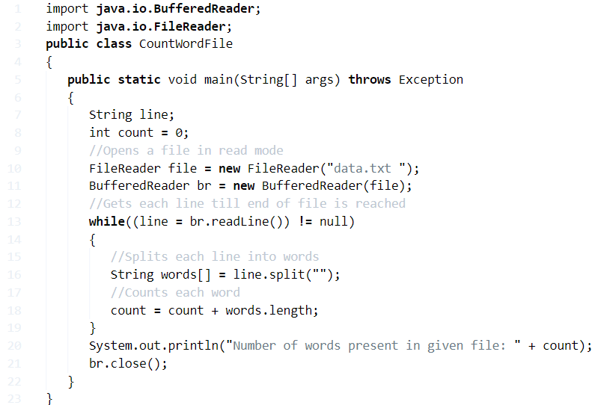

**Output:**

Number of words present in given file: 63

# Java Program to find Third Largest Number in an Array

We can find the third largest number in an array in java by sorting the array and returning the 3rd largest number. Let's see the full example to find the third largest number in java array.

1. **public** **class** ThirdLargestInArrayExample{
2. **public** **static** **int** getThirdLargest(**int**[] a, **int** total){
3. **int** temp;
4. **for** (**int** i = 0; i < total; i++)
5. {
6. **for** (**int** j = i + 1; j < total; j++)
7. {
8. **if** (a[i] > a[j])
9. {
10. temp = a[i];
11. a[i] = a[j];
12. a[j] = temp;
13. }
14. }
15. }
16. **return** a[total-3];
17. }
18. **public** **static** **void** main(String args[]){
19. **int** a[]={1,2,5,6,3,2};
20. **int** b[]={44,66,99,77,33,22,55};
21. System.out.println("Third Largest: "+getThirdLargest(a,6));
22. System.out.println("Third Largest: "+getThirdLargest(b,7));
23. }}

Output:

Third Largest:3

Third Largest:66

## Find 3rd Largest Number in Array using Arrays

Let's see another example to get third largest element or number in java array using Arrays.

1. **import** java.util.*;
2. **public** **class** ThirdLargestInArrayExample1{
3. **public** **static** **int** getThirdLargest(**int**[] a, **int** total){
4. Arrays.sort(a);
5. **return** a[total-3];
6. }
7. **public** **static** **void** main(String args[]){
8. **int** a[]={1,2,5,6,3,2};
9. **int** b[]={44,66,99,77,33,22,55};
10. System.out.println("Third Largest: "+getThirdLargest(a,6));
11. System.out.println("Third Largest: "+getThirdLargest(b,7));
12. }}

Output:

Third Largest: 3

Third Largest: 66

## Find 3rd Largest Number in Array using Collections

Let's see another example to get third largest number in java array using collections.

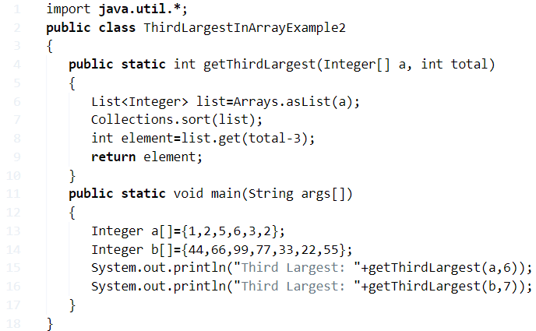

Output:

Third Largest: 3

Third Largest: 66

# Java Program to remove duplicate element in an Array

We can remove duplicate element in an array by 2 ways: using temporary array or using separate index. To remove the duplicate element from array, the array must be in sorted order. If array is not sorted, you can sort it by calling Arrays.sort(arr) method.

## 1) Remove Duplicate Element in Array using Temporary Array

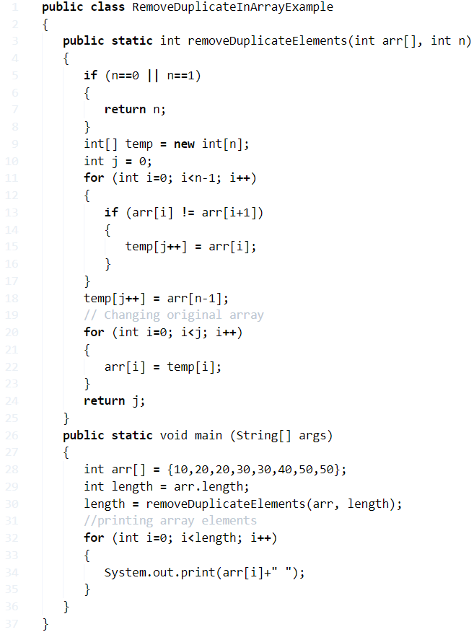

Output:

10 20 30 40 50

## 2) Remove Duplicate Element in Array using separate index

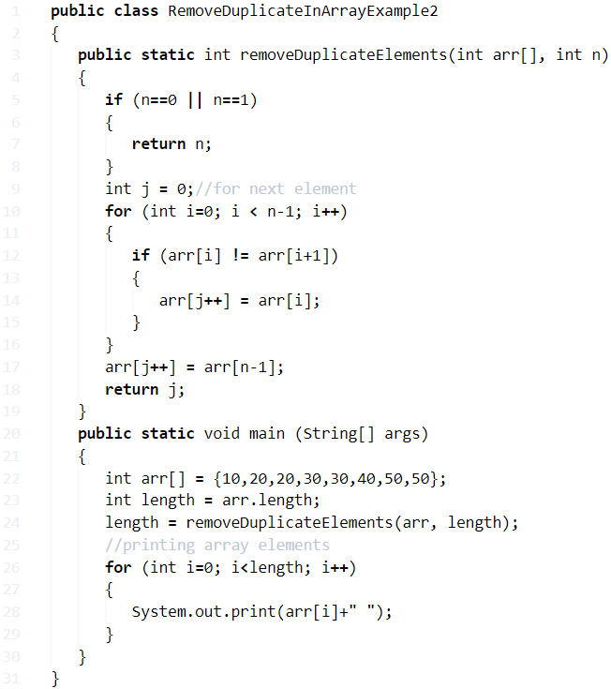

Output:

10 20 30 40 50

## Remove Duplicate Elements in Unsorted Array

If you have unsorted array, you need to sort it first. To do so, use Arrays.sort(arr) method.

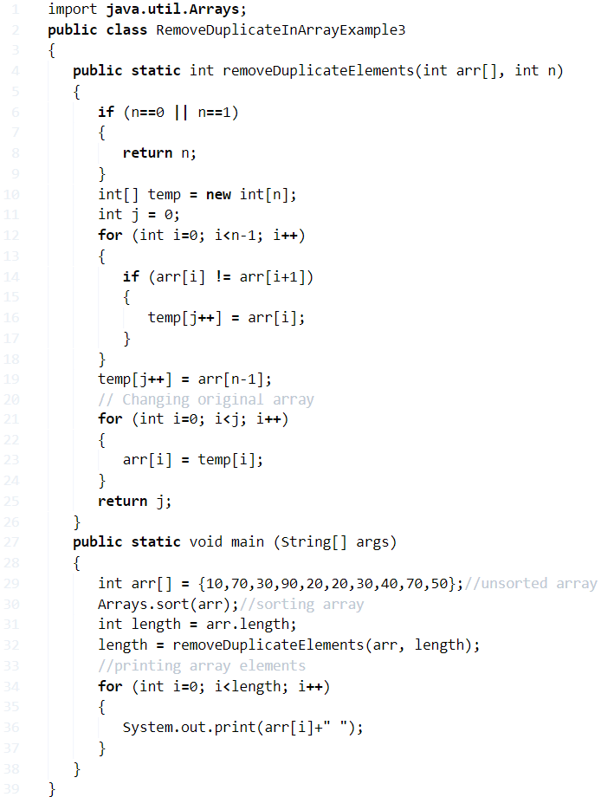

Output:

10 20 30 40 50 70 90

## Java Program to remove all the white spaces from a string

In this program, our task is to remove all the white-spaces from the string. For this purpose, we need to traverse the string and check if any character of the string is matched with a white-space character or not. If so, use any built-in method like replace() with a blank.

In C, we do not have any built-in method to replace. Therefore, we need to run for loop to traverse the string and see if there is any white-space character or not. If so, then start the inner loop (j) from ith character to len and keep replacing each element with its next adjacent element. Decrease the length of the string by 1 on the termination of this loop. Repeat this process until all the white-spaces of the string are removed.

The algorithm of the program is given below.

### Algorithm

* **STEP 1:** START
* **STEP 2:** DEFINE string str1 = "Remove white spaces".
* **STEP 3:** REPLACE all space characters with blank using replaceAll().
* **STEP 4:** PRINT str1.
* **STEP 5:** END

### Program:

1. **public** **class** removeWhiteSpace {
2. **public** **static** **void** main(String[] args) {
4. String str1="Remove white spaces";
6. //Removes the white spaces using regex
7. str1 = str1.replaceAll("\\s+", "");
9. System.out.println("String after removing all the white spaces : " + str1);
10. }
11. }

**Output:**

String after removing all the white spaces: Removewhitespaces

## Java Program to find missing numbers from given array

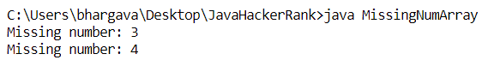

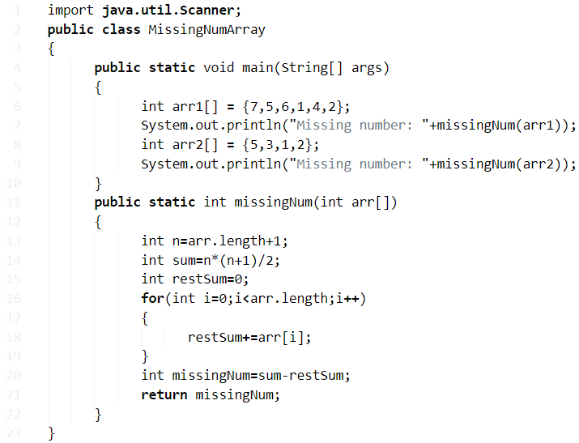

# Java program to Generate Random Number in Java

In **Java** programming, we often required to **generate random numbers** while we develop applications. Many applications have the feature to **generate numbers randomly**, such as to verify the user many applications use the **OTP**. The best example of random numbers is dice. Because when we throw it, we get a random number between 1 to 6.

In this section, we will learn what is a **random number** and **how to generate random numbers in**[**Java**](https://www.javatpoint.com/java-tutorial).

## Random Number

Random numbers are the numbers that use a large set of numbers and selects a number using the mathematical algorithm. It satisfies the following two conditions:

* The generated values uniformly distributed over a definite interval.
* It is impossible to guess the future value based on current and past values.

## Generating Random Number in Java

In Java, there is three-way to generate random numbers using the method and classes.

* Using the **random()** Method
* Using the **Random** Class
* Using the **ThreadLocalRandom** Class
* Using the **ints()** Method (in Java 8)

### Using the Math.random() Method

The Java **Math** class has many methods for different mathematical operations. One of them is the **random()** method. It is a **static** method of the Math class. We can invoke it directly. It generates only **double** type random number **greater than or equal to 0.0** and **less than 1.0**. Before using the random() method, we must import the java.lang.Math class.

**Syntax:**

1. **public** **static** **double** random()

It does not accept any parameter. It returns a pseudorandom double that is greater than or equal to 0.0 and less than 1.0.

Let's create a program that generates random numbers using the random() method.

**RandomNumberExample1.java**

1. **import** java.lang.Math;
2. **public** **class** RandomNumberExample1
3. {
4. **public** **static** **void** main(String args[])
5. {
6. // Generating random numbers
7. System.out.println("1st Random Number: " + Math.random());
8. System.out.println("2nd Random Number: " + Math.random());
9. System.out.println("3rd Random Number: " + Math.random());
10. System.out.println("4th Random Number: " + Math.random());
11. }
12. }

**Output:**

1st Random Number: 0.17434160924512265

2nd Random Number: 0.4297410090709448

3rd Random Number: 0.4828656381344487

4th Random Number: 0.13267917059488898

**Remember:** Every time we get a different output when we execute the program. Your output may differ from the output shown above.

We can also use the following formula if we want to a generate random number between a specified range.

1. Math.random() * (max - min + 1) + min

In the above formula, the min value is inclusive while the max value is exclusive.

Let's create a program that generates random numbers between 200 to 400.

**RandomNumberExample2.java**

1. **public** **class** RandomNumberExample2
2. {
3. **public** **static** **void** main( String args[] )
4. {
5. **int** min = 200;
6. **int** max = 400;
7. //Generate random double value from 200 to 400
8. System.out.println("Random value of type double between "+min+" to "+max+ ":");
9. **double** a = Math.random()*(max-min+1)+min;
10. System.out.println(a);
11. //Generate random int value from 200 to 400
12. System.out.println("Random value of type int between "+min+" to "+max+ ":");
13. **int** b = (**int**)(Math.random()*(max-min+1)+min);
14. System.out.println(b);
15. }
16. }

**Output 1:**

Random value of type double between 200 to 400:

233.88329802655377

Random value of type int between 200 to 400:

329

**Output 2:**

Random value of type double between 200 to 400:

254.8419979875385

Random value of type int between 200 to 400:

284

### Using the Random Class

Another way to generate a random number is to use the [Java **Random** class](https://www.javatpoint.com/post/java-random) of the java.util package. It generates a stream of pseudorandom numbers. We can generate a random number of any data type, such as integer, float, double, Boolean, long. If you are going to use this class to generate random numbers, follow the steps given below:

* First, import the class java.lang.Random.
* Create an **object** of the Random class.
* Invoke any of the following methods:
* **nextInt(int bound)**
* **nextInt()**
* **nextFloat()**
* **nextDouble()**
* **nextLong()**
* **nextBoolean()**

All the above methods return the next pseudorandom, homogeneously distributed value (corresponding method) from this random number generator's sequence. The **nextDouble()** and **nextFloat()** method generates random value between 0.0 and 1.0.

The **nextInt(int bound)** method accepts a parameter bound (upper) that must be positive. It generates a random number in the range 0 to bound-1.

Let's create a program that generates random numbers using the Random class.

**RandomNumberExample3.java**

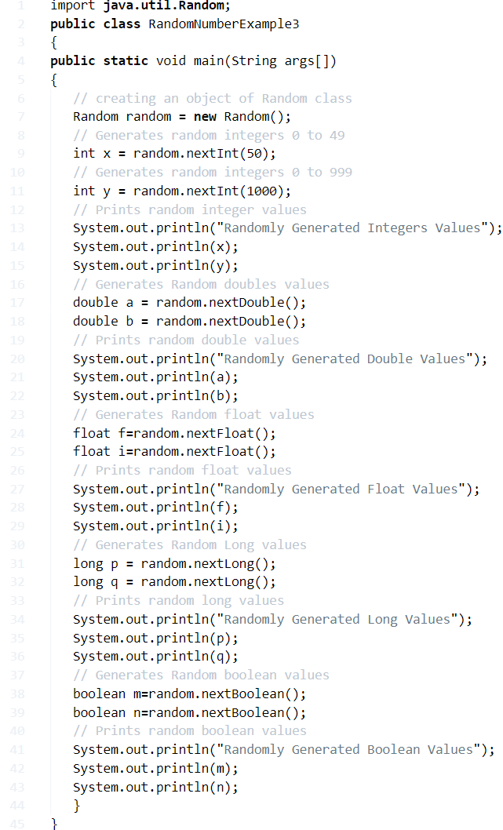

**Output:**

Randomly Generated Integers Values

23

767

Randomly Generated Double Values

0.37823814494212016

0.998058172671956

Randomly Generated Float Values

0.87804186

0.93880254

Randomly Generated Long Values

-4974823544291679198

3650240138416076693

Randomly Generated Boolean Values

false

true

## Java Program to swap two string variables without using third or temp variable.

In this program, we need to swap two strings without using a third variable.

Str1: Good Str2: morning

Swapping two strings usually take a temporary third variable. One of the approach to accomplish this is to concatenate given two strings into first string.

Str1Str1 = Str1 + Str2= Goodmorning

Extract string 2 using substring (0, length(string1) - (string2)) i.e. in our case it will be substring(0, (11-4)). It will assign string Good to string 2 which is highlighted by green.

Str2 = Goodmorning

Extract string 1 using substring (length(string2)) i.e. we need to extract string from in length(string2) till end of the string. In our case it will be substring(4). It will assign string morning to string 1 which is highlighted by green.

Str1 = Goodmorning

### Algorithm

* **STEP 1:** START
* **STEP 2:** DEFINE Strings str1 = "Good ", str2 = "morning " to swap
* **STEP 3:** PRINT "Strings before swapping " str1, str2
* **STEP 4:** str1 =str1 + str2
* **STEP 5:** EXTRACT str1 from indexes 0 to length (str1) - (str2) using substring function and store it in str2.
* **STEP 6:** EXTRACT str1 from index length(str2) till end using substring function and store it in str1.
* **STEP 7:** PRINT "Strings after swapping " str1, str2.
* **STEP 8:** END

### Program:

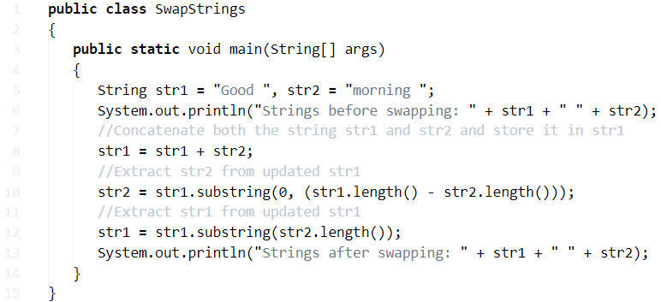

**Output:**

Strings before swapping: Good morning

Strings after swapping: morning Good

## Java Program to replace lower-case characters with upper-case and vice-versa

Here, our task is to replace all the lower-case characters in the string to upper-case and upper-case characters to lower-case.

For this purpose, we need to traverse the string and check for each character. If the character is a lower-case character, make it upper-case by using the language-specific built-in method or add 32 to the lower-case character in C to change the ASCII value of the character.

For programming, follow the algorithm given below:

### Algorithm

* **STEP 1:** START
* **STEP 2:** DEFINE string str = "Great Power".
* **STEP 3:** DEFINE newstr as StringBuffer object .
* **STEP 4:** SET i=0. REPEAT STEP 5 to STEP 6 UNTIL i<str.length().
* **STEP 5:** IF lower-case character encountered then CONVERT them in upper-case using built-in function  
  else  
  IF upper-case character encountered then CONVERT them in lower-case characters using built-in function.
* **STEP 6:** i=i+1
* **STEP 7:** PRINT newstr.
* **STEP 8:** END

### Program:

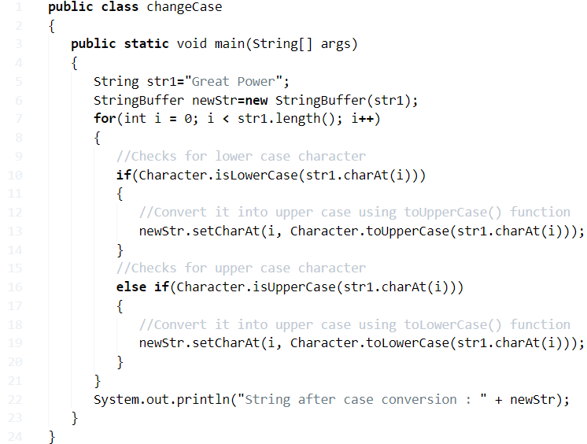

**Output:**

String after case conversion: gREAT pOWER

**Java Program To Calculate Average Marks**

**How to calculate the average of marks in math?**

A: That’s quite simple, for example, consider you have just completed your sem exams, and the result announced as:

* Maths                       –  75
* Science                      –  55
* Operating Systems  –  80
* Dataware house       –  75
* Now, sum up all      –      **285/4 = 71.25 ( Your average marks )**

**So, your average of entire subjects are  = 71.25 ( Formula stated below)**

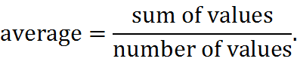

That’s a standard and the only way to calculate your average of marks. Now, check out the following programs.

## Average Marks Java Program Five Simple Ways

**Example Code -1: ( using standard values )**

* Basic version with standard values. Here we took Int n=5; it’s all up to you. And also check output screen.

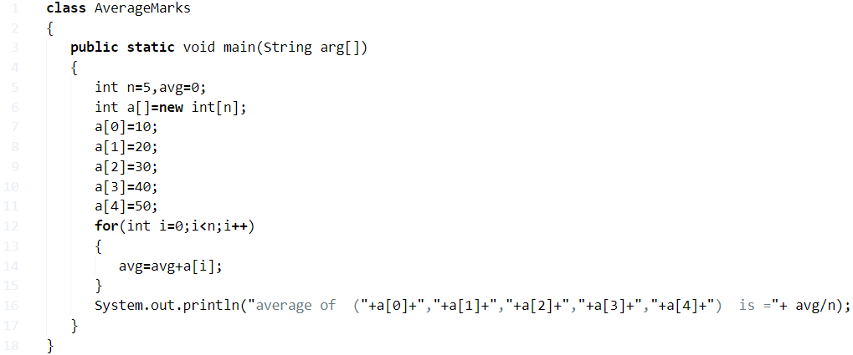

**OutPut :**

|  |  |
| --- | --- |
| 1 | average of  (10,20,30,40,50)  is =30 |

### Java Program Calculate Average Marks Using Arrays

* Java code for obtaining an **average of marks** taking inputs through Scanner class. Here it is: **#Inputs Through Scanner Class#**

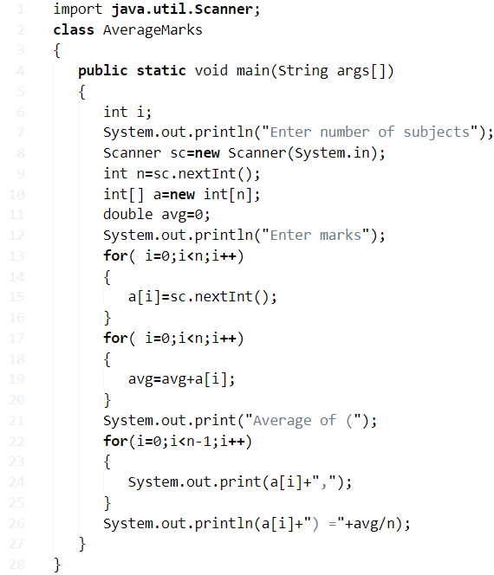

**Output:**

For example purpose, we have executed the above program with **three different outputs** as given below. You need to enter the total number of subjects that you need to calculate or find and followed by marks. The console will display the output as follows:

|  |  |
| --- | --- |
| 1  2  3  4  5  6  7  8  9  10  11  12  13  14  15  16  17  18  19  20  21  22  23  24  25  26  27  28  29  30  31  32  33  34 | output:1  Enter number of subjects  6  Enter marks  100  90  80  70  60  50  Average marks of (100,90,80,70,60,50) =75.0    output: 2  Enter number of subjects  6  Enter marks  75  87  79  89  77  60  Average marks of (75,87,79,89,77,60) =77.83333333333333    output:3  Enter number of subjects  5  Enter marks  50  50  50  50  51  Average marks of (50,50,50,50,51) =50.2 |

#### Average Marks Using Command Line Arguments

* Here we are using **command line arguments** if you have no idea about [**command line arguments in java**](http://javatutoring.com/command-line-arguments-java-with-examples/) then check out that link. As like above, the inputs are taken through scanner class, whereas here inputs are taking through command line arguments.

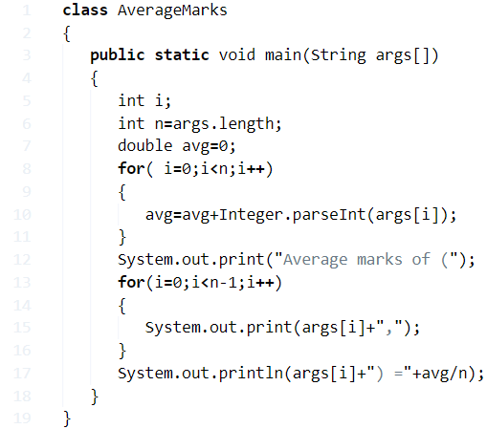

**Output :**

This is how the actual output screen will look alike, **c:\users\goutham\desktop** ( , because we are executed the above code on our system, so we copied the output here ). Output console may vary code to code.

|  |  |
| --- | --- |
| 1  2  3  4  5  6  7  8  9  10  11  12  13  14  15 | output:1    C:\Users\goutham\Desktop\E>javac AverageMarks.java    C:\Users\goutham\Desktop\E>java AverageMarks 2 100 50    Average marks of (2,100,50) =50.666666666666664    output:2    C:\Users\goutham\Desktop\E>javac AverageMarks.java    C:\Users\goutham\Desktop\E>java AverageMarks 100 90 80 70 60 50    Average marks of (100,90,80,70,60,50) =75.0 |

##### Java Program Average Marks Using Class

* Java program for calculating an average of marks through **creating a separate class(AverageCalculation)** and taking inputs through scanner class. Check out the code.

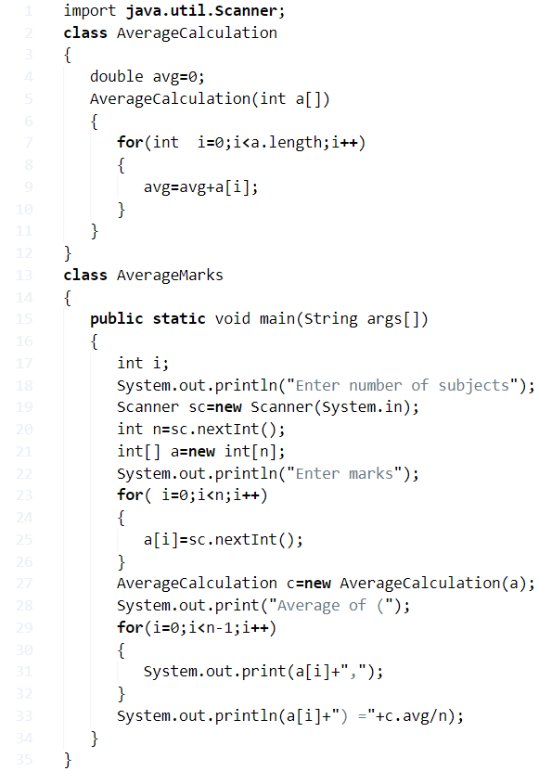

**Output: ( 2 Sample outputs )**

|  |  |
| --- | --- |
| 1  2  3  4  5  6  7  8  9  10  11  12  13  14  15  16  17  18  19  20  21  22  23 | Output:1  Enter number of subjects  5  Enter marks  50  50  65  45  14  Average of (50,50,65,45,14) =44.8    Output:2    Enter number of subjects  6  Enter marks  89  99  78  87  45  65  Average of (89,99,78,87,45,65) =77.16666666666667 |

###### Using Method

* Java code for calculating the average of marks **using a user-defined method**

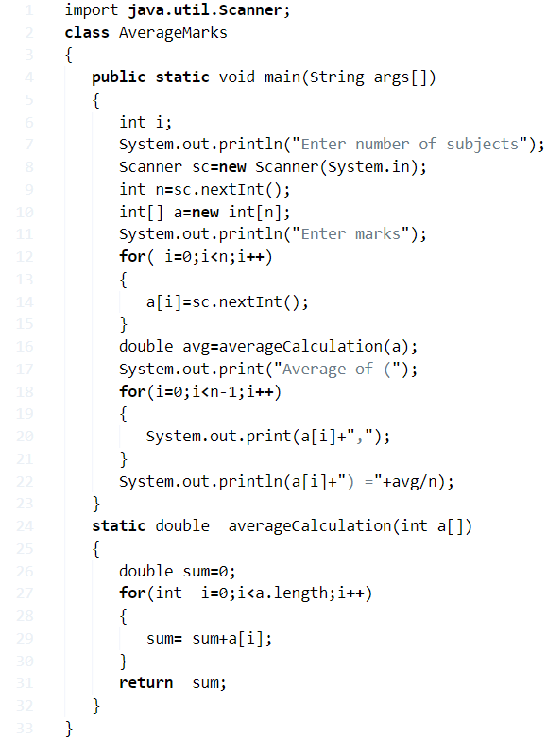

**Output:**

Output

Java

|  |  |
| --- | --- |
| 1  2  3  4  5  6  7  8  9  10  11  12  13  14  15  16  17  18  19  20  21  22  23 | output:1  Enter number of subjects  6  Enter marks  100  90  80  70  60  51  Average of (100,90,80,70,60,51) =75.16666666666667    output:2  Enter number of subjects  6  Enter marks  78  87  45  65  42  50  Average of (78,87,45,65,42,50) =61.166666666666664 |

**19) Java Program To Calculate Average Of N Numbers**

**How to calculate the average of N Numbers?**

The calculation of the average of N numbers ins quite simple: Here is the formula for it. Hope you get to understand-

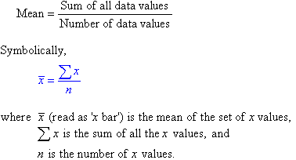

The Average has been calculated as **the sum of all data values / Number of data values.**

The following program can be applied for either average of two numbers or average of three numbers, or an average of N numbers. In the case of all N number. Just replace the SOP with the above-given formula.

The following code has been written in five different ways for both programs along with the sample output for an average of 2 numbers and **average of three numbers** or N numbers, in using standard values , while loop, for loop, do while loop, command line arguments, user define method, creating a separate class.

**Method - 1Using Standard values**

[wp_ad_camp_3]

There you go, the basic universal syntax for the average of**N Numbers program** or given 2 or 3 numbers as you wish.

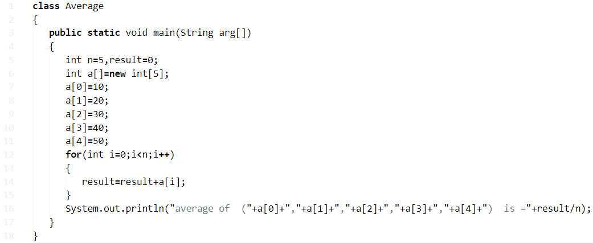

**output:**

|  |  |
| --- | --- |
| 1 | average of  (10,20,30,40,50)  is =30 |

**Method – 2 Taking inputs through scanner class**

Java code for obtaining an average of numbers taking **inputs through scanner class.**

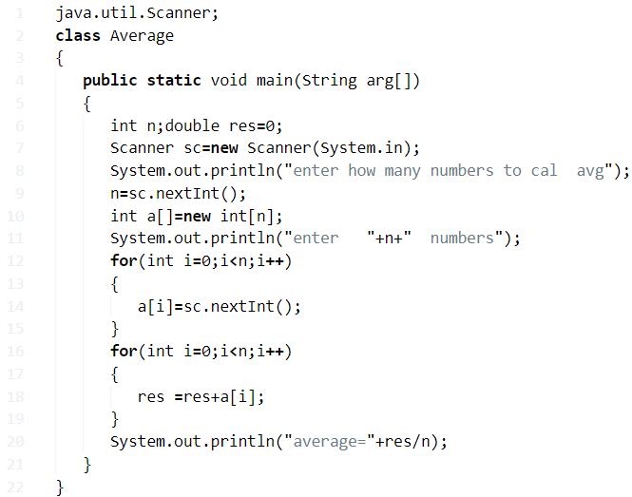

**output:**

|  |  |
| --- | --- |
| 1  2  3  4  5  6  7  8  9  10  11  12  13  14  15  16  17  18  19  20 | enter how many numbers to cal  avg  6  enter   6  numbers  1  2  3  4  5  6  average=3.5      enter how many numbers to cal  avg  4  enter   4  numbers  12  5  44  15  average=19.0 |

**Method - 3 Using Command Line Arguments**

[wp_ad_camp_3]

By using command line arguments: If you have no idea about command line arguments then do check out our guide here – [what are command line arguments in java with examples](https://javatutoring.com/command-line-arguments-java-with-examples/).

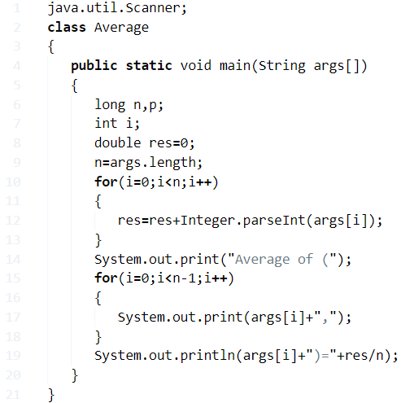

**output:**

|  |  |
| --- | --- |
| 1  2  3  4  5  6  7  8  9  10  11  12  13  14  15  16  17  18 | (1)javac Average.java       java Average 1 2 3 4 5       Average of (1,2,3,4,5)=3.0      2)java Average 1 2 3 4 5 6 7 8 9 10      Average of (1,2,3,4,5,6,7,8,9,10)=5.5    3)java Average 25 52 35 52 111      Average of (25,52,35,52,111)=55.0    4)java Average  12 34 56 78 91 23 45      Average of (12,34,56,78,91,23,45)=48.42857142857143 |

**Method – 4 Using the User Defined Method**

By using the user-defined method. You can do allocate whatever method. This is just for an example program.

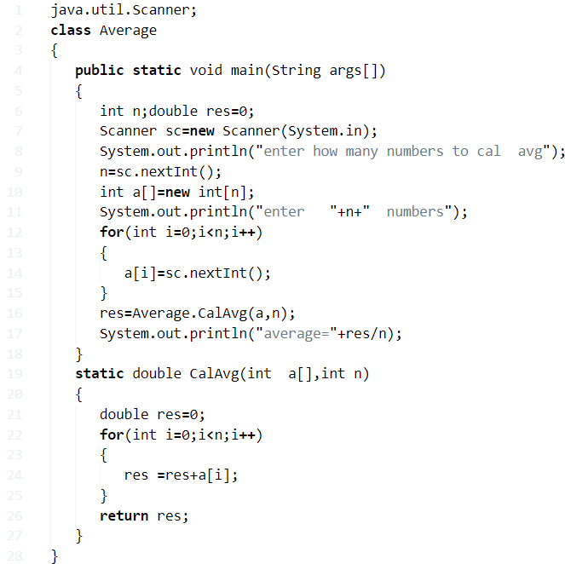

**output:**

|  |  |
| --- | --- |
| 1  2  3  4  5  6  7  8  9  10 | enter how many numbers to cal  avg  6  enter   6  numbers  11  21  31  41  51  61  average=36 |

**Method – 5 Through creating a separate class**

Java program for getting  average of numbers through creating a separate class( ) and taking inputs through scanner class

Java

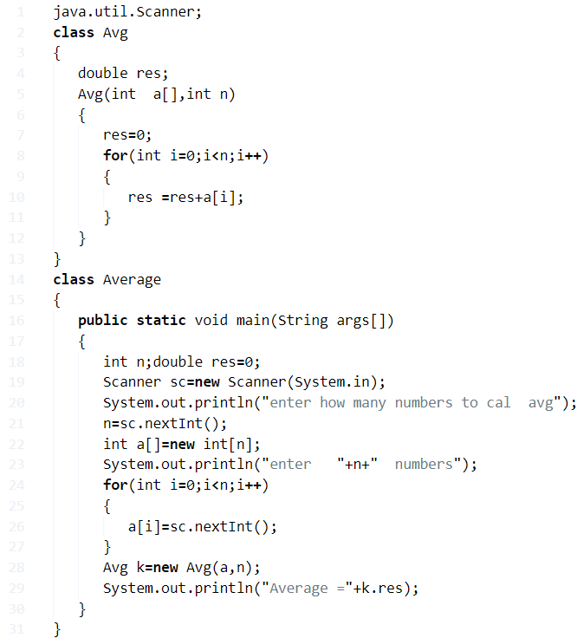

**Java Program To Check Vowel Or Consonant**

* **What are the Vowels ?**

A: Def: A speech sound which is produced with the vibration of vocal chords without audible friction, which is being blocked by teeth, tongue or lips :P.

We know that there are Five vowels: **a, e, i, o, u or A, I, E, O, U**.

* **What are the consonants then?**

Apart from A, E, I, O, U rest of the alphabets are consonants. That’s it.

Basically, we can write the code in two different ways, using if statement or if-else statement or Java switch case statement.

There you go:

## Java Program To Print Whether The Given Alphabet is Vowel Or Consonant

**1. Using Switch Case**

[wp_ad_camp_3]

Here we are using switch case, generally switch is used one out of multiple options, an if-else ladder can also be used to select one out of multiple options. In simple words, we can say [the switch is a multi-branch statement](https://javatutoring.com/java-switch-case-tutorial/).

Here the combination of both small letters and capital letters are represented as vowels. With the help of the case statement, the output will display on what the user is going to be entered. If it is out of 10 alphabets, it will display vowel or else consonant.

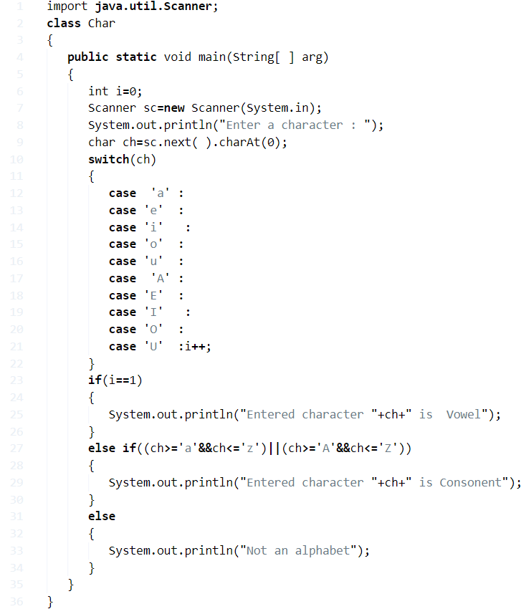

**3 Sample Outputs:**

|  |  |
| --- | --- |
| 1  2  3 | Enter a character :  a  Entered character a is  Vowel |
| 1  2  3 | Enter a character :  A  Entered character A is  Vowel |

|  |  |
| --- | --- |
| 1  2  3 | Enter a character :  Z  Entered character Z is Consonant |

### 2.  Using If else Statement

* There you go another program using if else statement with sample outputs – learn more about if else statement here.

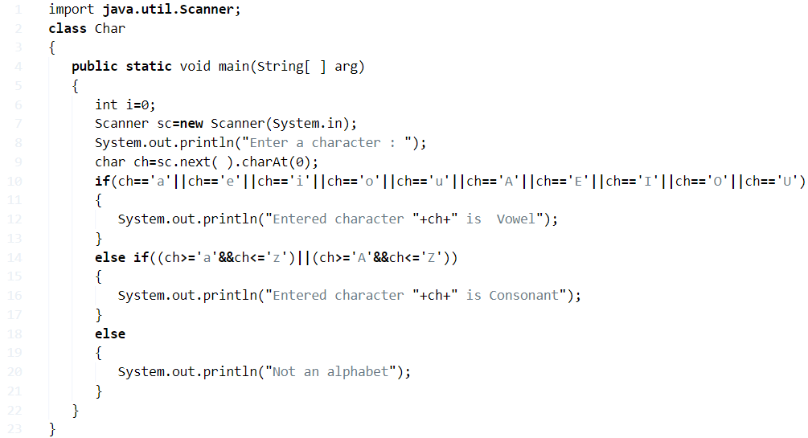

**Output:**

|  |  |
| --- | --- |
| 1  2  3 | Enter a character :  G  Entered character G is Consonant |
| 1  2  3 | Enter a character :  54  Not an alphabet |

#### 3. Using Method

Java program to print whether the given character is vowel or consonant using Method or function with sample outputs.

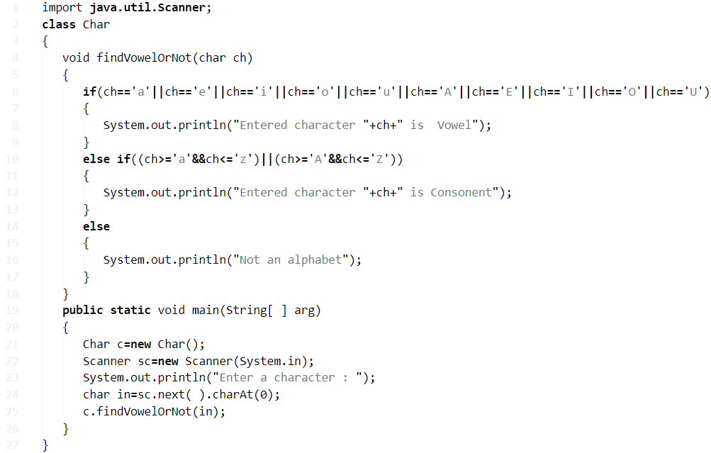

Output:

|  |  |
| --- | --- |
| 1  2  3 | Enter a character :  E  Entered character E is  Vowel |

Java

|  |  |
| --- | --- |
| 1  2  3 | Enter a character :  6  Not an alphabet |

**Java Program Count Vowels In A String**

**Vowels**are the words whose sounds are produced with an open vocal tract, giving them the distinct class of speech sound, apart from Consonants.

The English Alphabet series has 5 Vowels and 21 Consonants in the total combination of 26 Alphabets. Those are A, E, I, O & U.

There are several words in the English language that contains all the five vowels in contention. Those are as follows:

* **Abstemious**
* **Facetious**
* **Arsenious**
* **Annelidous**
* **Uncomplimentary**
* **Education etc.**

Thus, the methods used to find vowels in a given string in Java Programming are as follows:

## ****Find Vowels In  A String – Using Switch Case****

**1)** Read the entered string using scanner class object sc.nextLine(), and store in the variable “s” which is string type.

**2)**The for loop iterates from j=0 to j< length of the string. The variable ch assigned with the charter which is at the jth position in the string.

**3)** If charter at ch matches with any one of these cases then i initialized to  1 and that charter will be printed. We don’t have break statement in any one of the cases, so switch executes all cases.

**4)**If no one cases match with the switch then i value remains 0.

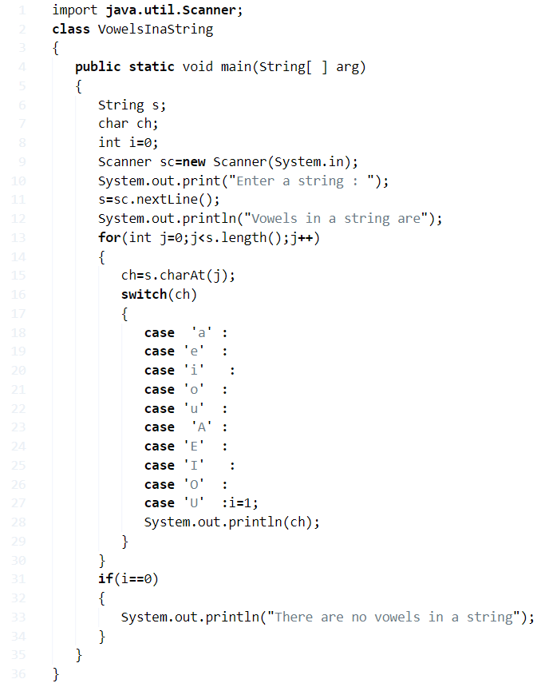

**Output:**

|  |  |
| --- | --- |
| 1  2  3  4  5  6  7 | Enter a string :java programming  Vowels in a string are  a  a  o  a  i |
| 1  2  3  4  5  6  7 | Enter a string : Vowels in a string  Vowels in a string are  o  e  i  a  i |

### ****Using Static Method****

**1)** Read the entered string using scanner object sc.nextLint(), and store it in the string variable s.

**2)** Static method vowels(String str), will find vowels at the given string.  This method calls at the main method as vowels(s), then vowels method will be executed.

**3)** In vowels(String str) method for loop iterates from j=0 to j< length of the string. , if ch matches with any one of the vowels then i=1 and ch will be printed. If no one ch of string array does not match with vowels then i=0 and prints “There are no vowels in an entered string”.

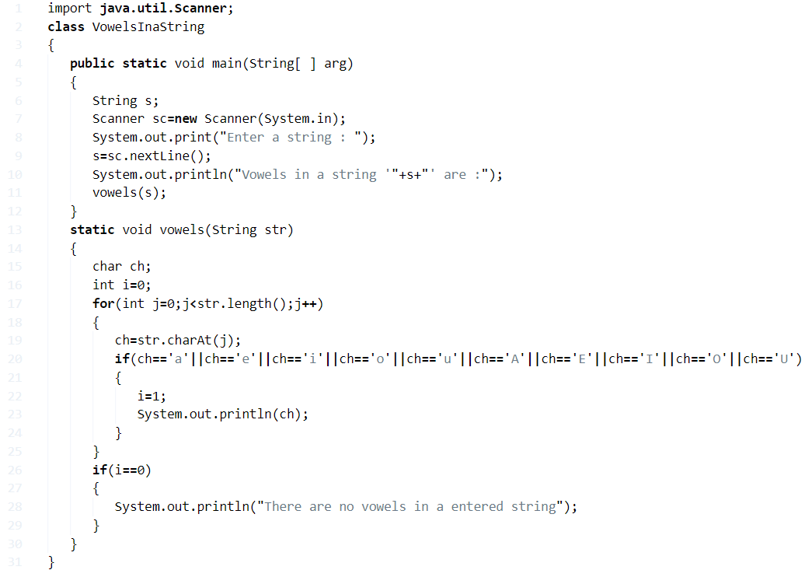

**Output:**

|  |  |
| --- | --- |
| 1  2  3  4  5  6  7 | Enter a string : abcdefghijklmnopqrstuvwxyz  Vowels in a string 'abcdefghijklmnopqrstuvwxyz' are :  a  e  i  o  u |

#### ****Using Functions****

**1)** In this program, we have vowels(String str) function to find the vowels in the entered string.

**2)** Read the entered String using scanner object sc.nextLine(), and store it in the string variable s.

**3)** The vowels(s) method calls at the main method by passing the entered string as an argument. This vowels method checks each charter at the given string with vowels. If any character matches with vowels then it prints that charter.

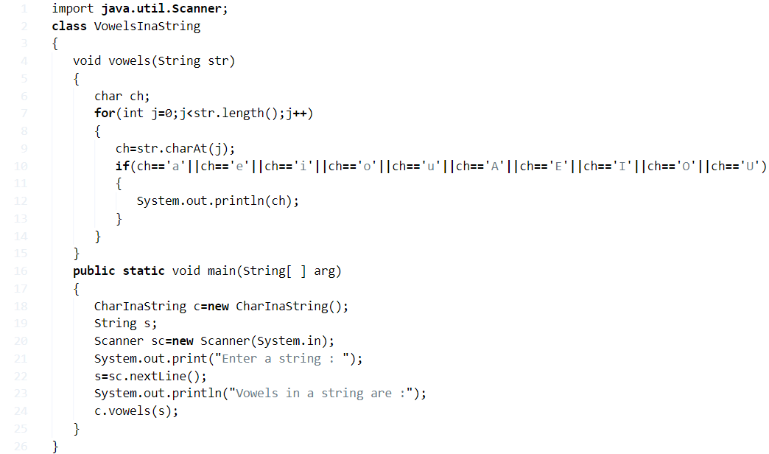

**Output:**

Output

Java

|  |  |
| --- | --- |
| 1  2  3  4  5 | Enter a string : hello world  Vowels in a string are :  e  o  o |

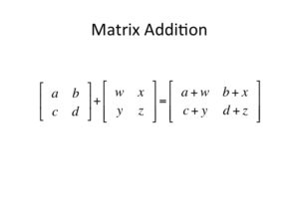**Java Program to Add Two Matrices – 4 Ways**

**Addition of two matrices** can be carried if and only if both the matrices are in the same order. In matrix addition, each term of one matrix is added to the other matrix’s term, at the same location, i.e. the term at first row first column of Matrix 1 will be added to the term at first row first column of Matrix 2 and so on. A pictorial example is given below.

## Addition Of Two Matrices – Using For Loop

**1)** If both matrices are of the same size then only we can add the matrices.

**2)**Use the double dimensional array to store the matrix elements.

**3)**Read row number,column number and initialize the  double dimensional arrays mat1[][],mat2[][],res[][] with same row number,column number.

**4)** Store the first matrix elements into the two-dimensional array mat1[][] using two for loops. i indicates row number, j indicates column index.Similarly matrix 2 elements in to mat2[][].

**5)** Add the two matrices using for loop

* for i=0 to i<row
* for j=0 to j<col
* mat1[i][j] + mat2[i][j] and store it in to the matrix res at res[i][j] .

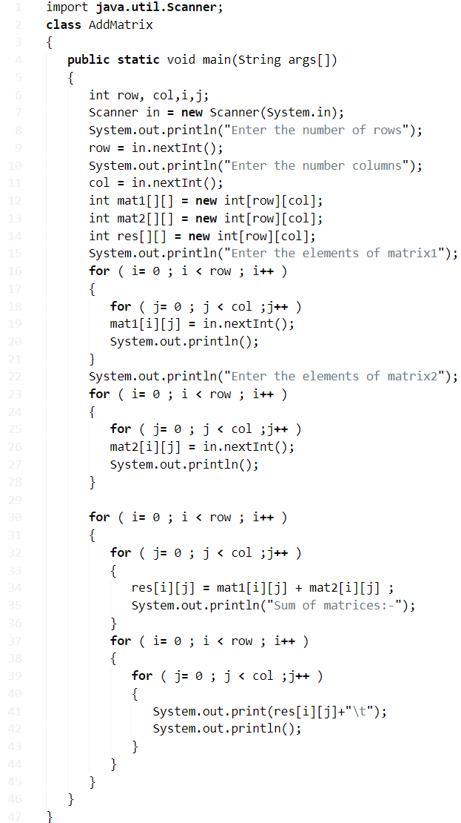

**Output:**

|  |  |
| --- | --- |
| 1  2  3  4  5  6  7  8  9  10  11  12  13  14  15  16  17 | Enter the number of rows  2  Enter the number  columns  2  Enter the elements of matrix1  1 1    1 1    Enter the elements of  matrix2  2 2    2 2    Sum of  matrices:-  3       3  3       3 |

### Using While Loop

**1)** For insert values in the matrices mat1, mat2 using loops –

* While loop iterates until i <row
* while iterates until  j<column
* insert the value at  mat1[i][j] and increases the j value.
* increase the i value.

**2)** To add matrices –

* while loop iterates until i<row
* while loop iterates until j<column
* add  mat1[i][j] + mat2[i][j] and insert the result at res[i][j].
* increase the j value.
* increase the i value.

**3)** Print res[i][j] using two for loops then we will get the addition of two matrices.

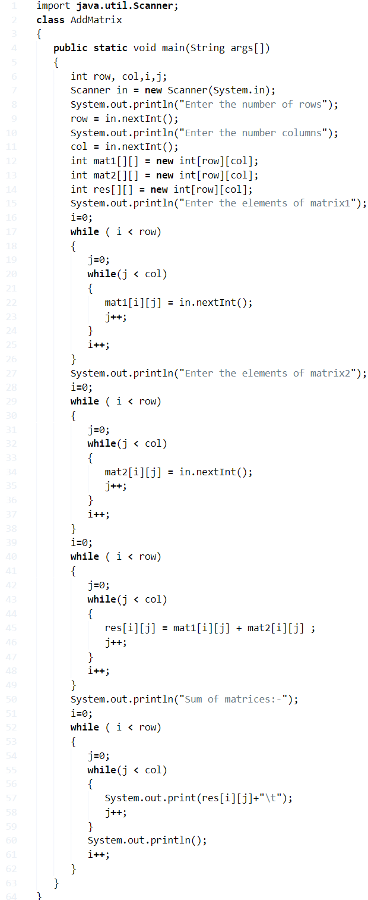

**Output:**

|  |  |
| --- | --- |
| 1  2  3  4  5  6  7  8  9  10  11  12  13  14  15  16 | Enter the number of rows  3  Enter the number  columns  3  Enter the elements of matrix1  1 2 3  4 5 6  7 8 9  Enter the elements of  matrix2  9 8 7  6 5 4  3 2 1  Sum of  matrices:-  10      10      10  10      10      10  10      10      10 |

##### **Using Do-While Loop**

**1)** For Addition of two matrices

* i=0
* do loop
* j=0
* do loop
* mat1[i][j] + mat2[i][j] and insert the result in to res[i][j].
* Increase the j value. checks the condition j<col.
* Increase the i value. Then checks the condition j<row.

**2)** Print res[][] then we will get the addition of two matrices.

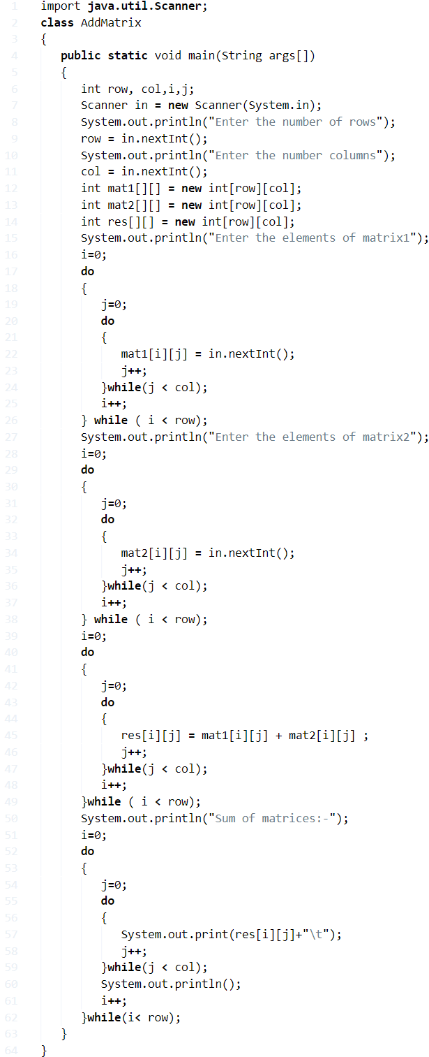

**Output:**

Output

|  |  |
| --- | --- |
| 1  2  3  4  5  6  7  8  9  10  11  12  13  14  15  16 | Enter the number of rows  3  Enter the number  columns  3  Enter the elements of matrix1  1 1 1  1 1 1  1 1 1  Enter the elements of  matrix2  9 9 9  9 9 9  9 9 9  Sum of  matrices:-  10      10      10  10      10      10  10      10      10 |

**Matrix Multiplication In Java – 4 Ways**

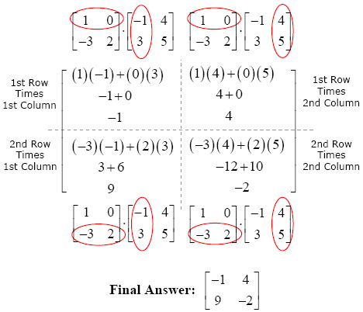**How To Perform Matrix Multiplication:**

Matrix multiplication is a simple binary operation that produces a single matrix from the entries of two given matrices. When two Matrices P & Q of order a*b and b*c are multiplied, the resultant matrix will be of the order a*c.

Here, the **a** entries across a row of P are multiplied with the **b** entries down a column of Q to produce the entry of PQ. The example given below explains the multiplication between two 2*2 matrices.

## Matrix Multiplication In Java – Using For Loop

**1)** Condition for multiplication of two matrices is -1st matrix column number equal to 2nd matrix row number.

**2)** Read row,column numbers of matrix1, matrix2 and check column number of matrix1= row number of matrix2. If condition is true then

**a)** Insert the elements at matrix1 using  two for loops:

* for ( i= 0 ; i < r1 ; i++ )
* for ( j= 0 ; j < c1 ;j++ )
* Insert element at mat1[i][j].

**b)** Similarly insert the elements at matrix2 using  2 loops with the  structures  for (i=0;i<r2;i++ ),for (j= 0;j<c2;j++ ).

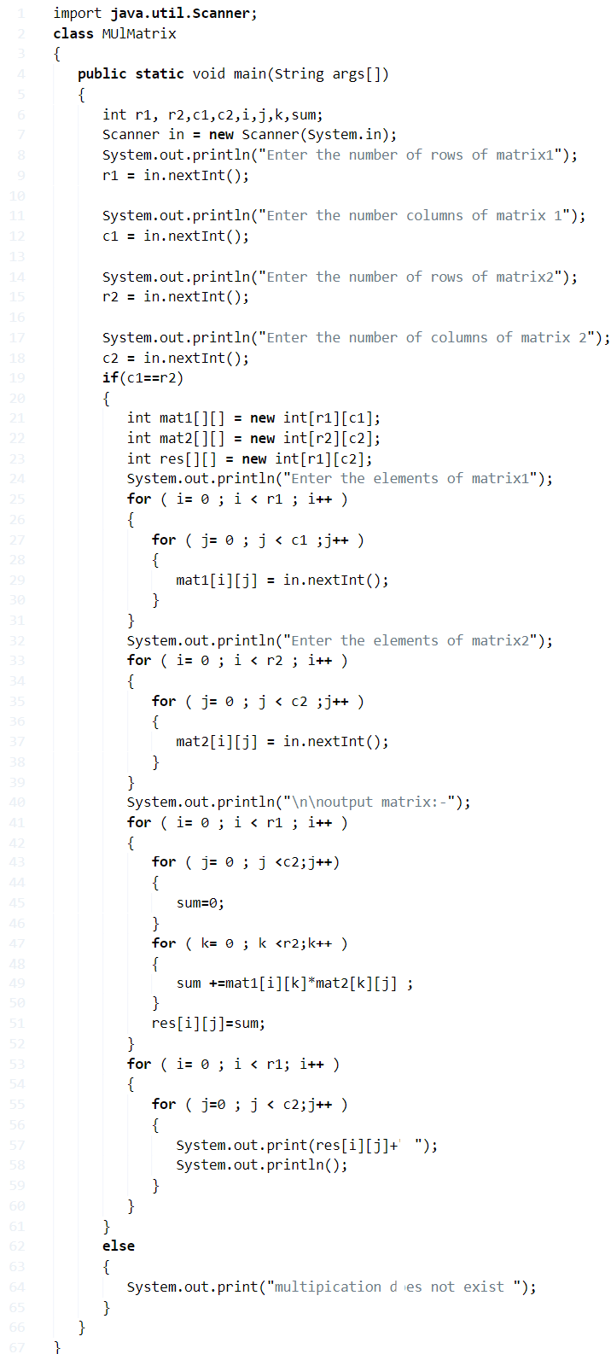

**Output:**

|  |  |
| --- | --- |
| 1  2  3  4  5  6  7  8  9  10  11  12  13  14  15  16  17  18  19  20  21  22 | Enter the number of rows of matrix1  3  Enter the number  columns of matrix 1  3  Enter the number of rows of matrix2  3  Enter the number  of columns of matrix 2  3  Enter the elements of matrix1  1 2 3  4 5 6  7 8 9  Enter the elements of matrix2  9 8 7  6 5 4  3 2 1      output   matrix:-  30 24 18  84 69 54  138 114 90 |

### Using While Loop

**1)** **Read row, column numbers of the two matrices** and checks the column number of matrix1 =row number of matrix2.If condition true then insert the elements into the matrices using while loop.

**2) a)**Insert elements at matrix1-

* While loop iterates until i <r1 condition is false.
* then j initialized to 0.
* while loop iterates until the condition j<c1 is true.
* insert the element at mat1[i][j].
* increase the j value.
* Now i value increased.

**b)** Similarly insert elements at matrix2 with the conditions i<r2,j<c2.

**2)** For multiplication

* while loop iterates until i<r1  is false.
* j initialized to 0.
* while loop iterates until j<c2 is false.
* sum initialized to 0.
* k=0.
* while loop iterates until k<r2.
* sum =sum+mat1[i][k]*mat2[k][j].
* increases the k value.
* insert sum value in to the resultant matrix at res[i][j].
* increase the j value.
* increase i value.

**3)** **Print the matrix using while loops** with the conditions i<r1, j<c2.

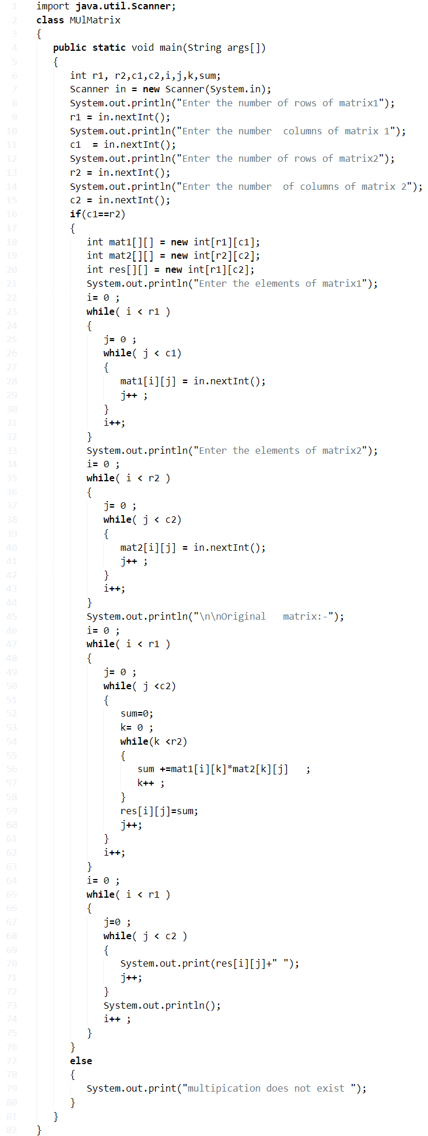

**Output:**

|  |  |
| --- | --- |
| 1  2  3  4  5  6  7  8  9  10  11  12  13  14  15  16  17  18  19  20 | Enter the number of rows  2  Enter the number  columns  3  Enter the elements of matrix  1  2  3  4  5  6      Original   matrix:-  1 2 3  4 5 6  Transpose  of   matrix:-  1 4  2 5  3 6 |

#### ****Using Do While Loop****

**1)** Multiply two matrices mat1,mat2, res is the resultant matrix.

* This loop iterates until k<r2 is false.
* Insert sum in to the resultant matrix at res[i][j],increase j value, then checks the condition j<c2.
* This loop iterates until j<c2 is false.
* Increase the i value, then checks the condition i<r1.
* This loop iterates until i<r1 is false.

|  |  |
| --- | --- |
|  |  |

**Output:**

Output:

|  |  |
| --- | --- |
| 1  2  3  4  5  6  7  8  9  10  11  12  13  14  15  16  17  18  19  20 | Enter the number of rows of matrix1  2  Enter the number  columns of matrix 1  3  Enter the number of rows of matrix2  3  Enter the number  of columns of matrix 2  2  Enter the elements of matrix1  1 1 1  1 1 1  Enter the elements of matrix2  1 1  1 1  1 1      Original   matrix:-  3 3  3 3 |

**Java Program To Display Transpose Matrix**

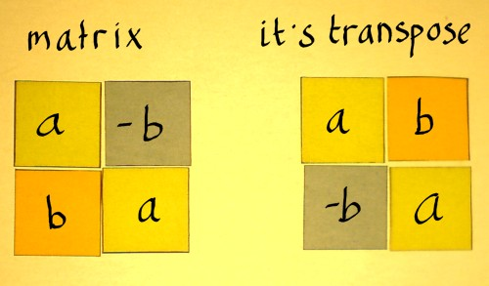The Transpose of a given matrix is an operator which flips it over its diagonal. The order of the matrix changes unless it is a square matrix. The transpose of a transpose of a matrix is the given matrix itself – [Check to Add two matrices](https://javatutoring.com/matrix-addition-java/).

Mathematically, [**A**T]T= **A**

## Using For Loop

**1)** Transpose matrix will formed by inter changing the rows and columns of the original matrix .

**2)** Read the row number and column number and insert the elements in to the array mat1[][] using two for loops. for i=0 to i<row. for j=0 to j<col. insert element at mat[i][j].

**3)** To transpose the matrix, row>col then n=row /row<col then n=col. for  i= 0  to  i < n. for  j= i+1  to j < n. Interchange the elements a[i][j] to a[j][i] and vice versa.

**4)** Print the transpose matrix using two for loops. for  i=0  to i < col. for  j=0 to  j< row. print mat[i][j].

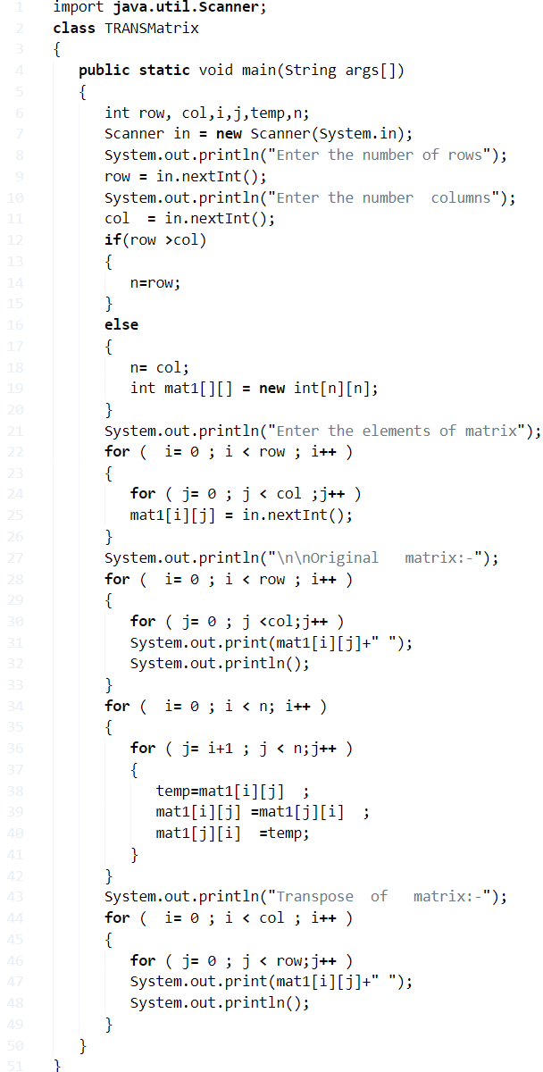

**Output:**

|  |  |
| --- | --- |
| 1  2  3  4  5  6  7  8  9  10  11  12  13  14  15  16 | Enter the number of rows  2  Enter the number  columns  3  Enter the elements of matrix  1 5 6  4 2 3      Original   matrix:-  1 5 6  4 2 3  Transpose  of   matrix:-  1 4  5 2  6 3 |

### Using While Loop

**1)** Insert the elements into the matrix mat1 using while loop.

**a)**The while loop iterates until i<row increases the i value.Inner loop iterates until the condition j<col is false. Insert the element at mat1[i][j]. Increase the j value.

**2)** Now We are finding the transpose of mat1[][]. If row>col then n=row otherwise n=col. while loop iterates until i<n. j=i+1. while loop iterates until j<n. interchange the elements mat1[j][i] to mat1[i][j] vise versa. increase the j value. increase the i value.

**3)** Print the transpose of a matrix using two while loops with conditions i < col, j < row.

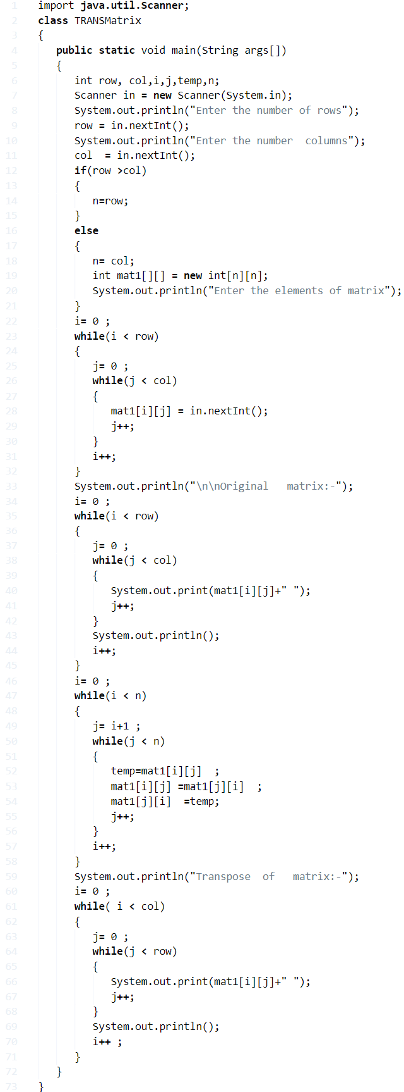

**Output:**

|  |  |
| --- | --- |
| 1  2  3  4  5  6  7  8  9  10  11  12  13  14  15  16  17  18  19  20 | Enter the number of rows  2  Enter the number  columns  3  Enter the elements of matrix  1  2  3  4  5  6      Original   matrix:-  1 2 3  4 5 6  Transpose  of   matrix:-  1 4  2 5  3 6 |

**GCD Of Two Numbers In Java – Programs | 5 Ways**

**GCD or Greatest Common Divisor** of two or more given numbers is the largest value that divides the given numbers wholly, without leaving any fraction behind.

As in the example shown below, we take two numbers 420 and 168.

After Prime Factorization, we get that

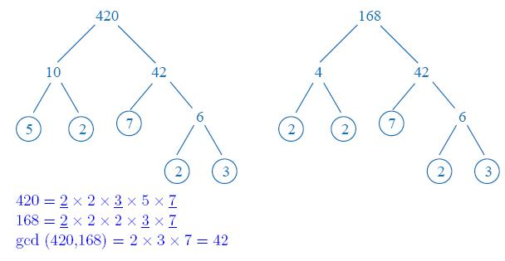168 = 2 * 2 * 2 * 3 * 7

420 = 2 * 2 * 3 * 5 * 7

The common factors are 2 * 3 * 7 = 42.

Hence, the GCD of 168 and 420 is 42.

[Source](http://mathandflash.com/wp-content/uploads/2011/03/gcd.jpg)

## Using Static Method

**1)** Read the values using scanner class method  sc.nextInt(),and store those values in to the variables n1,n2.

If both the numbers n1,n2>0 then call the static method gcdCal(n1,n2) in main method.

**2)** The n1,n2 values will be passed to a,b and Checks the while condition b>0,if the condition is true then b assigned to temp, b=remainder of b/a, “a” initialized with temp, repeats until the while condition b>0 is false and returns the “a” value which is GCD of two numbers.

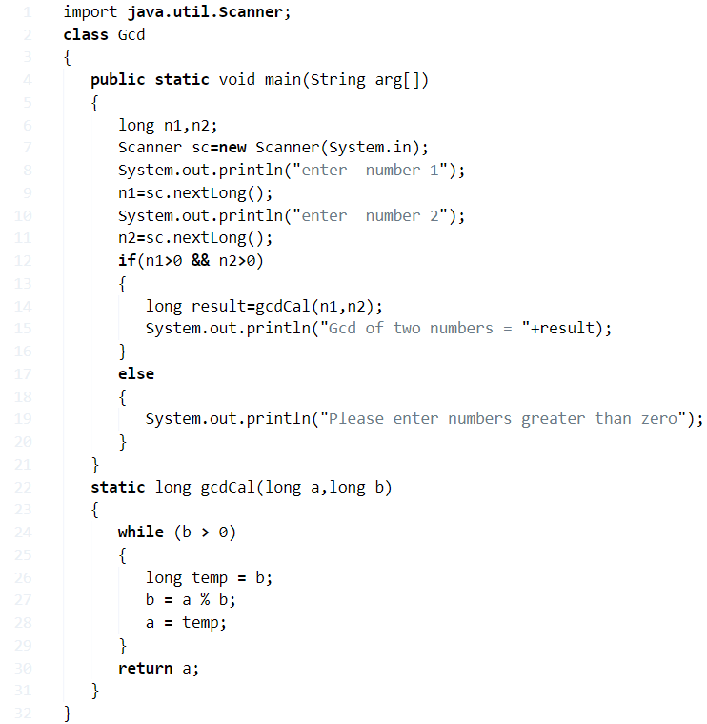

**Output:**

|  |  |
| --- | --- |
| 1  2  3  4  5 | enter  number 1  25  enter  number 2  50  Gcd of two numbers = 25 |

### Using While Loop

**1)** Read the values using scanner class object and assign those values to the variables x,y.

**2)** If both the numbers greater than 0, then checks the while condition while(x!=y), if it is true – then if x>y then x=x-y else y=y-x.

**3)** Repeat until x!=y and returns the x value which is the GCD of two numbers.

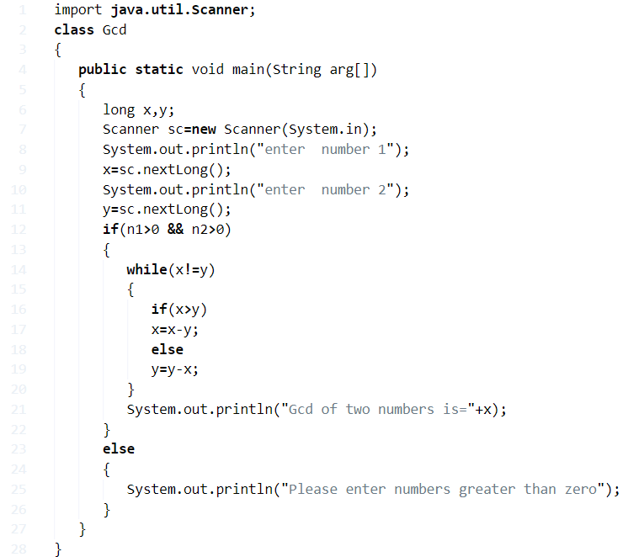

**Output:**

|  |  |
| --- | --- |
| 1  2  3  4  5 | enter  number 1  24  enter  number 2  48  Gcd of two numbers is=24 |

#### Using Functions

**1)** In this program we have a function long greater(long a, long b), it calculates the GCD of two numbers a,b and returns the number.

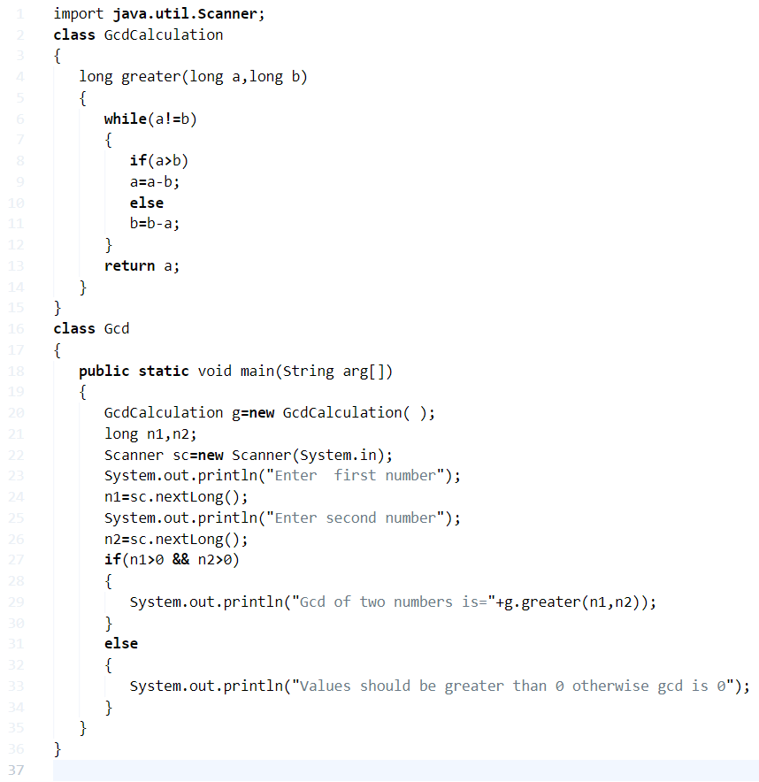

**Output:**

|  |  |
| --- | --- |
| 1  2  3  4  5 | Enter  first number  5  Enter second number  10  Gcd of two numbers is=5 |

##### Using Recursion

**1)** In this program greater(long a, long b) calls itself as greater(a,b), the greater method is a recursive method. It repeats until if the condition is false and returns “a” value which is GCD of a,b.

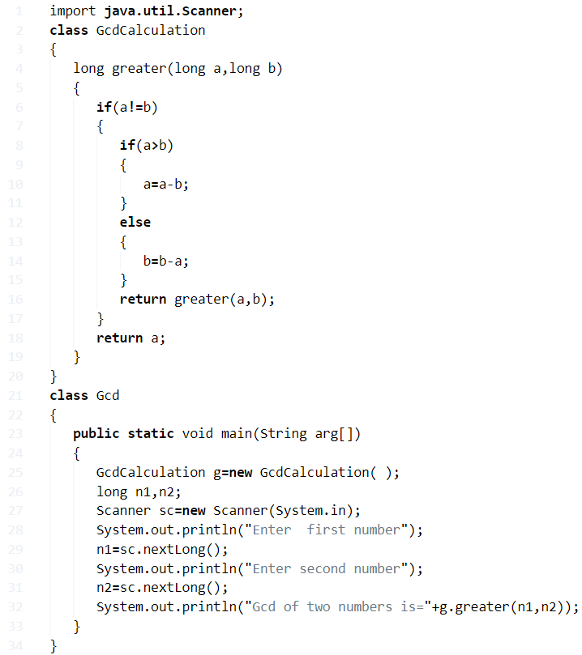

**Output:**

|  |  |
| --- | --- |
| 1  2  3  4  5 | Enter  first number  25  Enter second number  3  Gcd of two numbers is=1 |

## ****Finding GCD for n numbers****

**1)** To store elements into the int array

**2)** Find GCD of n numbers by passing “r” value and each element of an array to the constructor as GcdCalculation(long a, long b).

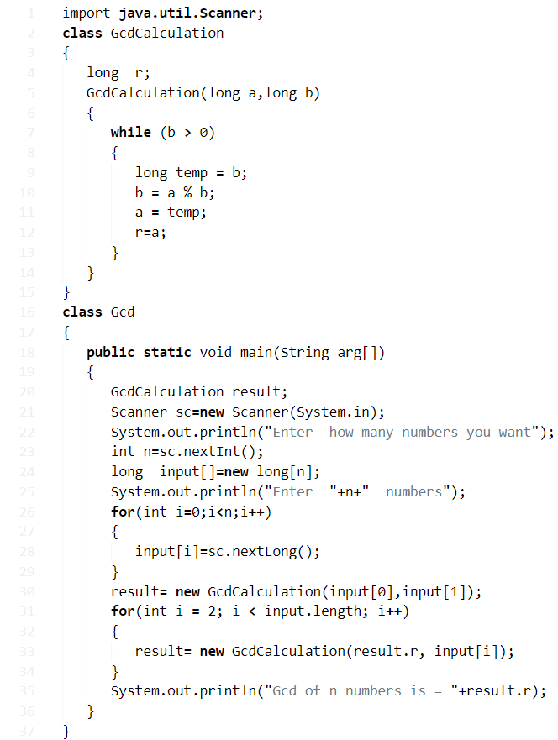

**Output:**

Output

|  |  |
| --- | --- |
| 1  2  3  4  5  6 | Enter  4  numbers  4  1  2  3  Gcd of n numbers is = 1 |

**HCF Of Two & N Numbers Java Program**

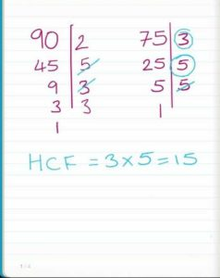**What Is HCF?**

HCF or Highest Common Factor is the greatest common divisor between two or more given numbers.

**For example:**

Let there be two arbitrary numbers such as 75 and 90.

75 = 3 * 5 * 5

90 = 2 * 3 * 3 * 5

Common Divisor = 3 * 5 = 15

Here, the HCF of the three given numbers would be 15 since it divides every given number without leaving a fraction behind.

## HCF Of Two Numbers – Command Line Arguments

**1)** The values we will pass at run-time are called command line arguments.

**2)** n1=Integer.parseInt(arg[0]); here reading the first value from string array which is at index “0”, and converting the string value into an integer using parseInt() method.

n2=Integer.parseInt(arg[1]); here reading the 2nd value from string which is at index “1” and converting string value into integer using parseInt() method. Here Integer is “wrapper” class.

**3)**The while loop iterates until n2>0 is false temp assigned to n2, n2 assigned to the remainder of n1/n2,  n1 assigned to n1. If the condition fails then it prints the HCF of two numbers is n1.

**4)** In our example, we are passing 15, 35 as command line arguments, and converted as integers and store the values at n1=15, n2=35.    while loop checks the condition  35>0 is true , temp=35, n2=5, n1=35, 5>o true,temp=5,n2=0,n1=5. For n2=0 condition fails and prints the HCF is 5.

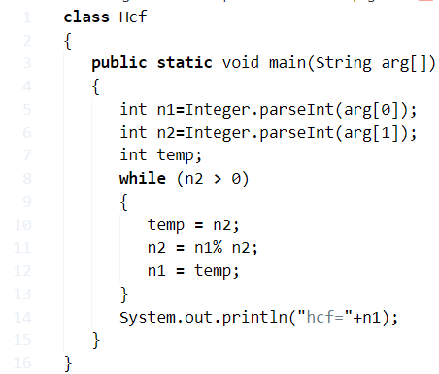

**Output:**

|  |  |
| --- | --- |
| 1  2 | >java Hcf 15 35  hcf=5 |

### Using Static Method

1. Calls the static hcfCal() method in the main method, the method executes the code and prints the value.

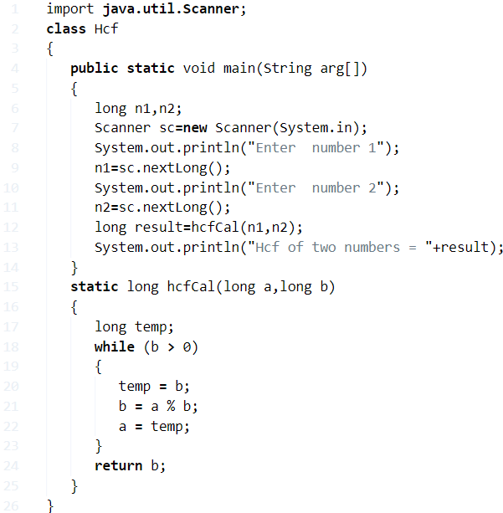

**Output:**

|  |  |
| --- | --- |
| 1  2  3  4  5 | enter  number 1  25  enter  number 2  50  Hcf of two numbers = 25 |

#### Using Recursion

**1)** In this program, the method highest(int a, int b) calls itself as highest(a,b).

**2)** Using scanner object, read the values and store in the variables n1, n2. Using Hcf class object call the method highest(n1,n2), the method starts the execution and calls itself, it repeats until the condition if(a!=b) is false.

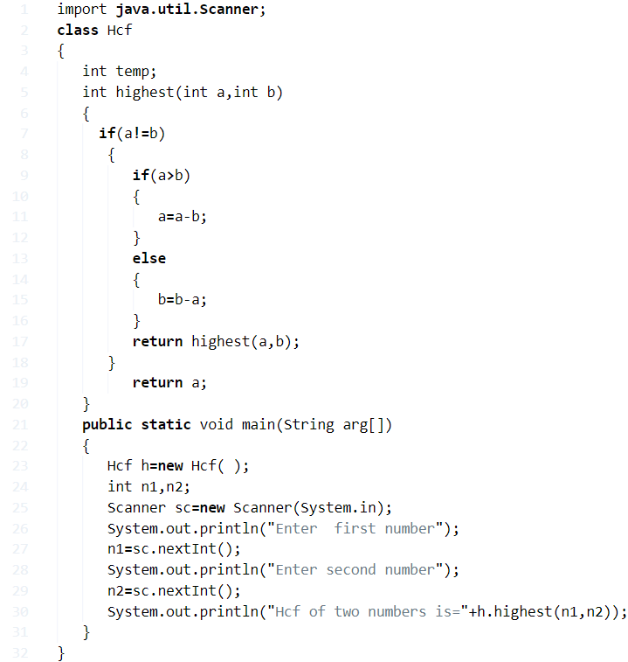

**Output:**

|  |  |
| --- | --- |
| 1  2  3  4  5 | Enter  first number  25  Enter second number  3  Hcf of two numbers is=1 |

##### Finding HCF Of n numbers

**1)** We are finding the HCF of n numbers by passing each element of an array to the function hcf(result, input[i]) using for loop with the structure for(int i = 1; i < input.length; i++).

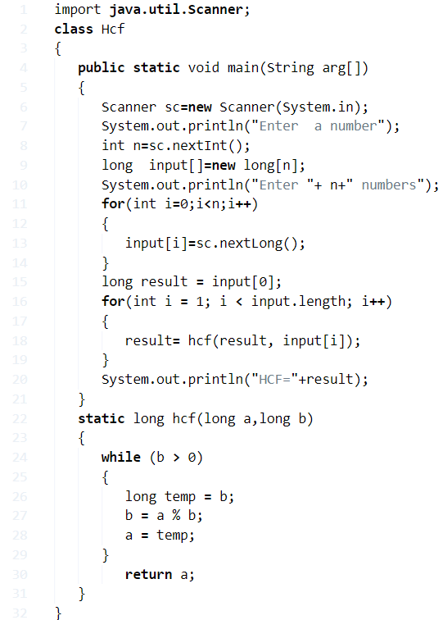

**Output:**

Output

Java

|  |  |
| --- | --- |
| 1  2  3  4  5  6 | Enter  a number  2  Enter 2 numbers  4  16  HCF=4 |

**LCM Of Two Numbers Java Program**

**What is LCM:**

Least Common Multiplier or LCM of any n numbers is the least value that is a multiple of the given numbers.

**For example:**

Let us take three numbers such as 12, 15 and 18.

* 12 = 2 * 2 * 3
* 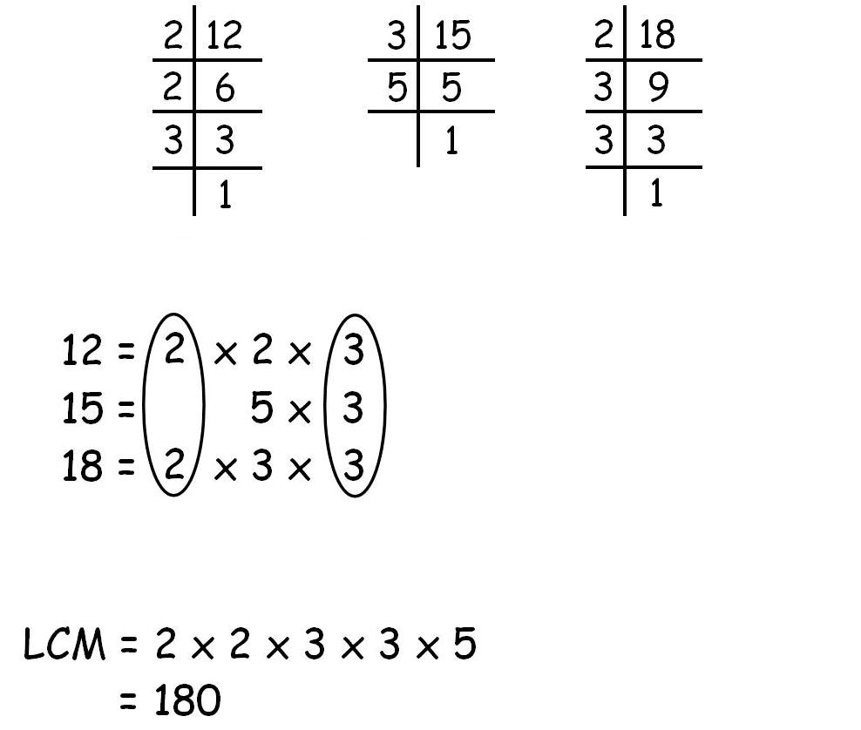15 = 3 * 5
* 18 = 2 * 3 * 3

So we take the common prime factors and then the rest of the ones and multiply them with each other which would give us the LCM.

LCM = 2 * 2 * 3 * 3 * 5 = 180

## Using Static Method

**1)** Read the values a,b using scanner object as sc.nextInt() and store these values in the variables a,b. In this program called the static method lcmCalculation(a,b) in the main method, lcmCalculation(a,b) will calculate the lcm of two numbers.

**2)** The a,b values passed to n1 , n2 ,then checks the if condition ,n1>n2 then res=n1 otherwise res=n2. temp initialized to res, until the condition (res%n1!=0 || res%n2!=0) is false ,it calculates the res=temp*i;, increases the i value by 1, returns the result value.

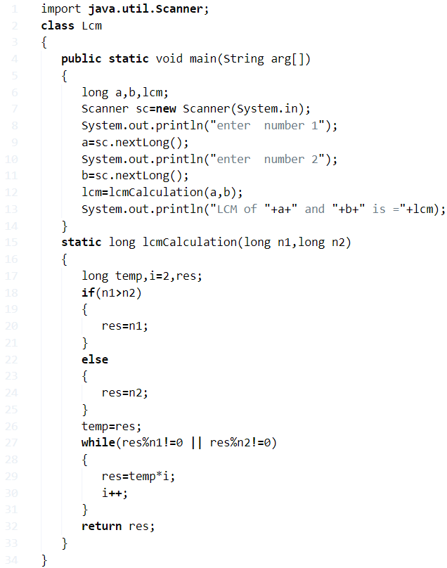

**Output:**

|  |  |
| --- | --- |
| 1  2  3  4  5 | enter  number 1  125  enter  number 2  4  LCM of 125 and 4 is =500 |

### LCM Of Two Numbers – Using Command Line Arguments

1) The values we will pass at run-time are called command line arguments, will store at string array “String args[]” of the main method.

2) We are converting the string present at the args[0], in to long using the wrapper class “Long”, and method parseLong() and the value will store it in the variable n1.

3) We are converting the string present at the args[1], in to long using the wrapper class “Long”, and method parseLong() and the value will store it in the variable n2.

4) Checks the if condition if n1>n2 then lcm=n1 otherwise lcm=n2 and b assigned with lcm, while loop will calculate the lcm=b*i until the condition is false.

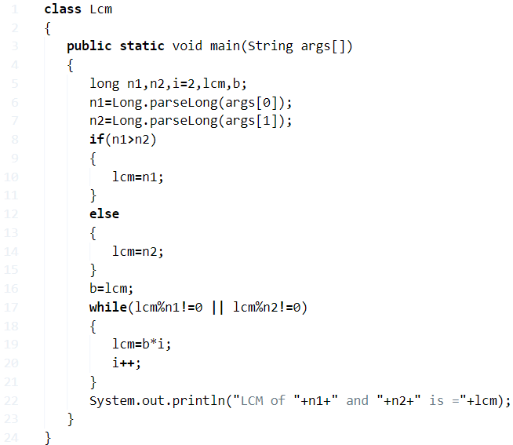

**Output:**

|  |  |
| --- | --- |
| 1  2 | >java Lcm 25 3  LCM of 25 and 3 is =75 |

#### ****Finding LCM of n numbers****

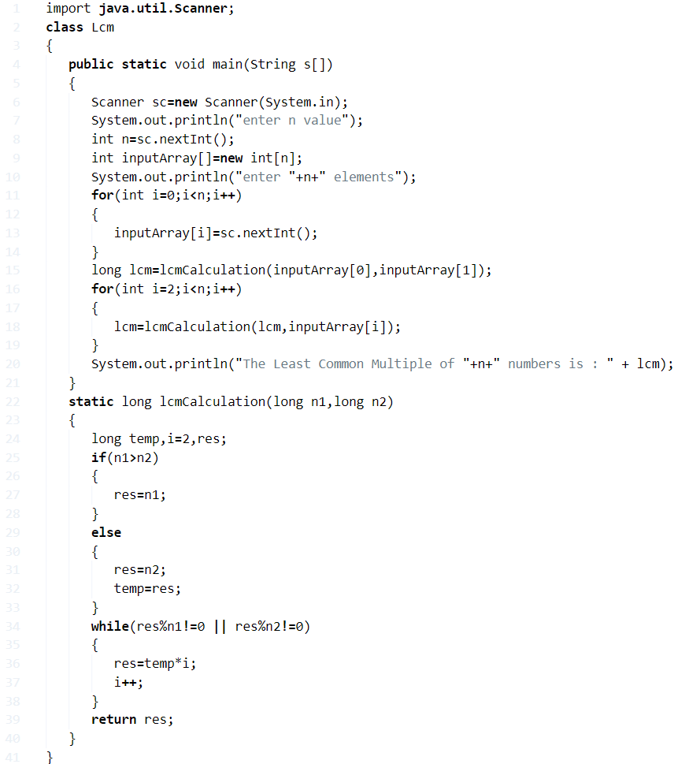

**Output:**

|  |  |
| --- | --- |
| 1  2  3  4  5  6  7  8  9 | enter n value  5  enter 5 elements  2  4  6  8  10  The Least Common Multiple of 5 numbers is: 120 |

#### Using Recursion Method

1) In this program, lcmCal(long n1,long n2,long temp,long res) method calls itself as lcmCal(n1,n2,temp,res), repeats until if condition is false ,then returns the value res.

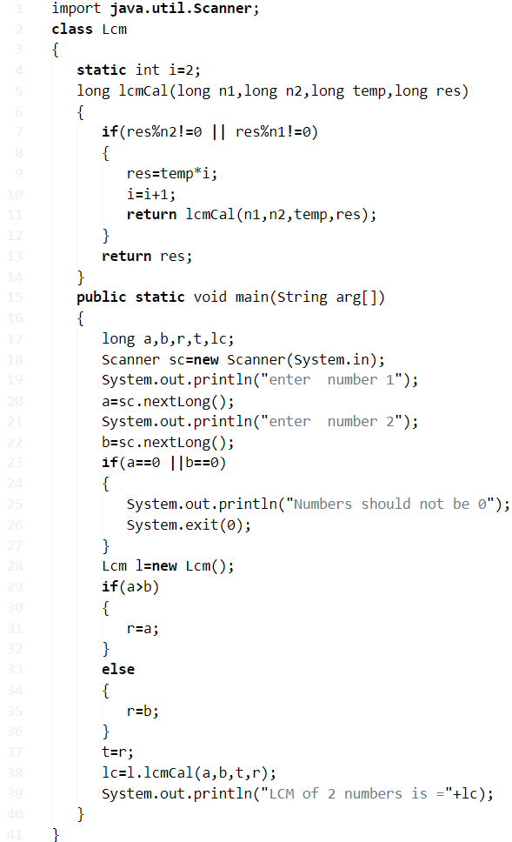

**Output:**

Output

Java

|  |  |
| --- | --- |
| 1  2  3  4  5 | enter  number 1  5  enter  number 2  25  LCM of 2 numbers is =25 |

**Java program to convert Hours To Seconds & Minutes | Vice Versa**

## Java convert hours into secondsJava to convert Hours into Seconds

Converting hours to seconds is quite simple. All we require is an input denoting the hours.

We are well aware that, one minute is 60 seconds and one hour is 60 minutes which will make, one hour to 3600 seconds (60*60). This same logic is used to convert hours to seconds.

For this, we need to read our input hours at runtime. This can be done by using Scanner class which is well known for reading any primitive datatype at runtime from the console screen.

So, we’ll first create an object of this Scanner class and then invoke the required method to read our input. Since our input is hours, which is generally an integer only, we will be making use of the nextInt() method of the class by writing the following statements:

|  |  |
| --- | --- |
| 1  2  3 | Scanner sc=new Scanner(System.in);    //object of Scanner class created  System.out.println("Enter hours");  hrs=sc.nextInt();         //invoking method using the created object |

Now that we have our input in hand, since 1 hour == 60*60 seconds or 3600 seconds

x hours == x*60*60 seconds by cross multiplication.

Therefore our output seconds will be calculated as:

sec=hrs*60*60;

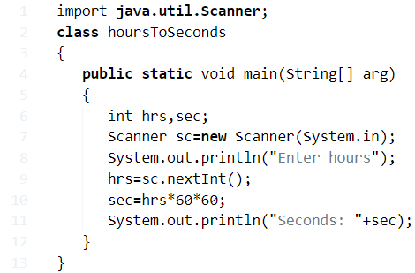

Output:

|  |  |
| --- | --- |
| 1  2  3  4 | >java hoursToSeconds  Enter hours  1  Seconds: 3600 |

**Using Method**

In this method, we’ll be making use of another method which will consist of the main logic for converting hours to seconds i.e.,

sec=h*60*60;

We are making use of another separate method so that, we can make the main logic of the code reusable.

So, we first read the input hours using Scanner class and then create an object (sc) of this method.

Since it is not within main method, object is required to invoke it.

Then with this created object (res) of the class (hoursToSceonds) we invoke the seconds() method by passing hours as parameter which performs calculation and stores resultant is a variable (sec).

This variable (sec) is then called in the main method using the same object to be printed on console screen using println() method.

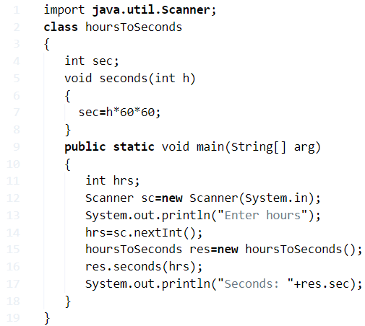

Output:

|  |  |
| --- | --- |
| 1  2  3 | Enter hours  3  Seconds: 10800 |

**Using Static Method**

Similar to the above method, even here we write the code is a separate method. The only difference is that, we make use of static method here instead.

The advantage of static method is that, we do not have the need to create an object for static method even though,

              the static method is outside main method because, it belongs to the class instead of the instance of the class.

So now, the static method (hrsToSec) contains the logic while the main method takes care of input output operations and call this static method (hrsToSec) by passing input hours as argument.

### 

### ****Java code to convert Hours To Minutes – Using Command Line Arguments****

In all the above methods, we have seen the use of Scanner class to read input at runtime.

Similarly, we can also make use of command line arguments to read input at runtime.

Here, while we write the run command itself we send our input as argument with a space in between.

This argument is generally of type string. So, we first convert it to desired type (integer) by parsing. This is then stored in a variable followed by which, the same logic as above is used.

|  |  |
| --- | --- |
| 1 | hrs=Integer.parseInt(args[0]); |

Since there is only one argument (arg[0]), we parse this as above which is our required input hours.

Java Code Hours To Minutes

Java

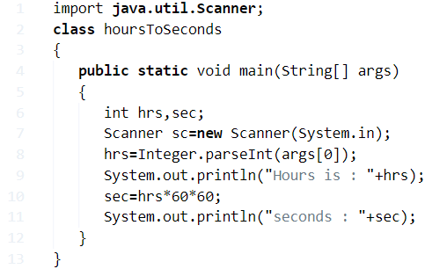

**Java Program To Convert Decimal To Binary**

A binary number is a number expressed in the base 2 numeral system. A Binary Number is made up of only **0**s and **1**s.

Example of a binary number is : 101010

A decimal number system is a term with base 10. It’s most commonly used number system.  The decimal number system consists of 10 digits from 0, 1, 2, 3, 4, 5, 6, 7, 8, 9.

1. Java Code Using Arrays

Here is the program using arrays with sample outputs.

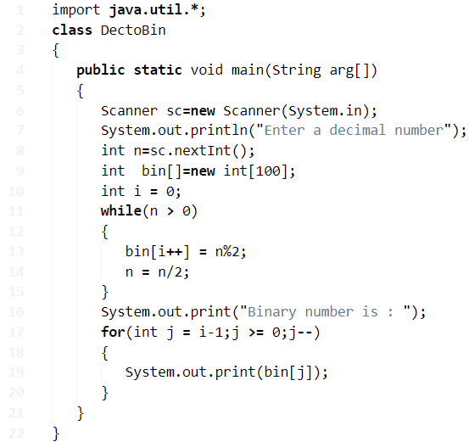

**Output:**

|  |  |
| --- | --- |
| 1  2  3 | Enter a decimal number  4  Binary number is : 100 |

2. Using static Method

* There you go another program using the static method to convert decimal to binary.

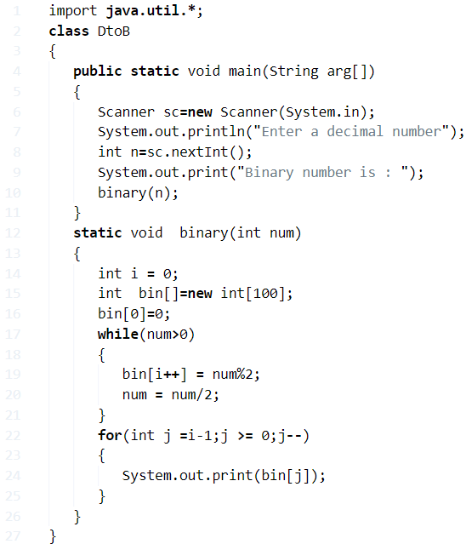

Output:

|  |  |
| --- | --- |
| 1  2  3 | Enter a decimal number  100  Binary number is : 1100100 |

3. Using Recursion

Another sample program using recursion method.

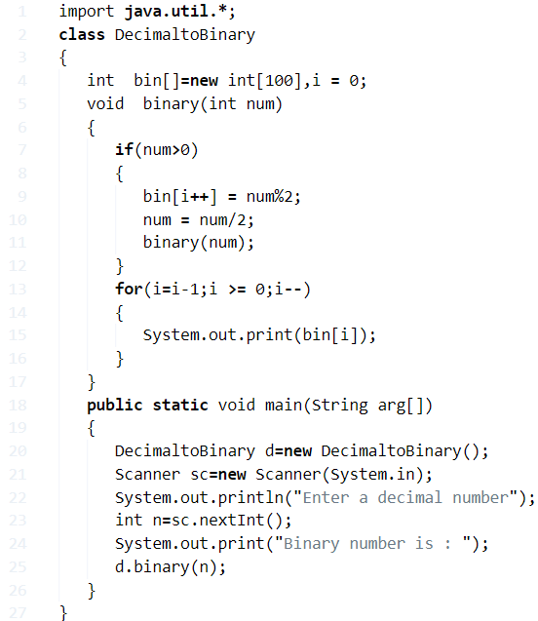

Output:

|  |  |
| --- | --- |
| 1  2  3 | Enter a decimal number  54  Binary number is : 110110 |

4. Using Stack

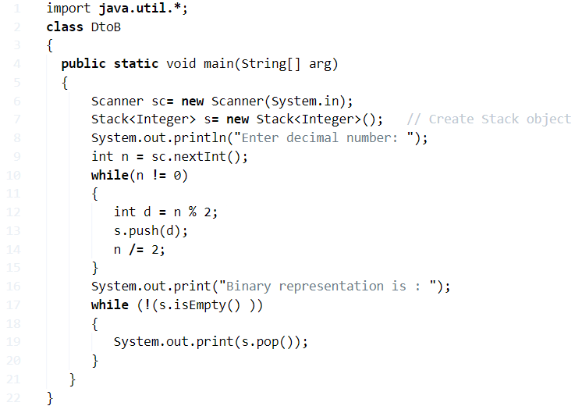

Output:

Output:

Java

|  |  |
| --- | --- |
| 1  2  3 | Enter decimal number:  16  Binary representation is : 10000 |

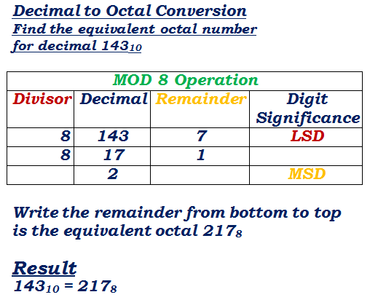**Java Program To Convert Decimal To Octal**

* What is octal?

An octal is a computer-based system with base eight. The digits in math are 0, 1, 2, 3, 4, 5, 6, 7. The value to the base eight represents as single 8 or Zero or 108.

* What is Decimal?

A decimal number system is a term with base 10. It’s most commonly used number system.  The decimal number system consists of 10 digits from 0, 1, 2, 3, 4, 5, 6, 7, 8, 9.

How to convert from decimal to octal?

[**source**](http://ncalculators.com/digital-computation/decimal-octal-converter.htm)

For Example, take one number e.g. 1792 when it is divided by 8, you will get quotient ‘ 224 ‘ remainder ‘ 0 ‘.Followed by 224 /8 you will get Q = 28, R = 0 if you continue like that the result in octal as = 3400. Hope you get it. Here is the Java code to print conversion.

**1. Using Static Method**

[wp_ad_camp_3]

* Here is the code in static format #with sample outputs.

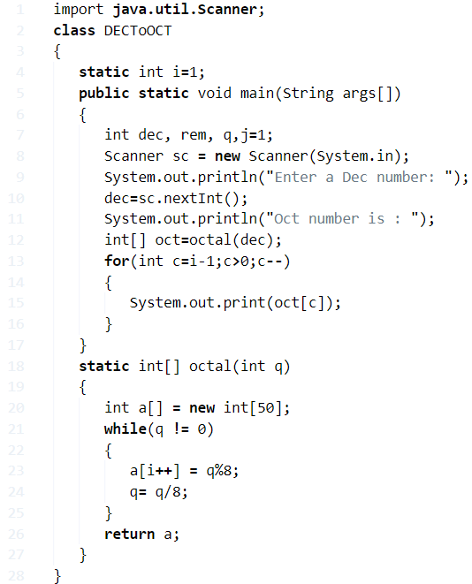

Output:

|  |  |
| --- | --- |
| 1  2  3  4 | Enter a Dec number:  52  Oct number is :  64 |

**2.**Using Recursion Method

Here is the code using recursion method with sample output code

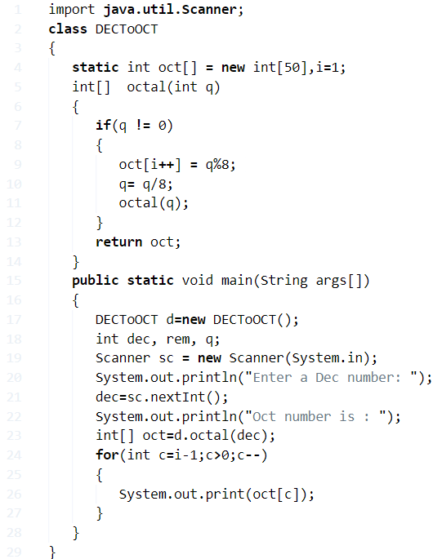

Output:

|  |  |
| --- | --- |
| 1  2  3  4 | Enter a Dec number:  256  Oct number is :  400 |

3. Basic Program

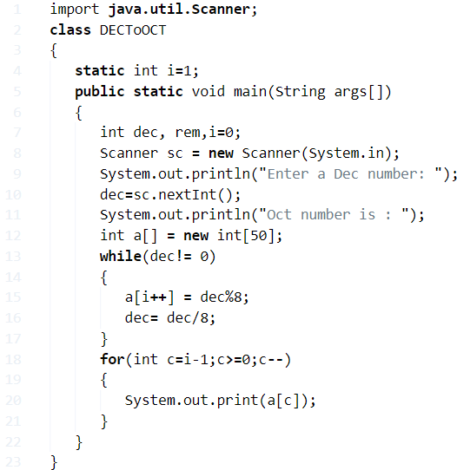

Output:

|  |  |
| --- | --- |
| 1  2  3  4 | Enter a Dec number:  16  Oct number is :  20 |

4. Convert Octal To Decimal: Vice versa

Here is the code from to convert from octal to decimal.

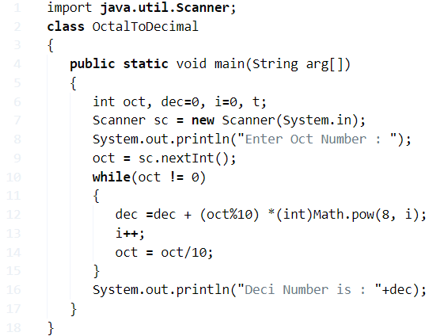

**Output:**

|  |  |
| --- | --- |
| 1  2  3 | Enter Oct Number :  65  Deci Number is : 53 |

**Java Program Convert Fahrenheit To Celsius | Vice Versa**

**Celsius Temperature Scale:**Earlier known as the Centigrade Scale, the Celsius Scale is a widely used one, also an SI derived unit for temperature. The normal scale of a Celsius thermometer measures from 0°C (Water’s freezing point at Standard Atmospheric Pressure) to 100°C (Water’s boiling point at Standard Atmospheric Pressure)

**Fahrenheit Temperature Scale:**The Fahrenheit Scale is specifically used in the U.S.A and few other places. The normal scale of a Fahrenheit thermometer ranges from 32°F (Water’s freezing point at Std Atm Pressure) and 212°F (Water’s boiling point at Std Atm Pressure)

The formula to convert **Fahrenheit** into **Celsius**:

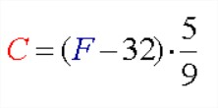

The formula to convert **Celsius** to **Fahrenheit**:

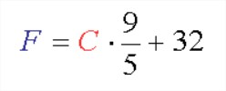

## Using Static Method

**1)** Read the temperature value using scanner object as sc.nextInt() and store it in the variable a.

In this program, we have the static method celsius(double f), which converts the Fahrenheit temperature into Celsius temperature by using the formula (f-32)*5/9.

**2)** In the main method, call the celsius method as celsius(a), then celsius(double f) method returns the Celsius temperature.

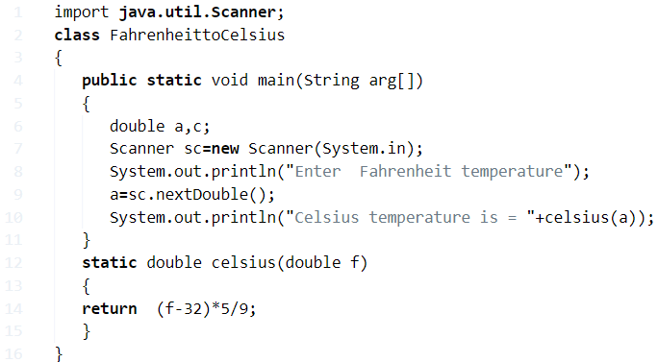

**Output:**

|  |  |
| --- | --- |
| 1  2  3 | Enter  Fahrenheit temperature  56  Celsius temperature is = 13.333333333333334 |

### Fahrenheit to Celsius Using method

**1)** In this program celsius(double f) is the method which calculates the Celsius temperature to the given Fahrenheit temperature using the formula (f-32)*5/9.

**2)** We will call this method using  FahrenheittoCelsius class object “fah” as fah.celsius(a), this method returns the double data type value.

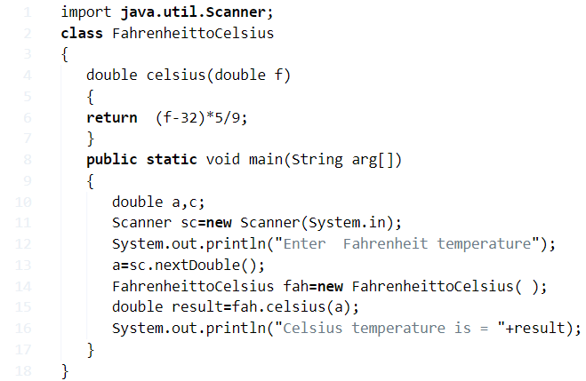

**Output:**

|  |  |
| --- | --- |
| 1  2  3 | Enter  Fahrenheit temperature  250  Celsius temperature is = 121.11111111111111 |

#### Fahrenheit to Celsius and Vice Versa Using Switch Case

**1)** Read the value using scanner class object sc.nextInt(), and store it in the variable ch. Here ch represents the  type of conversion i.e ch=1 represents  Fahrenheit to Celsius,ch=2 represents  Celsius  to Fahrenheit

**2)** If ch matches with case 1 then that block will be executed, if ch=2 then case 2 blocks will be executed. If we don’t have a break-in case then switch executes all cases.

**3)** If none of the cases matches with the switch then default block will be executed.

**4)** In our example ch=1 so case 1: will be executed and calculates the Celsius temperature using the formulas

c=(f-32)*5/9. it has “break” so it comes out of the switch.

if ch=2, then switch search for the case which matches with ch=2, so case 1 doesn’t match so come to case 2 and executes the case 2 block. Here case 1 will not be executed.

**Output:**

|  |  |
| --- | --- |
| 1  2  3  4  5  6  7 | Choose type of conversion  1.Fahrenheit to Celsius  2.Celsius to Fahrenheit  1  Enter  Fahrenheit temperature  32  Celsius temperature is = 0.0 |
| 1  2  3  4  5  6  7 | Choose type of conversion  1.Fahrenheit to Celsius  2.Celsius to Fahrenheit  2  Enter  Celsius temperature  32  Fahrenheit temperature is = 89.6 |

##### C To F using Static Method

**1)** In this program, we have the static method fahrenheit(double c) which converts the Celsius temperature into Fahrenheit temperature using the formula  ((9*c)/5)+32.

**2)** The main method which is static calls the static method fahrenheit(double c) as fahrenheit(a) then it returns the Fahrenheit temperature.

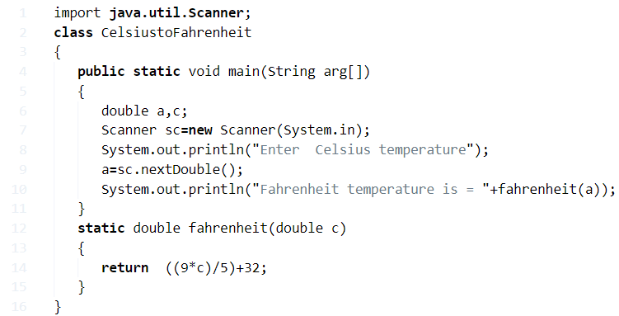

**Output:**

|  |  |
| --- | --- |
| 1  2  3 | Enter  Celsius temperature  32  Fahrenheit temperature is = 89.6 |

###### C To F using Method

**1)** double fahrenheit(double c) is the method which calculates fahrenheit temperature to the given celsius temperature using the formula  ((9*c)/5)+32.

**2)** We will call this method using CelsiustoFahrenheit class object “cel” as cel.fahrenheit(a), then it returns the value, and assigned to the variable “result”.

Convert Celsius To Fahrenheit Java Program Using Method

Java

### 

**Compound Interest : Java Program In 5 Simple Ways**

* **How to calculate compound interest in math?**

In simple, compound interest is a interest on interest. It’s the result of reinvesting.

* **What’s the formula to find the compound interest?**

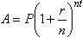

Where,

* A = ” Ending Amount “
* P = ” Principal “
* R =” Interest Rate “
* N = ” Number of compounding a year “
* T = ” Total Number Of Years “

Here we go Basic java program with standard values ( Formula-based ) to print compound Interest followed by recursion and **control statements**. At the end of the codes, we embedded an **online execution tool** where you can execute and print the output for the following programs. Check out the sample simple CI program -1 below with outputs as well.

**Find CI using standard values**

* ( **Using standard values** ) by using the simple/basic math formula you can write any program based on the following example. #Formula based Program#. Also, check the output and execute the following program at the end of the post.

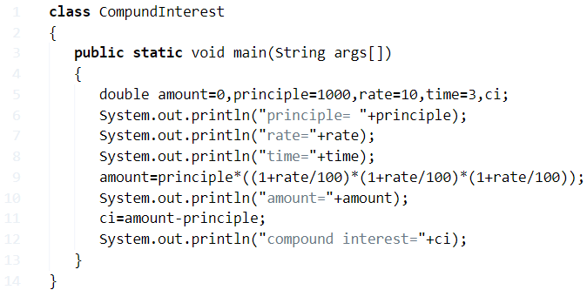

Output ( Standard Values ) :

|  |  |
| --- | --- |
| 1  2  3  4  5 | principle= 1000.0  rate=10.0  time=3.0  amount=1331.0000000000005  compound interest=331.00000000000045 |

**Using Command Line Arguments**

* Java program to find compound interest values taking inputs through [command line arguments](http://javatutoring.com/command-line-arguments-java-with-examples/). If you have no idea about command line arguments then do check out the guide here:[Command line arguments in java with examples](http://javatutoring.com/command-line-arguments-java-with-examples/). Where inputs were taken through the console. #Java Parse#.

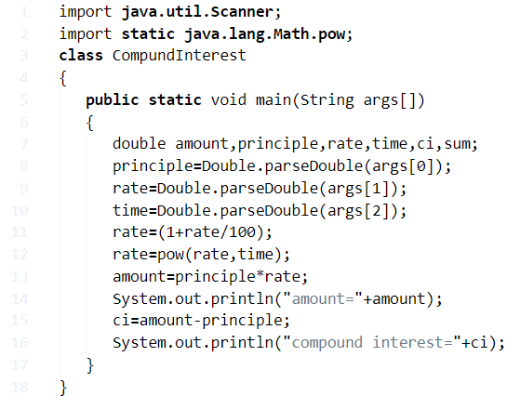

Output ( Using command line arguments ) :

|  |  |
| --- | --- |
| 1  2  3  4 | javac CompundInterest.java  ava CompundInterest 1000 10 2  amount=1210.0000000000002  compound interest=210.00000000000023 |

**Using  For Loop**

Here we go another basic and simple method to print CI values, java program to **calculate compound interest using For loop**.

Executing a set of statements repeatedly is known as looping. We have written an article about [**for loop here**](http://javatutoring.com/category/control-statements/). Check out. For loop is the most used loop in Java, where it can work out with both while and [**do while**](http://javatutoring.com/do-while-java-examples/). Check out the program below with outputs.

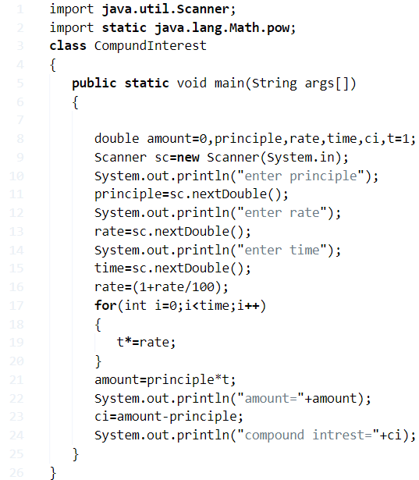

Output ( Using For Loop ) :

|  |  |
| --- | --- |
| 1  2  3  4  5  6  7  8 | enter principle  10000  enter rate  5  enter time  5  amount=12762.815625000003  compound interest=2762.815625000003 |

**Using While Loop**

* Another simple program to print CI values, here we used a while loop syntax to find the compound interest using while loop.
* The difference between for loop and while loop is nothing, but as per universal laws, the execution of statement differs with that code thereby all looping will have a different syntax which can impact on the execution of the statement.
* The definition of while loop is executing a set of statements repetitively until the condition is true. Check out the program.

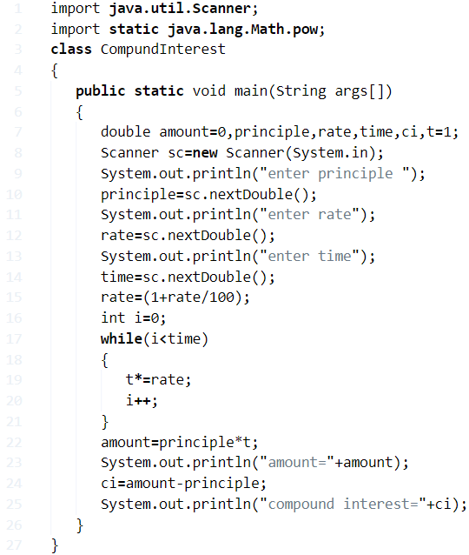

Output ( Using While Loop ) :

|  |  |
| --- | --- |
| 1  2  3  4  5  6  7  8 | enter principle  1000  enter rate  1  enter time  1  amount=1010.0  compound interest=10.0 |

**Using Recursion**

* Another method, using recursion. So basically what is recursion, recursion is a method calls itself repeatedly or a method in java that calls itself is called a recursive method**.** Check out the following program **using recursion**.

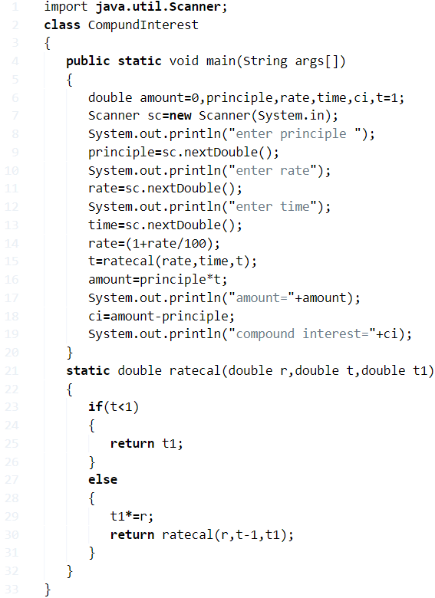

Output ( Using Recursion ) :

Output:

Java

|  |  |
| --- | --- |
| 1  2  3  4  5  6  7  8 | enter principle  1000  enter rate  1  enter time  2  amount=1020.1  compound interest=20.100000000000023 |

**18) Java Program To Calculate Electricity Bill**

**Q) How to calculate electricity bill?**

Consider the following example:

For example, a consumer consumes 500 watts per hour daily for one month.  Calculate the total energy bill of that consumer if per unit rate is 7? ( In $, £, €, INR, DHR, Riyal etc) [Take 1 month = 30 Days].

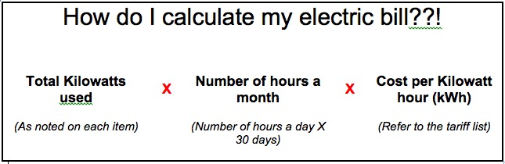**Solution :**

s we know that 1 Unit = 1kWh

So total kWh = 500 watts x 24 hours x 30 days

= 360000

So, we want to convert into units:

Where 1 unit = 1kWh

Total consumed units are as 360000/1000 = 360

And, cost per unit is = 7, the total cost of the electricity bill is 360 x 7 = 2520( In $, £, €, INR, Rs, DHR, Riyal etc).

That’s it. Let’s get into programming.

**Method – 1 Using the static method with outputs**

There you go by using the standard values along with the sample outputs. If you have any doubts related to the following program do leave a comment here.

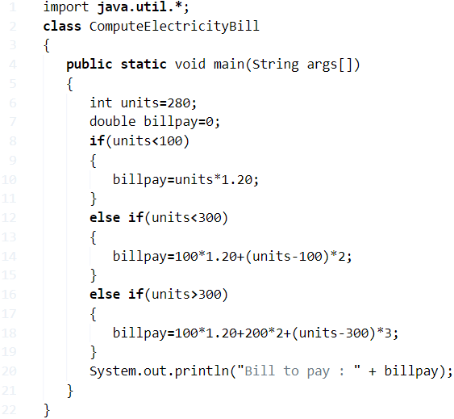

**output:**

|  |  |
| --- | --- |
| 1 | Bill to pay : 480.0 |

**Method – 2 Taking inputs through scanner class**

Java code for obtaining Electricity Bill taking inputs through scanner class, with outputs.

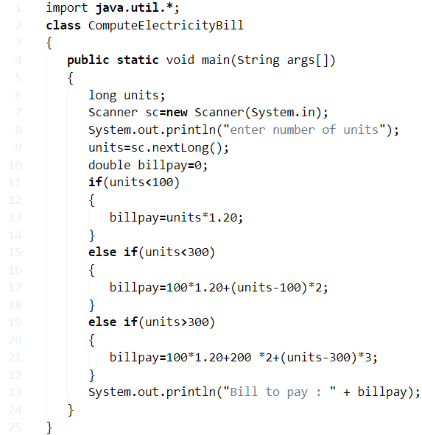

**output:**

|  |  |
| --- | --- |
| 1  2  3  4  5  6  7  8  9 | C:\Users\goutham\Desktop\E>javac ComputeElectricityBill.java    C:\Users\goutham\Desktop\E>java ComputeElectricityBill    enter number of units    550    Bill to pay : 1270.0 |

**Method – 3 Taking Inputs through command line arguments**

Taking inputs through command line arguments with an output.

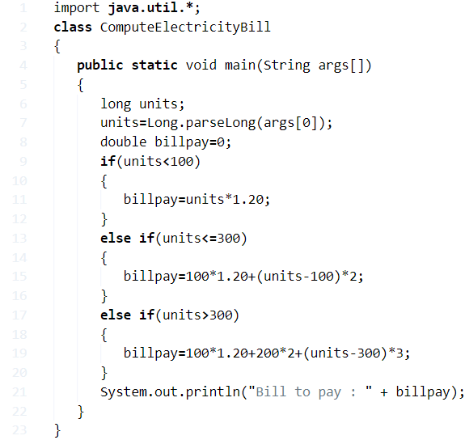

**output:**

|  |  |
| --- | --- |
| 1  2  3  4  5 | C:\Users\goutham\Desktop\E>javac ComputeElectricityBill.java    C:\Users\goutham\Desktop\E>java ComputeElectricityBill 500    Bill to pay : 1120.0 |

**Method – 4 Using Inheritance**

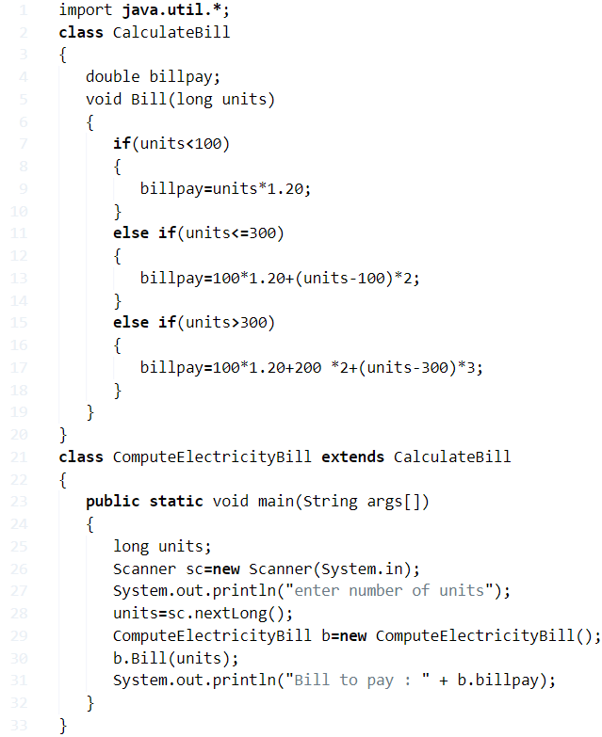

**output:**

|  |  |
| --- | --- |
| 1  2  3  4  5  6  7  8  9  10  11  12  13 | enter number of units  500  Bill to pay : 1120.0      enter number of units  250  Bill to pay : 420.0      enter number of units  1000  Bill to pay : 2620.0 |

**Method – 5 Electricity Bill code by creating a Separate class**

Through creating a separate class( ) and taking inputs through scanner class.

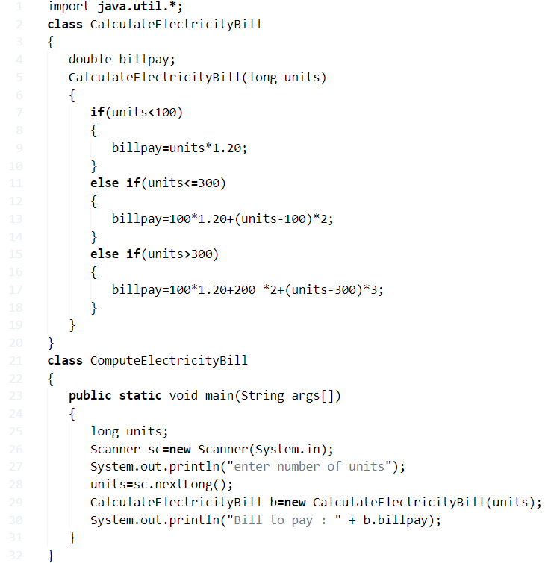

output:

|  |  |
| --- | --- |
| 1  2  3 | enter number of units  1000  Bill to pay : 2620.0 |

**Method - 6 User-defined method ( Function )**

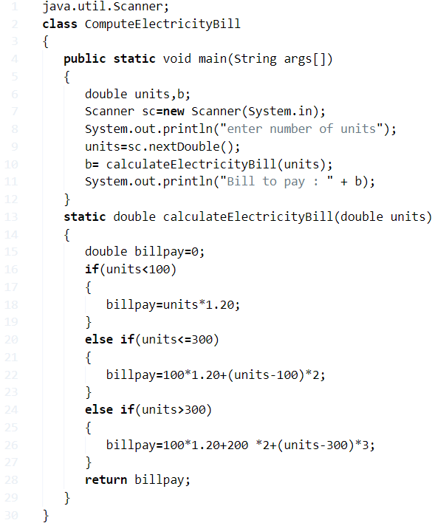

**output:**

output:

Java

|  |  |
| --- | --- |
| 1  2  3 | enter number of units  600  Bill to pay : 1420.0 |

**20) Java Program To Calculate Discount Of Product**

**How to calculate a discount on a product?**

**A:**  Discount is defined as the reduction in the price something you sell to the customers.  Most of the discount rate is given in percentage rate.

**Here is the formula to calculate the discount:**

**Discount = List price x Discount Rate**

For example :

A pen costs 50$ and it is been sold at a discount of 12%, what is the discount price of the pen?

A: = 50 x 12/100

= 50 × 0.12

= $ 6

**Discount price of the pen is : 44$. Hope you get it.**

Okay fine! Let’s get into the programming for the above equation is different formats.

## ****Discount Java Code****

**Method - 1Using standard values**

By using standard values consider this program is universal code.

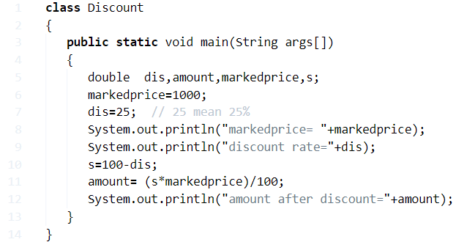

**output:**

|  |  |
| --- | --- |
| 1  2  3 | markedprice = 1000.0  discount rate=25.0  amount after discount=750.0 |

### Method - 2 ****Taking inputs through scanner classs****

Taking inputs through scanner class, with sample output.

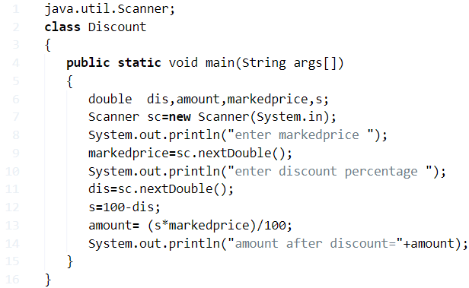

**output:**

|  |  |
| --- | --- |
| 1  2  3  4  5 | enter marked price  2000  enter discount percentage  30  amount after discount=1400.0 |

#### Method – 3 ****By Using Command-Line Arguments****

There you go another method: By using command line arguments. If you have no idea about command line arguments you can check out here – [**command line arguments with examples**](https://javatutoring.com/command-line-arguments-java-with-examples/)**.**

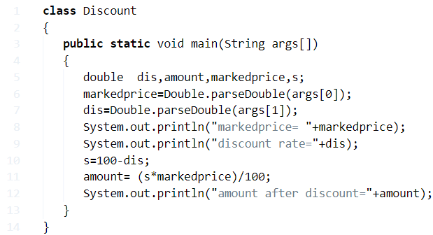

**output:**

|  |  |
| --- | --- |
| 1  2  3 | markedprice= 10000.0  discount rate=50.0  amount after discount=5000.0 |

**Method – 4 User Define Method**

By using user-defined method. Here you go:

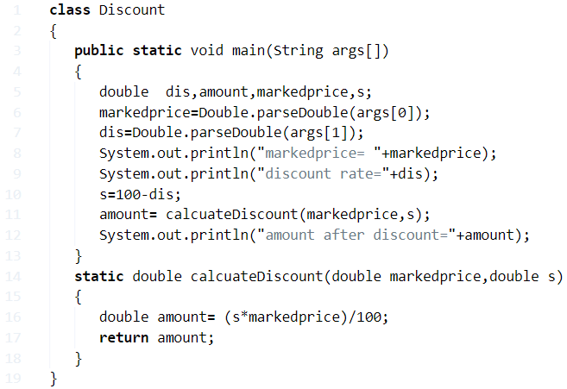

**output:**

|  |  |
| --- | --- |
| 1  2  3 | markedprice= 10000.0  discount rate=15.0  amount after discount=8500.0 |

##### **Method - 5 Inputs Through Scanner Class**

Java code for getting discount of product through creating a separate class( ) and taking inputs through scanner class.

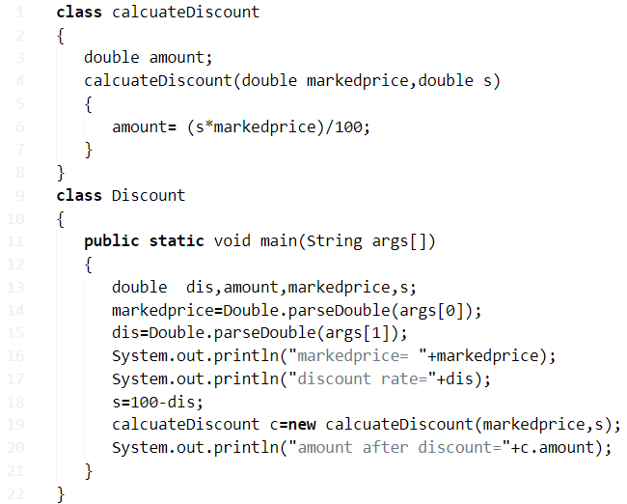

**output**

Output:

Java

|  |  |
| --- | --- |
| 1  2  3 | markedprice= 1000.0  discount rate=10.0  amount after discount=900.0 |

**21) Java Program To Calculate Distance Between Two Points**

The distance between two points formula derived from the Pythagorean Theorem.

To find the distance between two points (x1,y1) and (x2,y2), all that you need to do is use the coordinates of these ordered pairs and apply the formula pictured below.

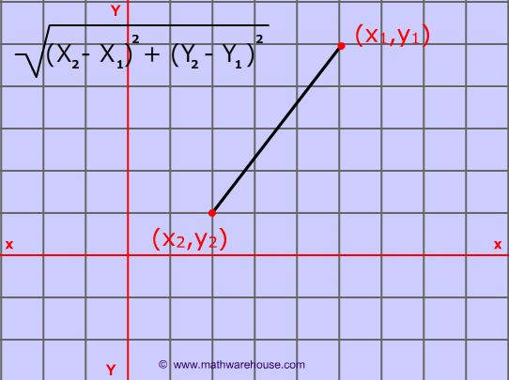

**Method - 1Java Program using standard values**

There you go formula-based program with sample output.

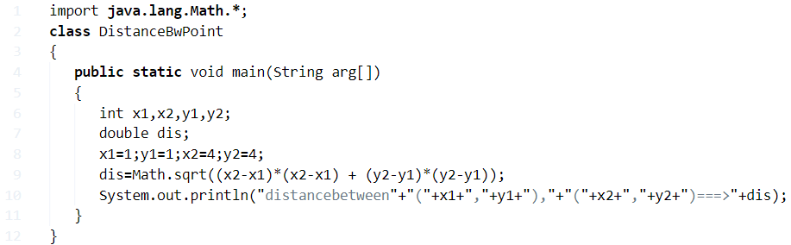

**output:**

|  |  |
| --- | --- |
| 1 | distancebetween(1,1),(4,4)===>4.242640687119285 |

**Method – 2 Taking inputs through scanner class**

Sample code #2: Taking inputs through scanner class.

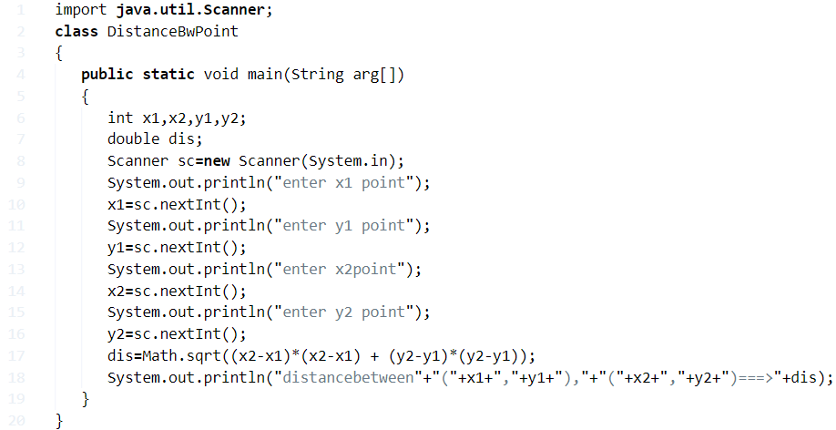

**output:**

|  |  |
| --- | --- |
| 1  2  3  4  5  6  7  8  9  10  11  12  13  14  15  16  17  18  19  20  21  22  23  24  25  26  27  28  29  30  31  32  33  34  35  36  37 | Output:1  C:\Users\goutham\Desktop\E>java DistanceBwPoint  enter x1 point  1  enter y1 point  2  enter x2point  1  enter y2 point  2  distancebetween(1,2),(1,2)===>0.0    Output:2    C:\Users\goutham\Desktop\E>java DistanceBwPoint  enter x1 point  4  enter y1 point  4  enter x2point  1  enter y2 point  1  distancebetween(4,4),(1,1)===>4.242640687119285    Output:3    C:\Users\goutham\Desktop\E>java DistanceBwPoint  enter x1 point  5  enter y1 point  3  enter x2point  2  enter y2 point  3  distancebetween(5,3),(2,3)===>3.0 |

**Method – 3 Using command line arguments**

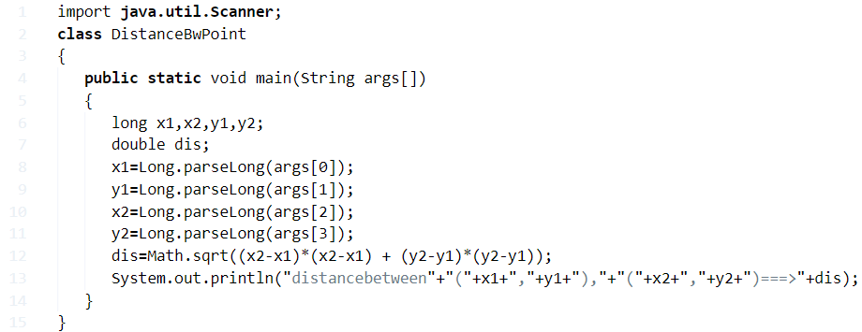

**output:**

|  |  |
| --- | --- |
| 1  2  3  4  5  6  7  8  9  10  11  12  13  14  15  16  17  18  19  20  21  22  23  24  25 | Output:1    C:\Users\goutham\Desktop\E>javac DistanceBwPoint.java    C:\Users\goutham\Desktop\E>java DistanceBwPoint 1 1 1 1    distancebetween(1,1),(1,1)===>0.0    Output:2    C:\Users\goutham\Desktop\E>java DistanceBwPoint 11 5  12 5    distancebetween(11,5),(12,5)===>1.0    Output:3    C:\Users\goutham\Desktop\E>java DistanceBwPoint 11 11   5   5    distancebetween(11,11),(5,5)===>8.48528137423857    Output:4    C:\Users\goutham\Desktop\E>java DistanceBwPoint 100 4  200 5    distancebetween(100,4),(200,5)===>100.00499987500625 |

**Method – 4 User Define Method**

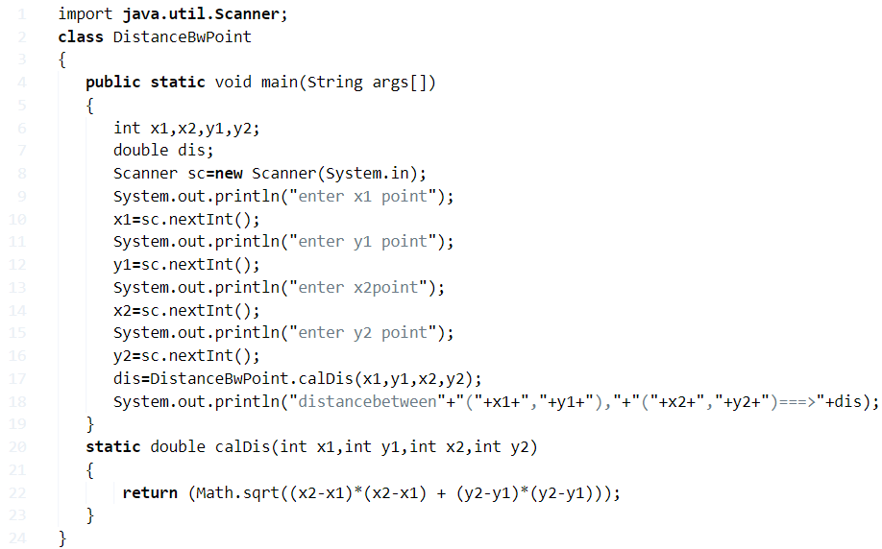

**output:**

|  |  |
| --- | --- |
| 1  2  3  4  5  6  7  8  9 | enter x1 point  1  enter y1 point  2  enter x2point  3  enter y2 point  4  distancebetween(1,2),(3,4)===>2.8284271247461903 |

**Method - 5 Creating a separate class**

Through creating a separate class( ) and taking inputs through scanner class.

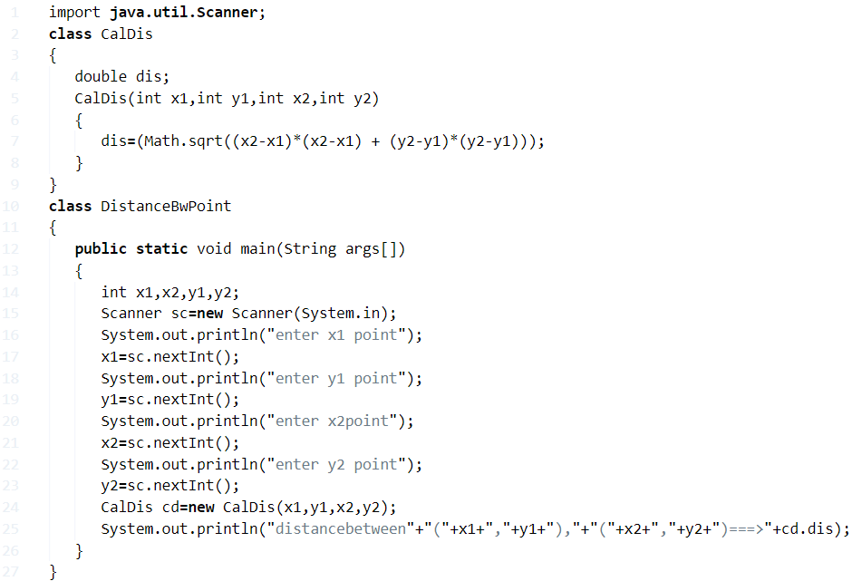

**output:**

Java

|  |  |
| --- | --- |
| 1  2  3  4  5  6  7  8  9 | enter x1 point  11  enter y1 point  5  enter x2point  6  enter y2 point  5  distancebetween(11,5),(6,5)===>5.0 |

**22) Java Program To Calculate Commission Percentage**

Multiply your commission rate by your commission base for the period to calculate your commissionpayment

**Example :**

If you made $30,000 worth of sales from March 1 to March 15 and your **commission** rate is 5 per cent, your **commission**payment is $1,500

**Method – 1 Using Standard Values**

There you go the following program is written based on a formula, consider this as a standard program. You can use this program anywhere like Java salesperson commission, commission calculator. #java salesperson commission

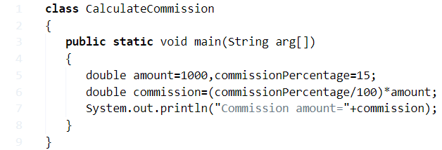

**output:**

|  |  |
| --- | --- |
| 1 | Commission amount =150.0 |

**Method – 2 Taking Inputs Through Scanner Class**

Java code for obtaining commission percentage taking inputs through scanner class, Java salesperson commission and, simple commission calculation program part 2.

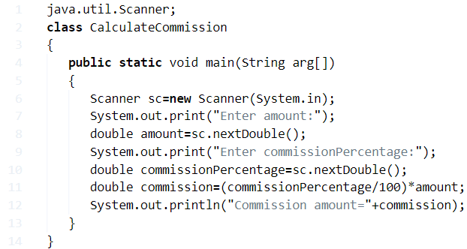

**output:**

|  |  |
| --- | --- |
| 1  2  3  4  5  6  7  8  9  10  11  12  13  14  15 | Output:1    Enter amount: 100000    Enter commissionPercentage: 10    Commission amount = 10000.0    Output:2    Enter amount:25000    Enter commissionPercentage:25    Commission amount=6250.0 |

**Method – 3 Through Command Line Arguments**

There you go another method by using command line arguments. If you no idea about command line arguments you can check out the guide here on how to command line arguments works #simple commission calculation program part 2.

**Learn more :**

* [What is Java Break?](https://javatutoring.com/java-break-guide/)
* [What is Java Hashmap?](https://javatutoring.com/java-hashmap-guide/)

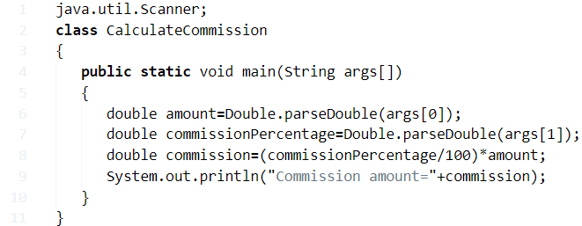

**output:**

|  |  |
| --- | --- |
| 1  2  3  4  5  6  7  8  9  10  11  12  13  14  15 | Output:1    C:\Users\goutham\Desktop\E>javac CalculateCommission.java    C:\Users\goutham\Desktop\E>java CalculateCommission 1000 10    Commission amount=100.0    Output:2    C:\Users\goutham\Desktop\E>javac CalculateCommission.java    C:\Users\goutham\Desktop\E>java CalculateCommission 20000 25    Commission amount=5000.0 |

**Method – 4 User Define Method**

By using a user-defined method we wrote the following program to calculate **commission percentage program.**

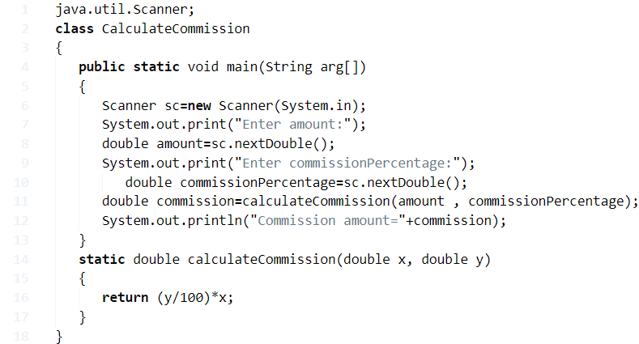

**output:**

|  |  |
| --- | --- |
| 1  2  3  4  5  6  7  8  9  10  11  12  13  14  15 | Output:1    Enter amount:1000    Enter commissionPercentage:17.55    Commission amount=175.50000000000003    Output:2    Enter amount:15500    Enter commissionPercentage:50    Commission amount=7750.0 |

**Method – 6 Creating Separate Class**

Java program for getting commission percentage through creating a separate class( ) and taking inputs through scanner class. #java code sales commission calculator #simple commission calculation program part 2

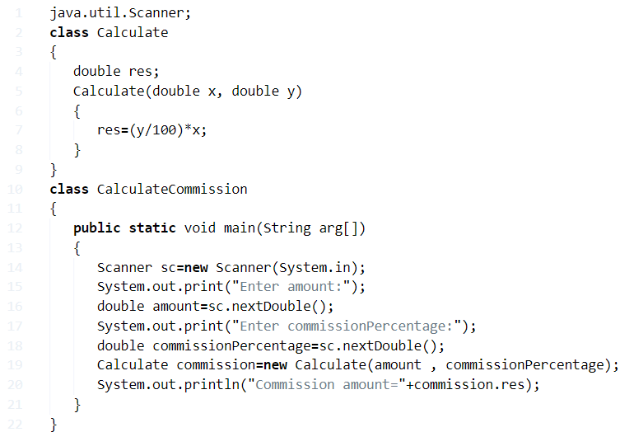

**output:**

Output:

Java

|  |  |
| --- | --- |
| 1  2  3  4  5  6  7  8  9  10  11  12  13  14  15 | Output:1    Enter amount:3000    Enter commissionPercentage:20    Commission amount=600.0    Output:2    Enter amount:10000000    Enter commissionPercentage:50    Commission amount=5000000.0 |

**Java Program To Calculate Salary Of An Employee**

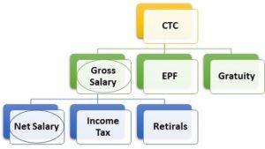Net Salary, as we all know, is the amount of money that an employee takes home after having all of the deductions cleared and finished at the end of a month.

Usually, people have a few deductions going on with their gross salaries.

As you can see in the image, CTC or Cost To Company is the price that a company is spending on you. Out of that, come out several branches. Deducting one after the other we land at the Net Salary.

The formula for Net Salary is as follows:

Net Salary = Gross Salary – Income Tax – Public Provident Fund – Professional Tax

Thus, at the end of the day, the salary in-hand is not exactly what you work for in your workplace.

Hence, the various methods to calculate the net salary in Java Programming are as follows:

## Gross Salary Of Employee Java Code

The easiest way to find the net salary of employee is by first taking the values of gross salary, [income tax,](https://javatutoring.com/java-income-tax-calculator/) provident fund and professional tax in the main function and directly use the below formula.

**Net Salary = Gross Salary – Income Tax – Public Provident Fund – Professional Tax**

This is a [simple arithmetic calculation](https://javatutoring.com/java-swing-calculator/) that will give you your desired result i.e., the net salary or salary-in-hand. This can then be printed in the console screen.

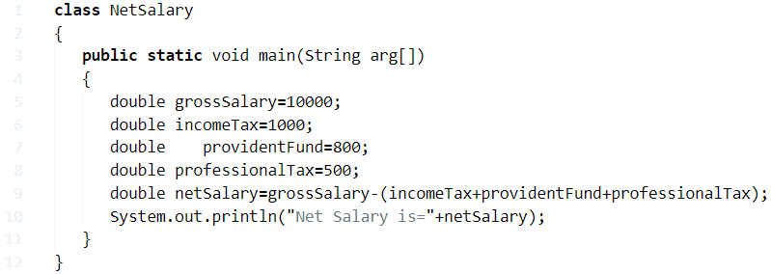

**Output:**

|  |  |
| --- | --- |
| 1 | Net Salary is=7700.0 |

**Using Scanner Class**

In the above scenario, we had seen that the values have already been given in the code itself and if one were to change these values they have to go and make changes in the code.

This is not very convenient at a user’s perspective.

So to read the input, we use the Scanner Class. The inputs for this program are gross salary (gs), income tax (it), professional tax (pt) and public provident fund (pf).

So using this, we read the input at run time after which the same calculations are performed.

A small difference here is the income tax, public provident fund and professional tax are taken as percentage of gross salary in the input. So first, the amount is calculated using

Amount=Percentage*GrossSalary/100 and then the below formula is used.

Net Salary = Gross Salary – Income Tax – Public Provident Fund – Professional Tax

This is a simple arithmetic calculation that will give you your desired result i.e., the net salary or salary-in-hand. This can then be printed in the console screen.

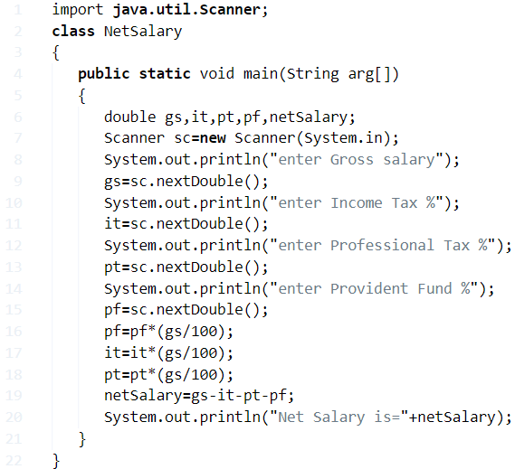

Output:

|  |  |
| --- | --- |
| 1  2  3  4  5  6  7  8  9 | enter Gross salary  2000  enter Income Tax %  10  enter Professional Tax %  10  enter Provident Fund %  10  Net Salary is=1400.0 |

### Employee Program in Java – Static Method

Static method is a method in [Java which are referenced with the class](https://javatutoring.com/java-generics-class-with-multiple-parameters/) name itself and do not require separate object to reference it.

For the given problem, static method can be used as a block which will be consisting of the main logic used to derive at the net salary of the employee.

This is the block where the same logic used in the example of Scanner Class is used with the same arithmetic operation to be performed.

This static class named ‘salary’ is then called in the main class. As it can be observed that, the return type of static method is double which is precisely the same as that of our desired net salary.

This method first finds the exact [amount of income tax](https://javatutoring.com/java-income-tax-calculator/), professional tax and provident fund. After obtaining these, it finds the net salary using

Net Salary = Gross Salary – Income Tax – Public Provident Fund – Professional Tax

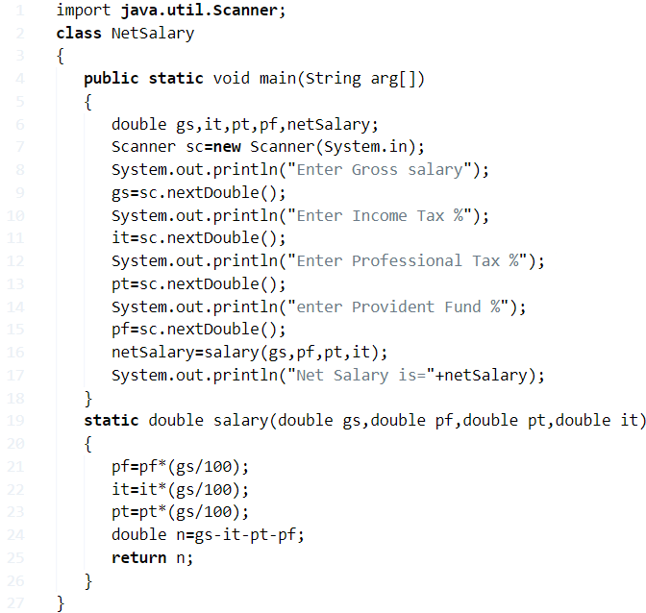

Output:

|  |  |
| --- | --- |
| 1  2  3  4  5  6  7  8  9 | Enter Gross salary  10000  Enter Income Tax %  5  Enter Professional Tax %  5  enter Provident Fund %  5  Net Salary is=8500.0 |

#### Using Command – Line Arguments

Command line arguments are where we can give input in the form of argument in the command prompt itself while running the java code.

We can directly the values as arguments in command line while running the code with space in between.

The first argument arg[0] is taken as the gross salary, second argument arg[1] is taken as the income tax percentage, third argument arg[2] is taken as the professional tax percentage and the fourth argument arg[3] is taken as the provident fund percentage.

After getting the input, the same operations as above are performed to arrive at our desired result i.e., net salary.

using Command-Line Arguments for employee salary

Java

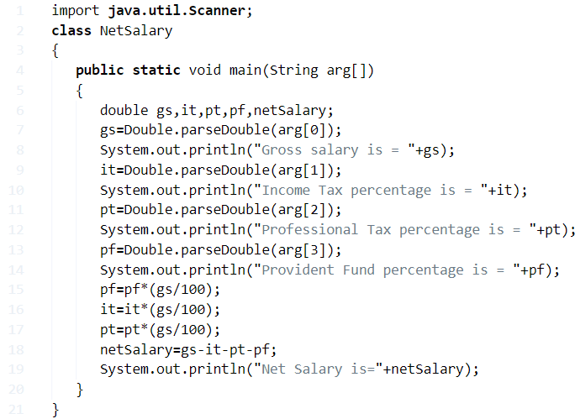

**24) Java Program To Calculate Depreciation**

The decrease in value of assets (fair value depreciation). The allocation of the cost of assets to periods in which the assets are used (depreciation with the matching principle)

Depreciation is a method of reallocating the cost of a tangible asset over its useful lifespan of it being in motion. Businesses depreciate long-term assets for both tax and accounting purposes.

There are mainly three ways to calculate Depreciation.

1. Straight line method
2. Unit of production method
3. Double-declining balance method

**Method – 1 Java Program By Using Standard Values**

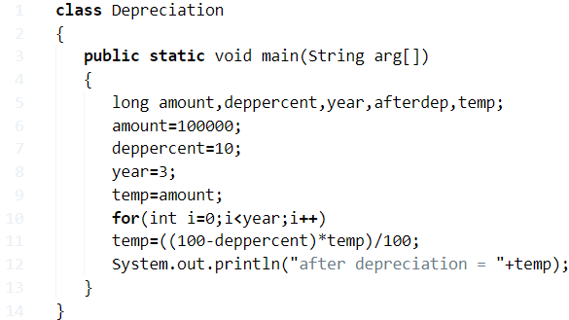

**output:**

|  |  |
| --- | --- |
| 1 | after depreciation = 72900 |

**Method – 2 Java Program To Calculate Depreciation Through Scanner Class**

Here we are taking inputs through scanner class.

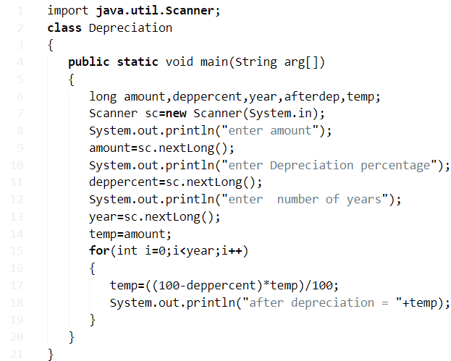

**output:**

|  |  |
| --- | --- |
| 1  2  3  4  5  6  7  8  9  10  11  12  13  14  15  16  17  18  19  20  21  22  23  24  25  26  27 | output:1  enter amount  1000  enter Depreciation percentage  10  enter  number of years  1  after depreciation = 900    output:2  enter amount  1000  enter Depreciation percentage  10  enter  number of years  2  after depreciation = 810      output:3  enter amount  1000  enter Depreciation percentage  10  enter  number of years  3  after depreciation = 729 |

**Method – 3 Inputs Through Command Line Argument**

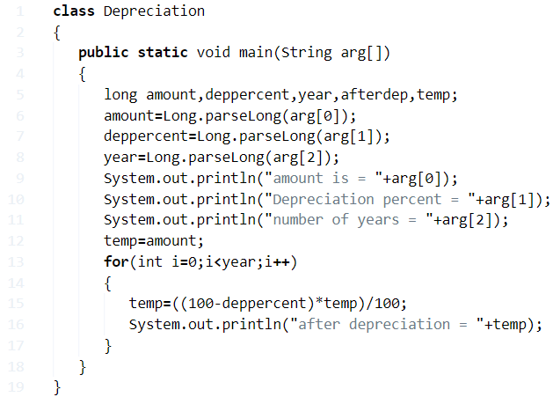

**output:**

|  |  |
| --- | --- |
| 1  2  3  4  5  6  7  8  9  10  11  12  13  14  15  16  17  18  19  20  21  22  23  24  25  26  27  28 | C:\Users\goutham\Desktop\E>javac Depreciation.java    C:\Users\goutham\Desktop\E>java Depreciation 2000 20 1  amount is = 2000  Depreciation percent = 20  number of years = 1  after depreciation = 1600    output:2  C:\Users\goutham\Desktop\E>javac Depreciation.java    C:\Users\goutham\Desktop\E>java Depreciation 2000 20 2  amount is = 2000  Depreciation percent = 20  number of years = 2  after depreciation = 1280    output:3    C:\Users\goutham\Desktop\E>javac Depreciation.java    C:\Users\goutham\Desktop\E>java Depreciation 2000 20 3  amount is = 2000  Depreciation percent = 20  number of years = 3  after depreciation = 1024 |

**Method – 4 Using User Define Method**

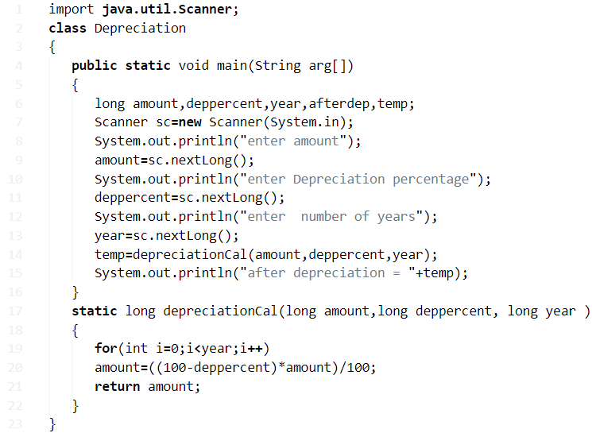

**output:**

|  |  |
| --- | --- |
| 1  2  3  4  5  6  7  8  9  10  11  12  13  14  15  16  17  18  19  20  21  22  23  24  25  26 | output:1  enter amount  10000  enter Depreciation percentage  50  enter  number of years  1  after depreciation = 5000    output:2  enter amount  10000  enter Depreciation percentage  50  enter  number of years  2  after depreciation = 2500    output:3  enter amount  10000  enter Depreciation percentage  50  enter  number of years  3  after depreciation = 1250 |

**Method – 5 Creating a Separate Class**

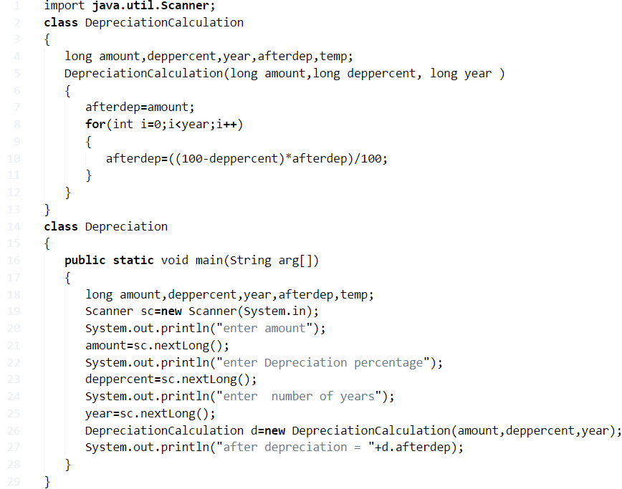

**output:**

|  |  |
| --- | --- |
| 1  2  3  4  5  6  7  8  9  10  11  12  13  14  15  16  17  18  19  20  21  22  23  24  25  26 | output:1  enter amount  100000  enter Depreciation percentage  10  enter  number of years  5  after depreciation = 59049    output:2  enter amount  80000  enter Depreciation percentage  20  enter  number of years  2  after depreciation = 51200    output:3  enter amount  9000  enter Depreciation percentage  50  enter  number of years  1  after depreciation = 4500 |

**25) Java Program To Calculate CGPA** **( Cumulative Grade Point Average ) Percentage**

CGPA is overall grade point average. For each course, there are certain credits which are usually based on how many hours the class is held in each week.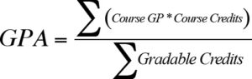 Your grade point average (GPA) is calculated by dividing the total amount of grade points earned by the total amount of credit hours attempted. Your grade point average may range from 0.0 to a 4.0. To get the example student’s GPA, the total grade points are divided by the total credit hours attempted. Here is the simple formula to calculate the GPA ( Grade point average formula )

## Method – 1 ****Using standard values with outputs****

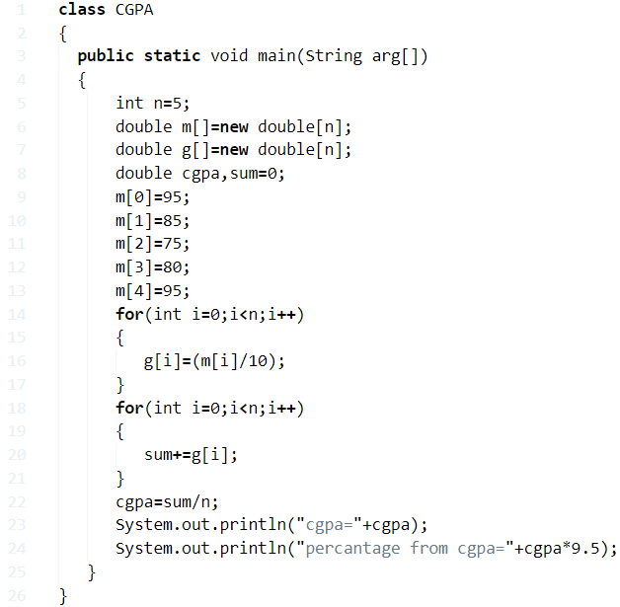

**Output:**

|  |  |
| --- | --- |
| 1  2 | cgpa=8.6  percantage from cgpa=81.7 |

### Method – 2 ****Using Command-Line Arguments****

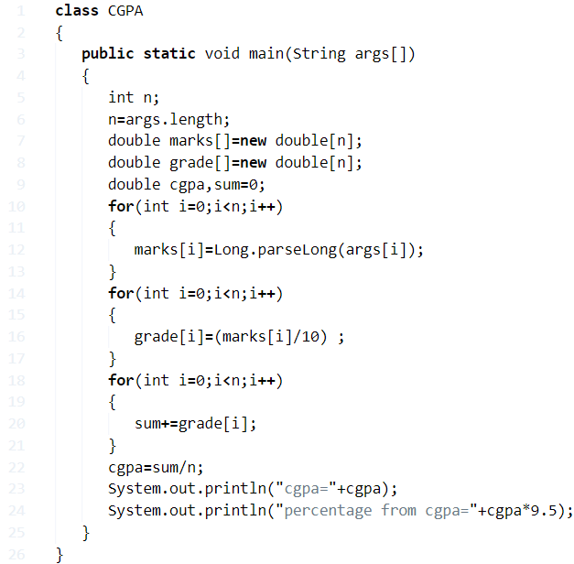

**Output ( Using command line arguments ) :**

|  |  |
| --- | --- |
| 1  2  3  4  5  6  7  8  9  10  11  12  13  14  15  16  17  18  19  20  21  22  23 | output:1  javac CGPA.java  java CGPA 85 95 66 77 25  cgpa=6.960000000000001  percantage from cgpa=66.12    output:2  javac CGPA.java  java CGPA 90 95 98 99 100  cgpa=9.64  percantage from cgpa=91.58000000000001    output:3  javac CGPA.java  java CGPA 85 95 66 77 55  cgpa=7.5600000000000005  percantage from cgpa=71.82000000000001    output:4  javac CGPA.java  java CGPA 70 70 70 70 70  cgpa=7.0  percantage from cgpa=66.5 |

#### Method – 3 Using Arrays

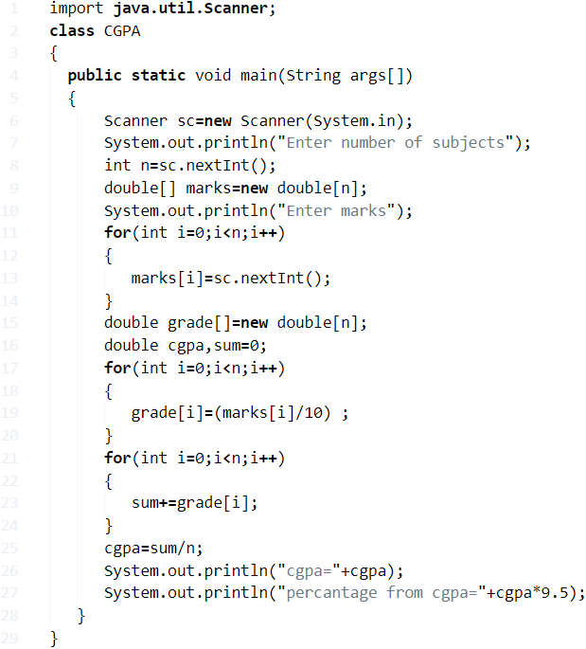

**Output ( Inputs Through Scanner Class ):**

|  |  |
| --- | --- |
| 1  2  3  4  5  6  7  8  9  10  11  12  13  14  15  16  17  18  19  20  21  22  23  24  25  26  27  28  29  30  31  32  33  34  35  36 | output:1  Enter number of subjects  5  Enter marks  90  80  70  80  90  cgpa=8.2  percantage from cgpa=77.89999999999999    output:2  Enter number of subjects  6  Enter marks  90  80  78  87  50  45  cgpa=7.166666666666667  percantage from cgpa=68.08333333333334    output:3  Enter number of subjects  5  Enter marks  75  85  88  98  65  cgpa=8.22  percantage from cgpa=78.09 |

##### **Method – 4 Using Method**

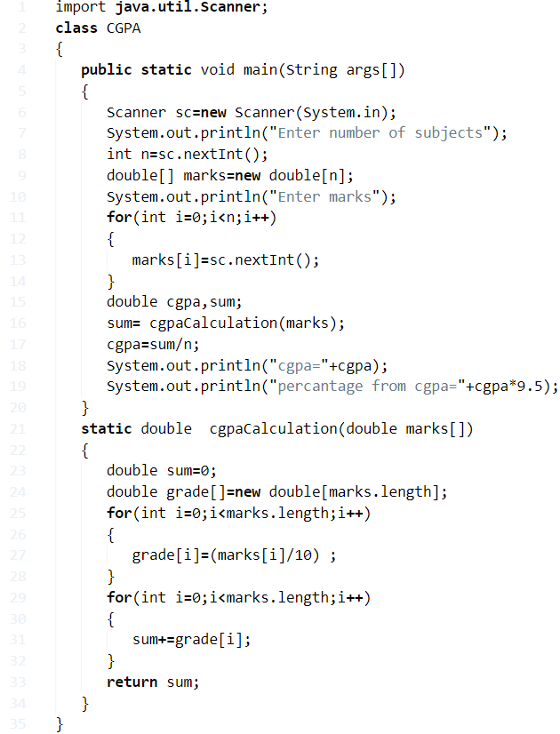

**Output ( User define method ) :**

|  |  |
| --- | --- |
| 1  2  3  4  5  6  7  8  9  10  11  12  13  14  15  16  17  18  19  20  21  22  23  24  25  26  27  28  29  30  31  32  33  34  35  36  37 | output:1  Enter number of subjects  5  Enter marks  100  98  78  48  59  cgpa=7.659999999999999  percantage from cgpa=72.77    output:2  Enter number of subjects  6  Enter marks  90  90  90  90  90  90  cgpa=9.0  percantage from cgpa=85.5      output:3  Enter number of subjects  5  Enter marks  100  95  90  80  85  cgpa=9.0  percantage from cgpa=85.5 |

**Method – 5 Using class**

Here we go another version of a program to calculate the GPA by creating a **new separate class** for ( CGPAcalculation) and taking inputs using  scanner class method with sample outputs.

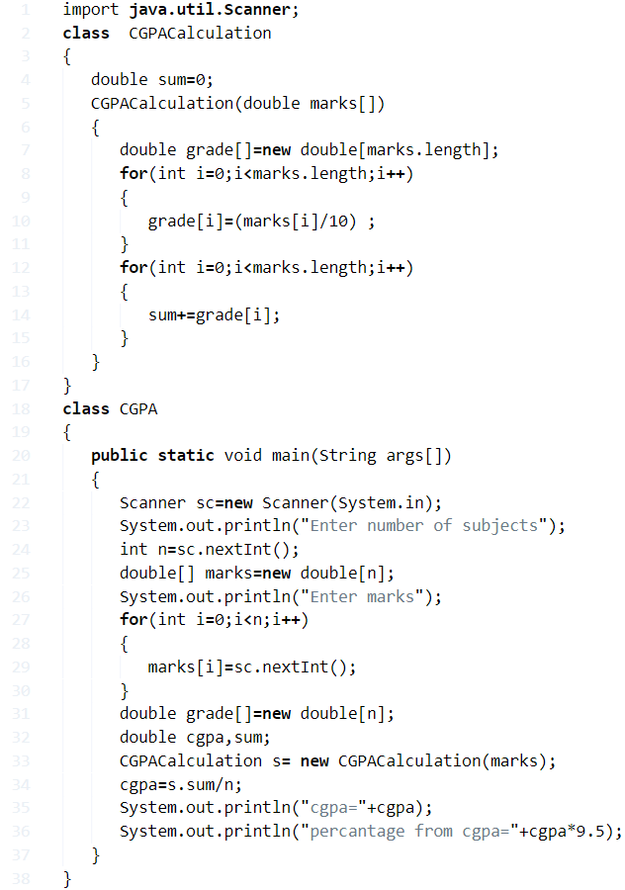

**Output:**

Output:

Java

|  |  |
| --- | --- |
| 1  2  3  4  5  6  7  8  9  10  11  12  13  14  15  16  17  18  19  20  21  22  23  24  25  26  27  28  29  30 | output:1  Enter number of subjects  1  Enter marks  100  cgpa=10.0  percantage from cgpa=95.0    output:2  Enter number of subjects  4  Enter marks  100  90  80  60  cgpa=8.25  percantage from cgpa=78.375    output:3  Enter number of subjects  5  Enter marks  50  60  70  80  90  cgpa=7.0  percantage from cgpa=66.5 |

**23) Java Program To Calculate Power Of Number**

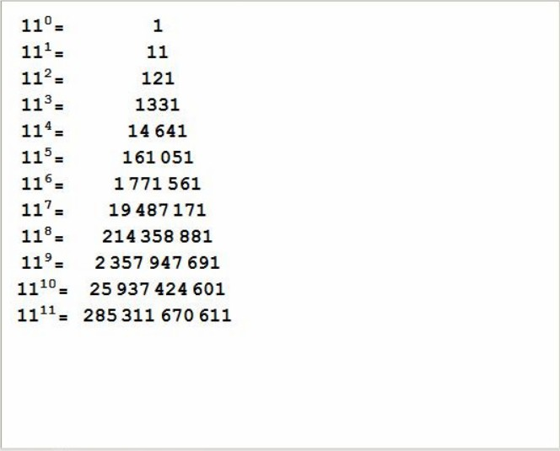As we all know, the power of a number is the times a number is multiplied with itself. The power of a number, in more simpler terms, is the number of times you have to multiply the number by itself.

For example, 5^3 is called as 5 to the power of 3.

Here, 5^3 = 5*5*5 = 125.

Similarly, 5^(-2) = (1/5)^2 = 1/25.

The power of 0 will always give the result as 1, no matter what the number is, unless if it is undefined or infinite.

As given in the photo above, the powers of the number 11 from 0 to 11 are mentioned there. It is clearly seen that 11 is multiplied by the result once after the other as the power increases.

Thus, the manifold ways to calculate the power of a number in Java programming are as follows:

## Method – 1 Using Standard Method

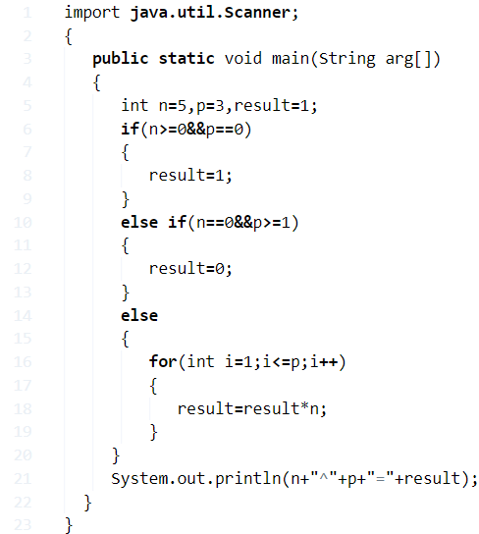

**Output:**

|  |  |
| --- | --- |
| 1 | 5^3=125 |

### Method – 2 Using For Loop

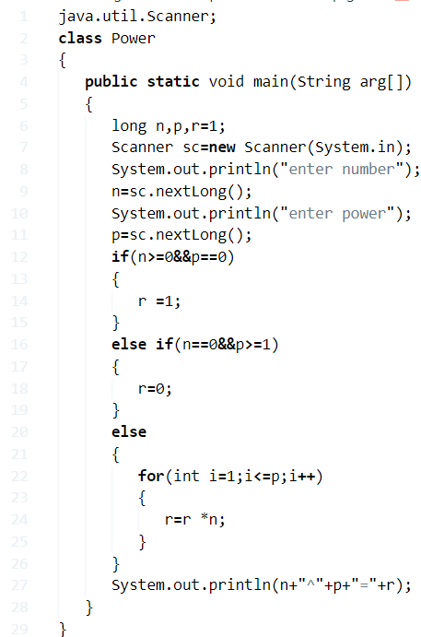

**Output:**

|  |  |
| --- | --- |
| 1  2  3  4  5  6  7  8  9  10  11  12  13 | 1.    enter number    6    enter power    6    6^6=46656    2.    enter number    8    enter power    9    8^9=134217728 |

#### Method – 3 Using Command Line Arguments

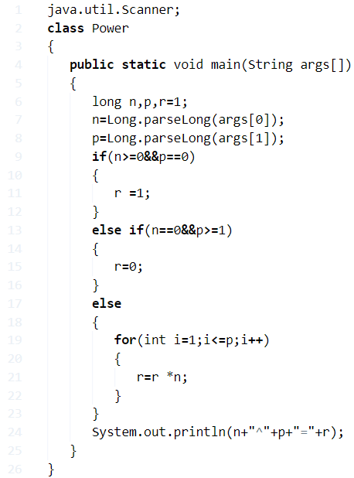

**Output:**

|  |  |
| --- | --- |
| 1  2  3  4  5  6  7  8  9  10  11  12  13  14  15  16  17  18  19 | javac Power.java  java Power 4 5  4^5=1024    javac Power.java  java Power 0 0  0^0=1    javac Power.java  java Power 0 1  0^1=0    javac Power.java  java Power 100 20  100^20=-5047021154770878464    javac Power.java  java Power 100 3  100^3=1000000 |

##### **Method – 4 Using Function**

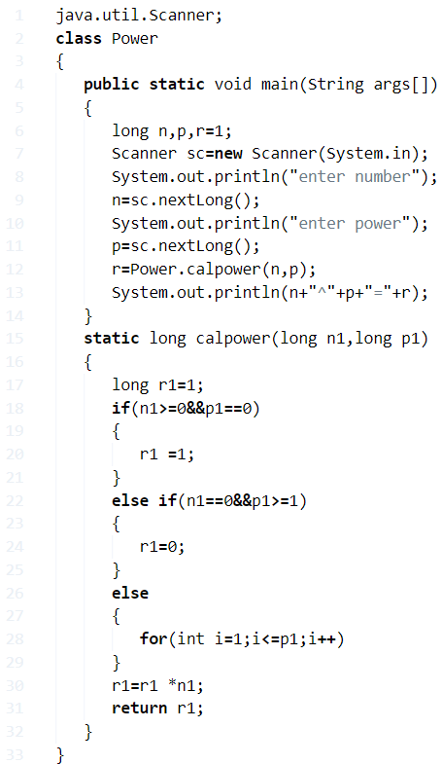

**Output:**

|  |  |
| --- | --- |
| 1  2  3  4  5 | enter number  51  enter power  6  51^6=17596287801 |

###### Method – 5 Using Class

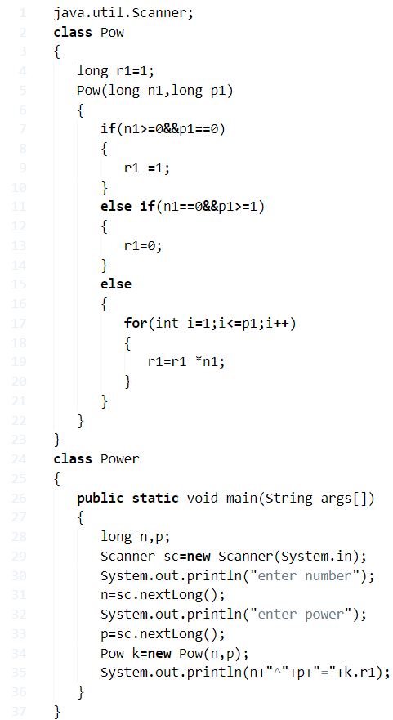

**Output:**

|  |  |
| --- | --- |
| 1  2  3  4  5 | enter number  6  enter power  5  6^5=7776 |

###### Method – 6 Using Recursion

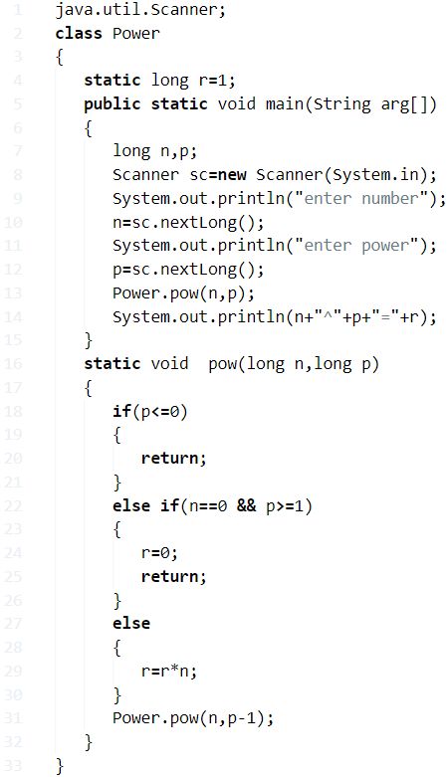

**Output:**

|  |  |
| --- | --- |
| 1  2  3  4  5 | enter number  5  enter power  5  5^5=3125 |

**Linear Search In Java Program**

## Method – 1Using ****Standard****

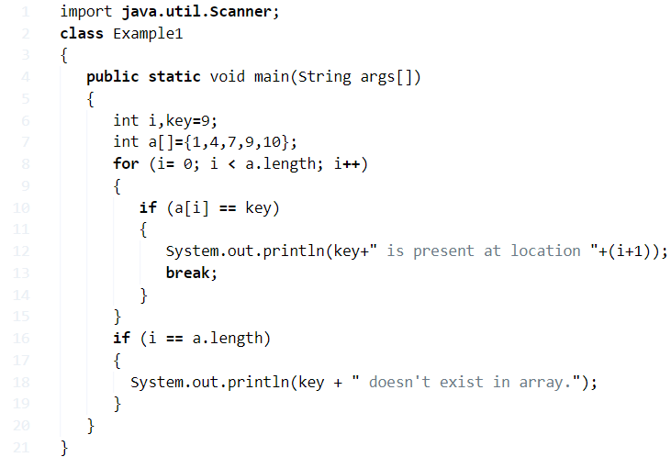

**Output:**

|  |  |
| --- | --- |
| 1 | 9 is present at location 4 |

### Using Array

**1)** We are [searching the key in the array](https://javatutoring.com/c-program-search-element-array/).

**2)** Read the [array length and store the value into](https://javatutoring.com/c-program-to-put-even-and-odd-elements-of-array-into-two-separate-arrays/) the variable len, read the elements using the Scanner class method and store the elements into the array array[].

**3)**Read the key value and search for that key in the array.

**4)** Run the [for loop](https://javatutoring.com/java-for-loop/)

* for i = 0 to  i < length of the array.
* compare array[i] with the key, If any one of the elements of an array is equal to the key then print the key and position of the key.

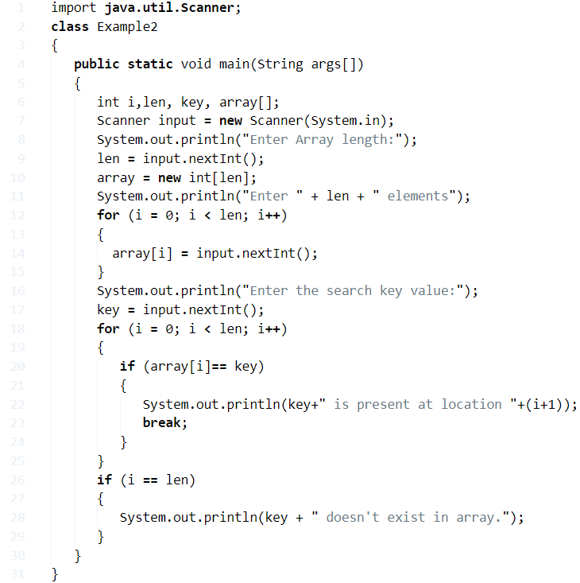

**Output1:**

|  |  |
| --- | --- |
| 1  2  3  4  5  6  7  8  9  10  11 | Enter Array length:  5  Enter 5 elements  8  3  56  4  8  Enter the search key value:  1  1 doesn't exist in array. |

**Output2:**

|  |  |
| --- | --- |
| 1  2  3  4  5  6  7  8  9 | Enter Array length:  3  Enter 3 elements  11  21  31  Enter the search key value:  11  11 is present at location 1 |

#### Using Recursion

**1)** Read the [array length len, store array elements](https://javatutoring.com/c-program-sort-array-elements-in-ascending-order/) in to the array array[] using Scanner class method.

**2)** Read the key value and call recursionSearch(array,0,len-1,key) of RecursionExample3 class.

**3)**RecursionSearch(int arr[], int start, int last, int x)

* returns -1 value if last<start.
* Compare the element at the index “start” of the array with the key, if both are equal, returns the index value.
* if key not equal to the that element call recursionSerach(arr,start+1,last,x) by increasing the start value.

**4)**  This method returns the index value. If index !=-1, then prints key is found at the location index+1 otherwise, prints “key not available”.

|  |  |
| --- | --- |
|  |  |

**Output:**

Output

|  |  |
| --- | --- |
| 1  2  3  4  5  6  7  8  9  10  11 | Enter Array length:  5  Enter 5 elements  2  4  6  8  9  Enter the search key value:  6  6 is found at location 3 |

**Sort Programs**

### 32) [Sort ArrayList in descending order?](https://www.javatpoint.com/how-to-sort-java-arraylist-in-descending-order)

To sort the ArrayList in descending order, we can use the reverseOrder method of Collections class.

Consider the following example.

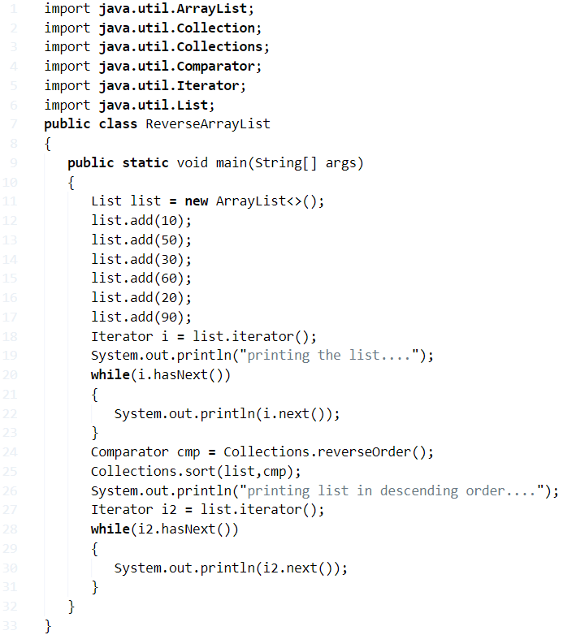

**Output**

printing the list....

10

50

30

60

20

90

printing list in descending order....

90

60

50

30

20

10

**Merge Sort Java – Program 2 Ways**

**Merge Sort**is a basic comparison based sorting algorithm which generally has Arrays as it’s data structure.

## merge sort javaUsing Array

**1)** Merge sort combines the two sorted arrays in sorted format.

**2)** Sort(int a[],int l,int h) if l<h then the array will be divided in to two partitions at the index m=(l+h)/2.

One array is from index l to m, the 2nd array is from m+1 to h.

**3)** Sort(a,l,m) calls the sort method and again divided in to partitions until there is no possibility to next partition, and each partition will be sorted, Sort(a,m+1,h) calls the sort() method recursively until no possibility for next partition and sorted the each partition.

**4)** Merge method merge the partitions of the array by comparing the elements of two arrays and place the elements in order.**is**

In given example, the array is 12,4,0,5,3. This array will be divided into two partitions.  12,4,0 and 5,3.

12,4,0 again divided into 12 ,4 and 0. 12,4 again divided into 12 and 4 merge method sort the two partitions 12,4 and merge both partitions as 4,12, again merge method sort the two partitions 12,4 and 0 and merge both partitions as 0,4,12.

Similarly, 5,3 divided into two partitions 5,3. Merge method sort the two partitions and merge both partitions as 3,5.

Now merge method sort the two partitions 0,4,12 and 3,5 and merge these two as 0,3,4,5,12.

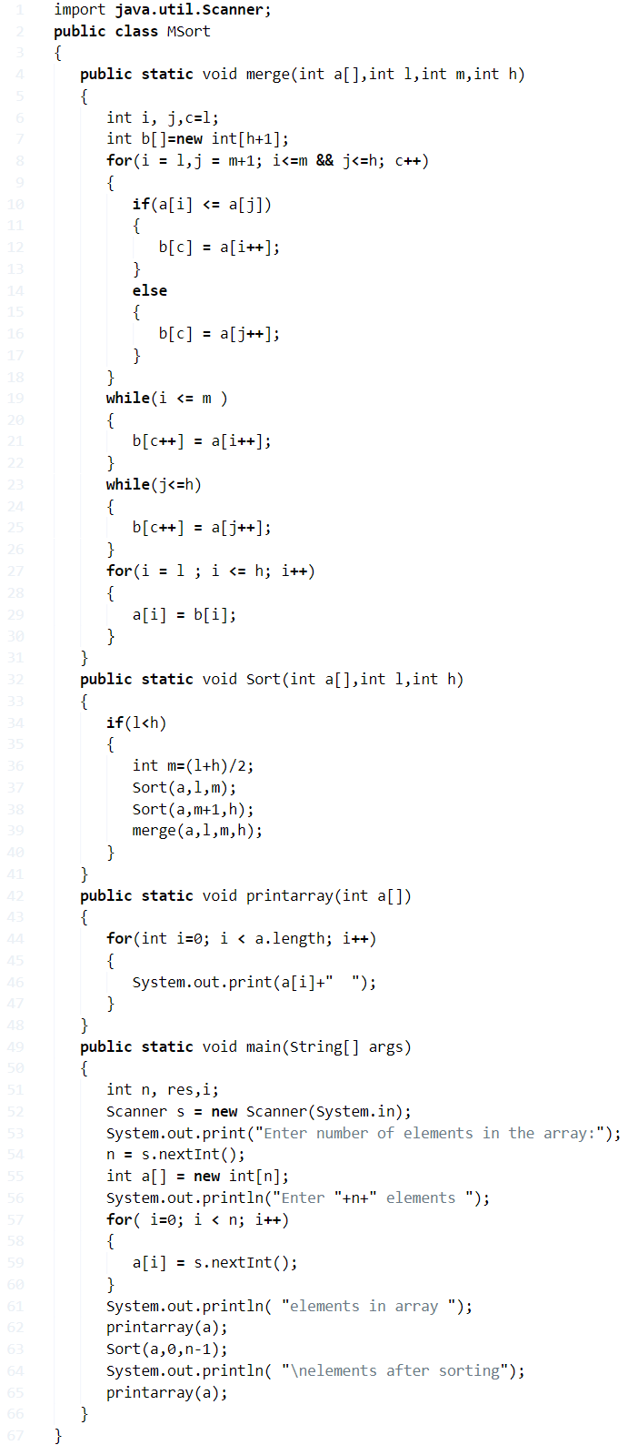

**Output:**

|  |  |
| --- | --- |
| 1  2  3  4  5  6  7  8  9  10  11 | Enter number of elements in the array:5  Enter 5 elements  12  4  0  5  3  elements in array  12  4  0  5  3  elements after sorting  0  3  4  5  12 |

### Using Buffered Reader

**1)** readLine() method of BufferedReader class reads the data line by line.

**2)** BufferedReader class reads the charter as String. If we do not mention the size of the BufferedReader then it uses the default size.

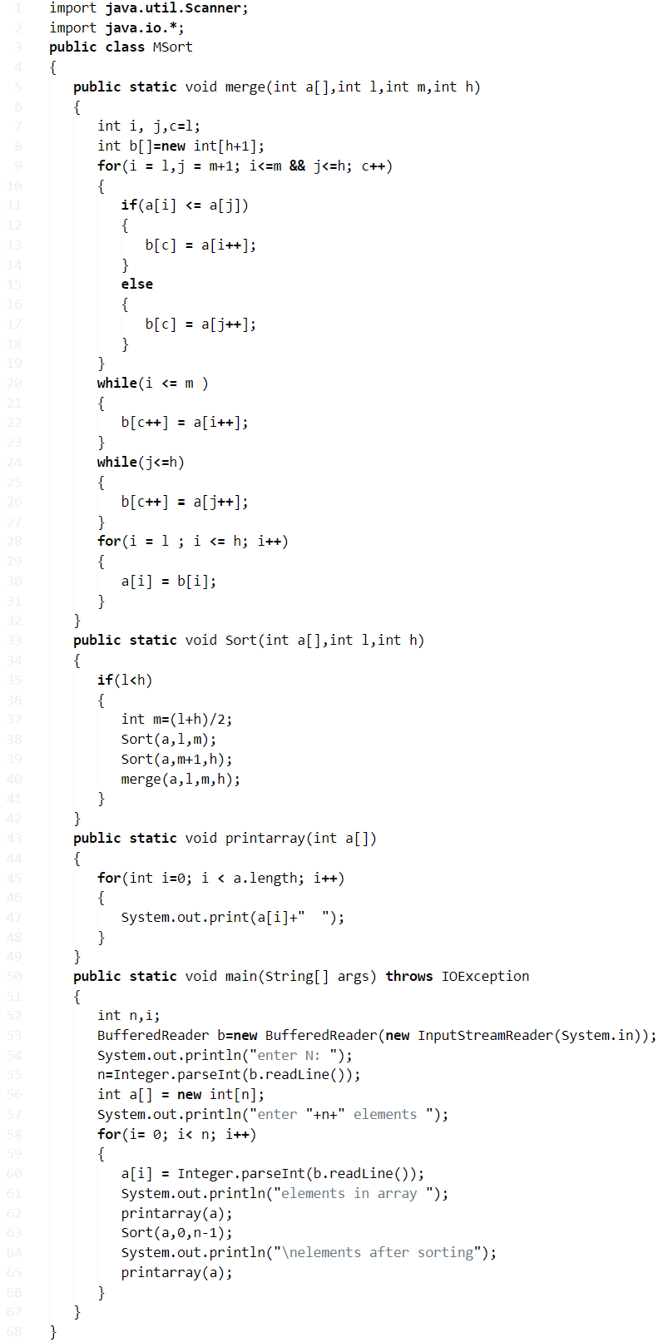

**Output:**

Output for merge sort

|  |  |
| --- | --- |
| 1  2  3  4  5  6  7  8  9  10  11 | Enter number of elements in the array:5  Enter 5 elements  12  4  0  5  3  elements in array  12  4  0  5  3  elements after sorting  0  3  4  5  12 |

**Selection Sort**

## Method – 1 Using Array

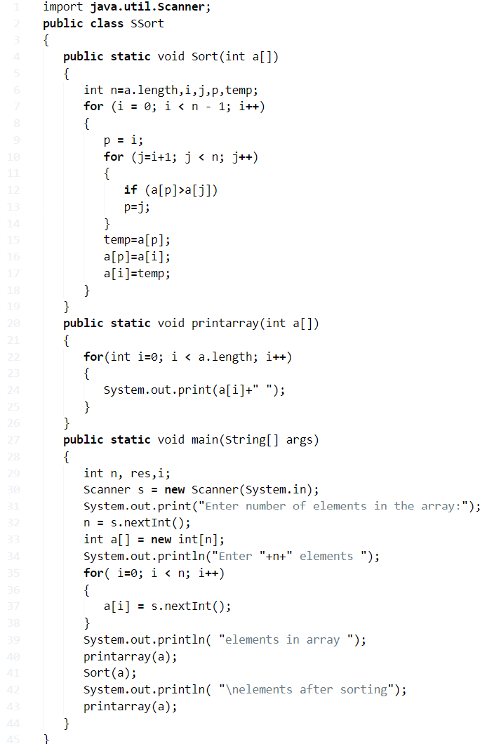

**Output:**

|  |  |
| --- | --- |
| 1  2  3  4  5  6  7  8  9  10  11  12 | Enter number of elements in the array:6  Enter 6 elements  9  0  1  23  99  5  elements in array  9  0  1  23  99  5  elements after sorting  0  1  5  9  23  99 |

**Explanation For Above Algorithm:**

**1)** The entered numbers will store in to the int array a[] using for loop with the structure for( i=0; i < n; i++).

**2)** Printarray(int a[]) will print the numbers, from the index i=0 to i<length of the array.

**3)** Sort(int a[]) will sort the numbers in ascending order. The inner loop will find the next least number to the previous number and the outer loop will place the least number in proper position in the array.

Given numbers are 9, 0, 1, 23, 99, 5.

**a)** The inner loop will compare the first two numbers 9,0 , the least number is 0, then the loop compares 0 with 1, 23, 99, 5. There is no least number available than 0. So outer loop swap the 9,0 numbers. Then the series is 0, 9, 1, 23, 99, 5.

**b)** Now the inner loop compares the 9,1, the number 1 is the least than 9, then compare 1 with 23, 99, 5. Compare with the next elements, 1 is the least number. Outer loop swap the numbers 9,1. Now the series is 0, 1, 9, 23, 99, 5.

**c)** Compare 9,23, then the least number is 9, find the least number than 9. In this series 5 is least compare with 9, so the outer loop swap the numbers 9,5. The series is 0, 1, 5, 23, 99, 9.

**d)** Compare 23,99, the least number is 23, find the least number than 23, 9 is the least number in the remaining series, Outer loop swap the numbers 23,9.Now the series is 0,1,5,9,99,23.

**e)** Compare 99 with 23, 23 is the least number, swap the numbers 23,99.

After selection sort, the number series is 0, 1, 5, 9, 23, 99.

### Using Buffered Reader

**1)** Buffered Reader class reads the text from character input stream. In this program, “InputStreamReader” is the character input stream reader, which converts bytes into characters “System.in” reads the bytes from the keyboard.

**2)** b.readLine() reads the text as string, convert the string into an integer using Integer.parseInt() method. Integer is wrapper class, it converts the string into an integer.

**3)** Sort() method will find the next least element to the previous element and place the least element in the proper position in the array.

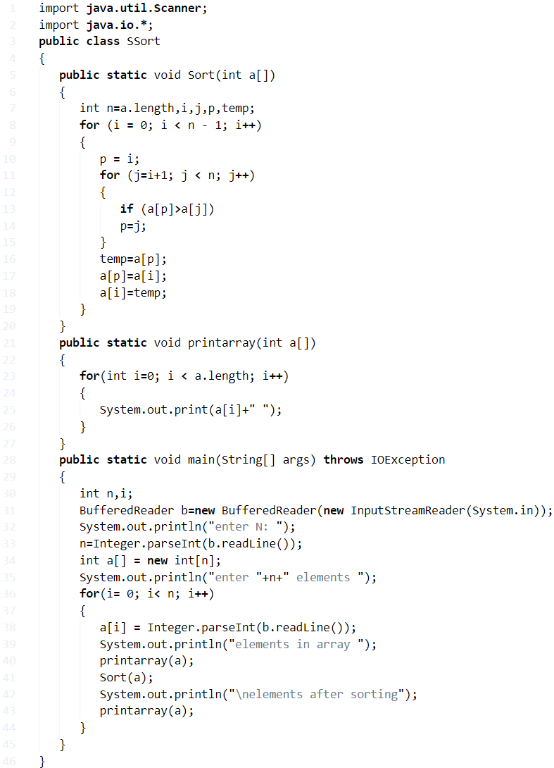

**Output:**

Selection Sort Java Output

|  |  |
| --- | --- |
| 1  2  3  4  5  6  7  8  9  10 | enter N:  3  enter 3 elements  59  0  1  elements in array  59  0  1  elements after sorting  0  1  59 |

**Implement Bubble Sort Java – Algorithm**

## Bubble Sort Java Algorithm – Using Array

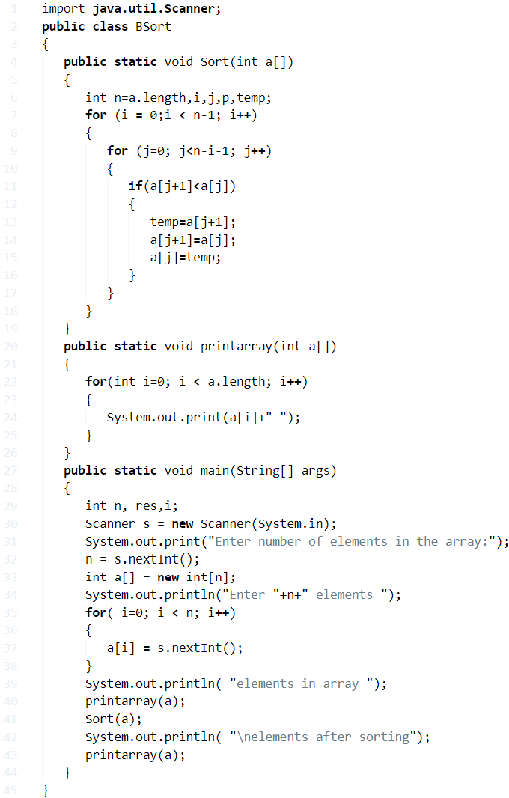

**Output:**

|  |  |
| --- | --- |
| 1  2  3  4  5  6  7  8  9  10  11 | Enter number of elements in the array:5  Enter 5 elements  5  4  3  2  1  elements in array  5  4  3  2  1  elements after sorting  1  2  3  4  5 |

### Explanation For Above Program:

**1)** For bubble sort, we are using array concept.

**2)**Printarray() method prints the array elements, sort() method will sort the array elements using bubble sort logic.

**3)** For each iteration of i, the inner loop compare the adjacent numbers and moves the large number towards the right and the large number will be placed in the proper position.

**4)** The given series is 5, 4, 3, 2, 1.

For the first iteration of i

**a)** The inner loop will compare 5,4. 5 is the large number compared with 4, so 5 shifted to the right. Now the series is 4, 5, 3, 2, 1.

**b)** Compare 5 with 3 and shift 5 to right. The series is 4, 3, 5, 2, 1.

**c)** Compare 5 with 2 and shift 5 to right. The series is 4, 3, 2, 5, 1.

**d)** Compare 5 with 1 and shift 5 to right. The series is 4, 3, 2, 1, 5.

After 1st iteration, 5 will be shifted to the last index. Now the series is 4, 3, 2, 1, 5.

For the 2nd iteration of i

**a)** The inner loop compares 4,3 and shift 4 to right. The series is 3, 4, 2, 1, 5.

**b)** Compare 4,2 and shift 4 to right, series is 3, 2, 4, 1, 5.

**c)** Compare 4,1 and shift 4 to right, series is 3, 2, 1, 4, 5.

For the 3rd iteration of i

**a)**The inner loop will compare 3,2 and shift the number 3 to right, series is 2, 3, 1, 4, 5.

**b) C**ompare 3 with 1 ,shift 3 to right, series is 2, 1, 3, 4, 5.

For 4th iteration

**a) I**nner loop compares 2,1 and shifts 2 to right, the series is 1, 2, 3, 4, 5.

After all iterations, the sorted array is 1, 2, 3, 4, 5.

### Bubble Sort Java – Using Buffered Reader

**1)** Buffered Reader reads the entered number as a string using readLine() method. Convert each element in to integer using Integer.parseInt().

**2)** printarray() prints the array elements, sort() method will sort the array elements using bubble sort logic.

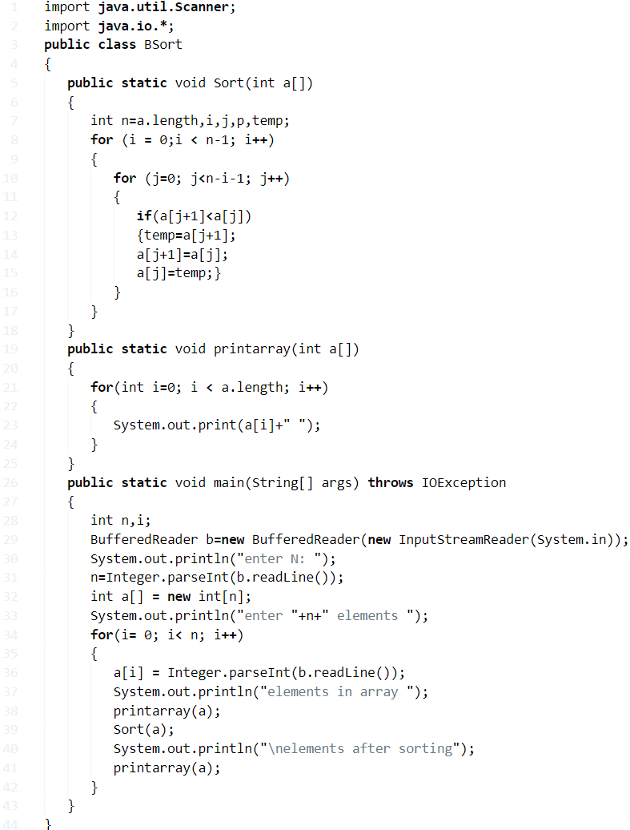

**Output:**

Output

|  |  |
| --- | --- |
| 1  2  3  4  5  6  7  8  9  10  11  12 | enter N:  5  enter 5 elements  5  6  1  7  5  elements in array  5  6  1  7  5  elements after sorting  1  5  5  6  7 |

**QuickSort Java – Algorithm**

## Using Array

**1)** In quick sort, divide the array into partitions and sort each partition, then we will get the sorted array. So quick sort is also called as divide and conquer algorithm.

**2)**In this program sort() method calls itself recursively then partition() method partitions the array, repeats until there is no possibility to partition the array. Partition method partitions the array and sorts them.

**3)**Partition method returns the m value. m indicates where the array will be divided into partitions. Array divided in to two partitions as (a,l,m-1), (a,m+1,h)

**4)**From the given example the array elements are 12, 0, -2, 54, -1, -10.

partition method returns m=4 and the array is  sorted as-1,0,-2,-10,12,54.

**5)** Now the array from index 0 to 3 will be sorted by sort(a,0,3) method, the rest of the elements in the array from index 4 to 5 will not be sorted. The array from index 0 to 3 is sorted and divided into a partition, now the partition from 0 to 2 elements are sorted and divided into a partition, partition from 0,1 elements are sorted, and there is no possibility to next partition. now the array from index 0 to 3 is sorted array. The array after sort(a,l,m-1) is -10,-2,-1,0,12,54.

Sort(a,m+1,h) will sort the remaining unsorted array and partition method will partition the unsorted part of the array. After two sort methods the sorted array is -10,-2,-1,0,12,15.

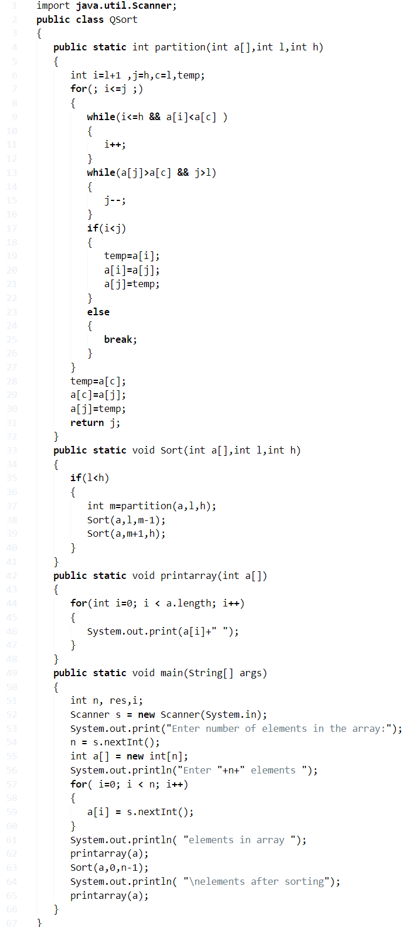

**Output:**

|  |  |
| --- | --- |
| 1  2  3  4  5  6  7  8  9  10  11  12 | Enter number of elements in the array:6  Enter 6 elements  12  0  -2  54  -1  -10  elements in array  12  0  -2  54  -1  -10  elements after sorting  -10  -2  -1  0  12  54 |

### Using Buffered Reader

**1)** InputStreamReader reads the byte as character and BufferedReader reads the character as a string. BufferedReader class is available at java.io package.

**2)** Convert the string data into integer data using the wrapper class Integer, and the method is parseInt() of the Integer class.

**3)** In this program to sort the array elements, we are using the quick sort technique.

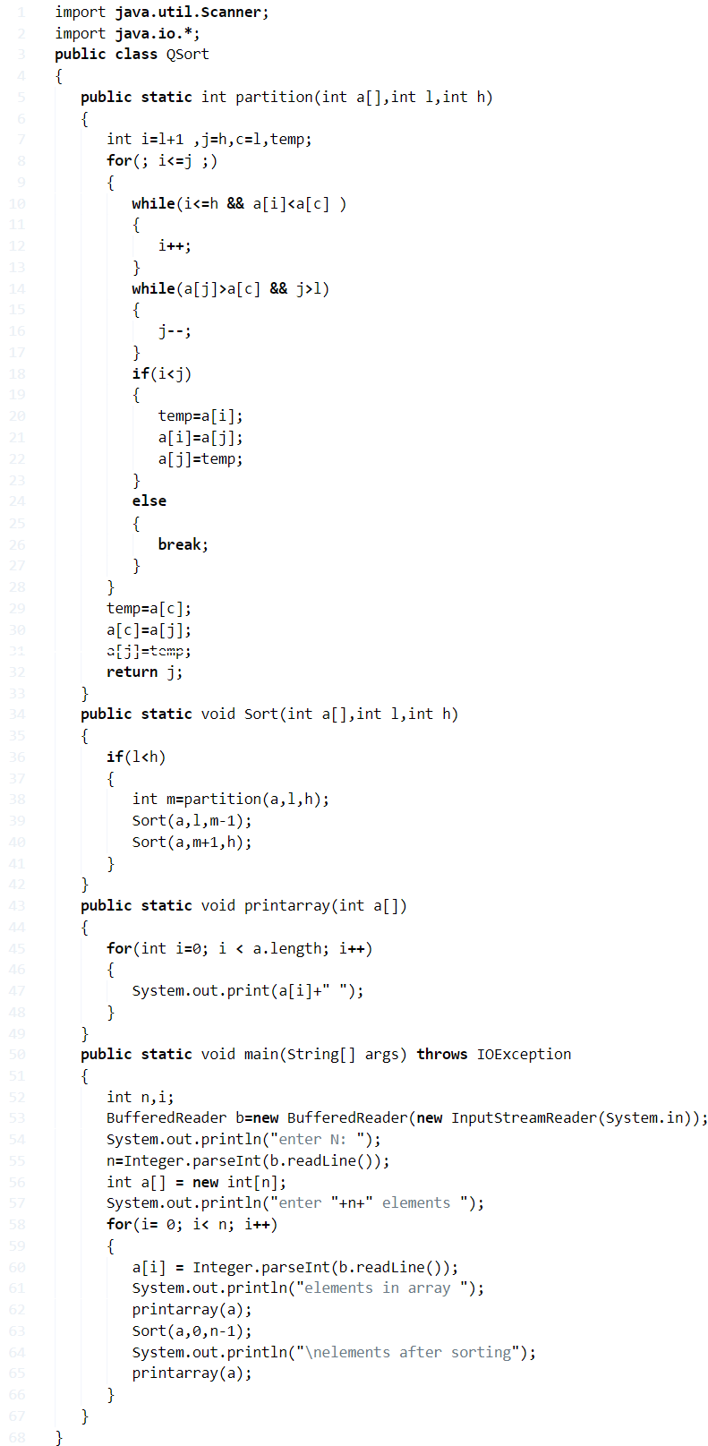

**Output:**

Output

Java

|  |  |
| --- | --- |
| 1  2  3  4  5  6  7  8  9  10  11  12 | Enter number of elements in the array:6  Enter 6 elements  12  20  -2  54  1  -10  elements in array  12  20  -2  54   1  -10  elements after sorting  -10  -2   1  12   20  54 |

**Program – 1 Java Program to Calculate Area of Circle**

**Method - 1**

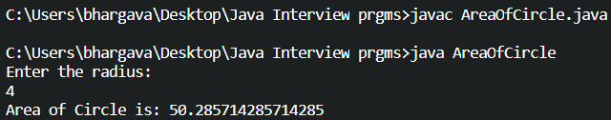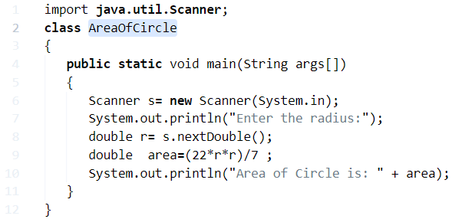

* **As we know that formula in math is :**
* But, if you were written like that, then the system won’t understand, until and unless you assign the value of “PIE” is 22/7.  Asusual, you always represent the values in binary numbers.
* The system can’t able to understand whether the given number is a number, or given letter is a letter. All it understood as” **Character**” or just a “**Symbol** “. Here goes the complete step by step explanation of the above code and how it works.

**Step 1:** import java.util.Scanner;

Here ‘import’ is a keyword in java used to get features from inbuilt packages. Here we using a package called until it consist of many classes and using one of the classes Scanner to get command over console which is the interface between user and program.

**Step 2:** public static void main(String args[])

The main function, where the execution of program **start**from here onwards

**Step 3:** Scanner s= new Scanner(System.in);

* The scanner is a class used to scan the input data which was given by the user through a console.
* so to get access on a console we want to create an object  Syntax:new Scanner(); after creating an object that reference will store in variable ‘s’

**Step 4:** System.out.println("Enter the radius:");

Above code is giving instructions for the user to give the input for radius

**Step 5:** double r= s.nextDouble();

* Here above instruction is get input in the required format.  first we want to know about  nextDouble() method it takes a token(collection of symbols divide by [**white space**](https://javatutoring.com/c-program-trim-leading-white-space-characters-from-string/)

Example:”ABC”,  “DEF” , “GHI”,”10″,”20″

* which is given by  user.when user give 10 as input actually in user perspective  it is number but any number or string  which entered on  console by default  those are  strings,  1o as  string but we want 10 as  number format  for that we have method to convert string to number(Int, Double, Float, Long…) some of those method are:

1.nextDouble() ,

2 nextFloat(),

3.nextInt(),

4.nextLong()

5.nextShort()

6.next() or nextString()

**Step – 6:** double area = (22*r*r)/7 ;

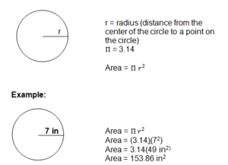

**Step – 7:** System.out.println(“Area of Circle is: ” + area);

Once, you entered the radius, the value stored in a particular function (nextDouble();) and read those values with the help of a scanner and display the output for a given value. The major difference is where double can represent the output even after the decimal point , whereas in ” Int ” only the numbers before decimal point will take into consideration.

**Method – 2, with online compile using command line arguments method:**

**Here is the sample line for an integer:**

let arg[0]=”10″;

**int r=Integer.parseInt(args[0]);//r=10;**

* The purpose of using the “double” is, whenever you enter the radius of a particular number like “7”, the answer is 153.86; numbers after decimal points will also be displayed on the screen. Whereas if you use the “int” , the digits   after the decimal point will be loss.
* If you have any doubts related to this program, do comment here. We are glad to help you out.

### ****Method – 3, Using Interface****

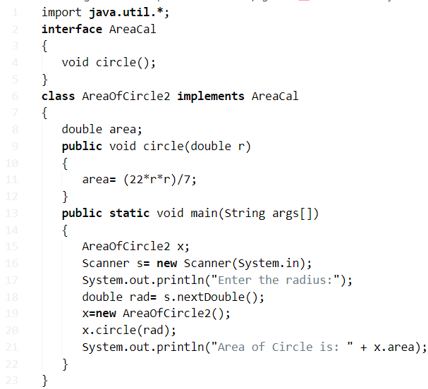

### ****Method – 4, Using Inheritance****

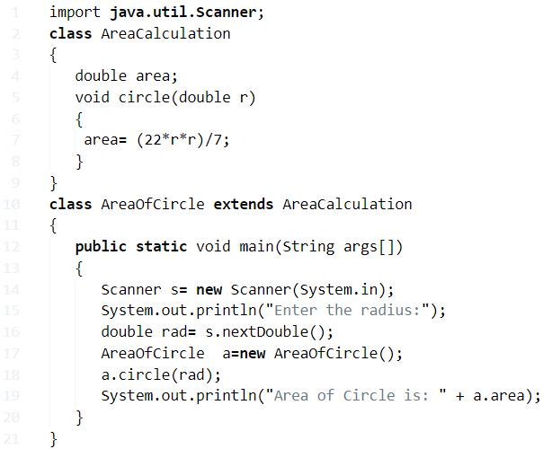

**Method – 5, Using Constructor**

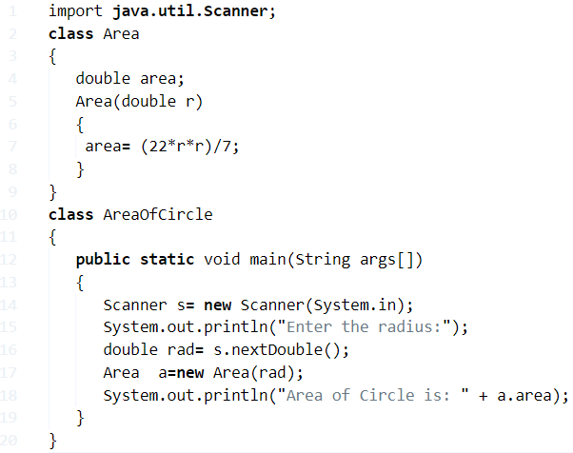

**Method – 6, Using Method**

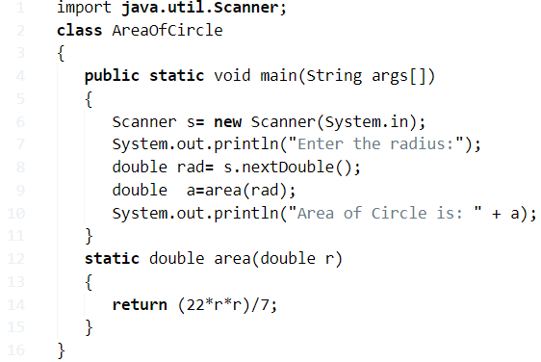

**Program – 2 Java Program To Find Area of Triangle**

**Method – 1**

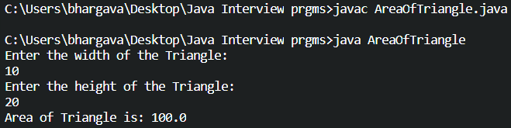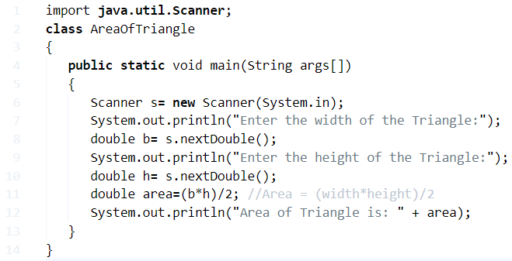

### ****Method – 2 using constructor****

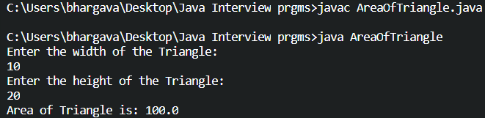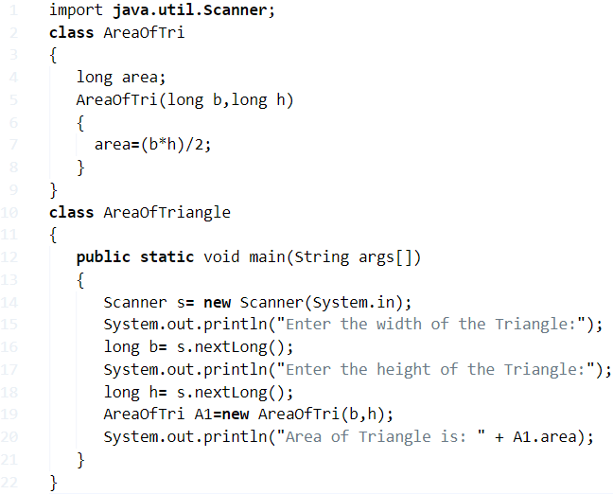

**Method – 3 Using User-Defined Method**

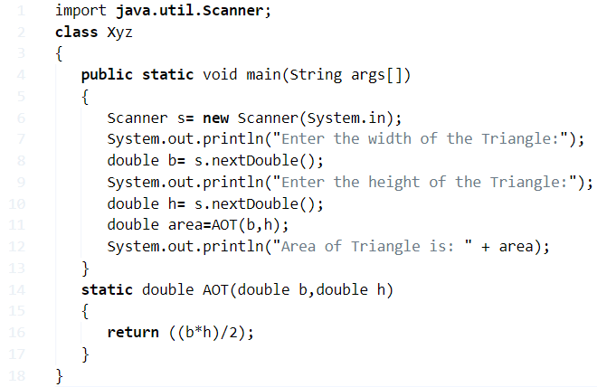

#### ****Method – 4 when three sides are given****

* Basically, In order to calculate the area, you need to find out the Height of the triangle. If you don’t know the height or you may have no idea how to find out the height of the triangle, then you can use the below program to calculate the area of a triangle. When three sides are given we have used the following formula: only when three sides are given. **s(s-a)(s-b)(s-c)**
* Where the value of S is {( a+b+c)/2} and the loop method as ” if((a+b)>c && (a+c)>b && (b+c)>a) ”

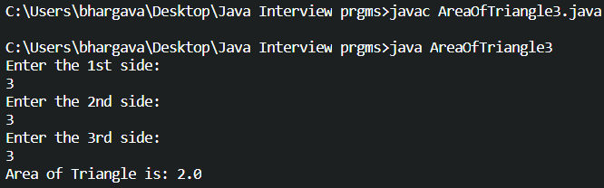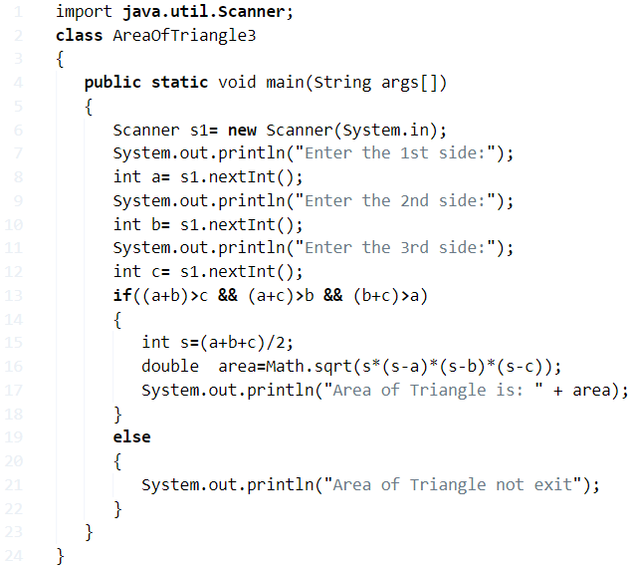

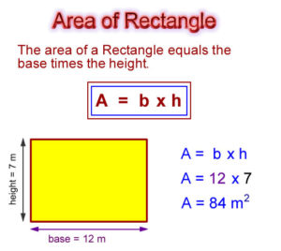

**Program – 3 Java Program To Find Area of Rectangle**

**What is a rectangle?** A rectangle is a plane figure with four straight sides or just four right angles.

**Formula:**Length * Breadth. Or Length * Width

Here goes the sample program to find or to calculate the area of a rectangle.

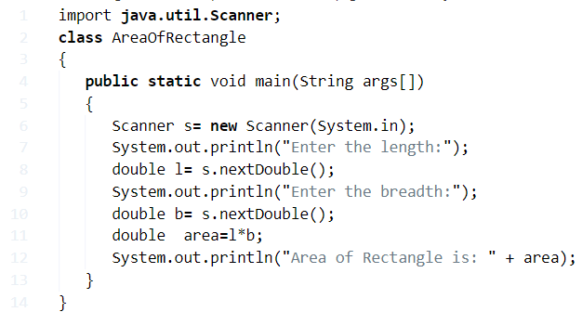

**Output:**

Enter the length

5

Enter the breadth

2

Area of rectangle is:10.0

**Here is the online execution tool!**

* The above program is just a simple one. Since there may be several ways to represent the program. If you good at basic skills of java programming, just skip the below code explanation part and move on to the sample method-2. Where you can execute the program there by itself. Consider it has another sample method-2.
* We always make sure to write the java program in a simple way to the users and newbies can able to understand the program better. Lengthy codes are way better too, but those extra couple of code lines are actually not necessary.

Here is another simple method to find out the area of a rectangle, the below program is quite simple.

**Method – 2**

**Output:**

The value of length: 5

The value of breadth: 2

Area of triangle is: 10.0

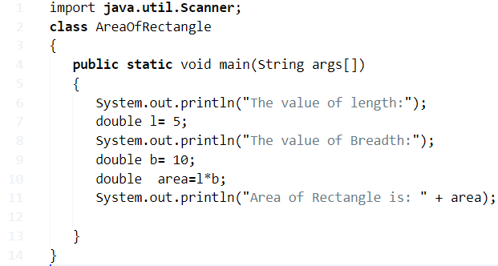

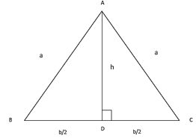**Program – 4 Java Program To Find Area of isosceles triangle**

**Def:** An isosceles triangle is a triangle where any two sides of a triangle should be equal both in terms of length and angles. Below is the sample figure.

**Formula:** Since the area of a normal triangle and isosceles have the same formula. And, the same program is applicable when it comes to the coding part in java. Here goes the formula, make sure to note down the base and height values. The base is opposite to the two-sided lengths or angles which are in equal. **[ B/4√((4*a*a)-(b*b)) ]**

**You can write the code in different formats, one of the format here as follows,**

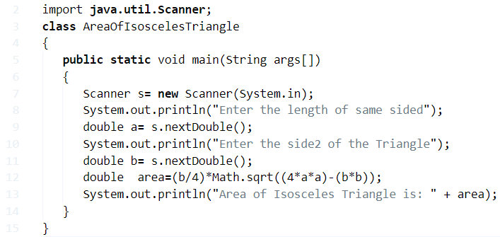

**Output:**

Enter the length of same sided

5

Enter the side2 of the triangle

8

Area of isosceles triangle is: 12.0

**Program – 5 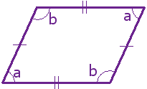Java Program To Find Area of Parallelogram**

**What is a parallelogram?**

A parallelogram is a 4 shaped four-sided flat shaped with opposite sides are parallel and equal in length and opposite angles are same as well. Check it out the below figure, you will get an idea.

**Examples:** **Rhombus, rectangle, square are all parallelograms.**

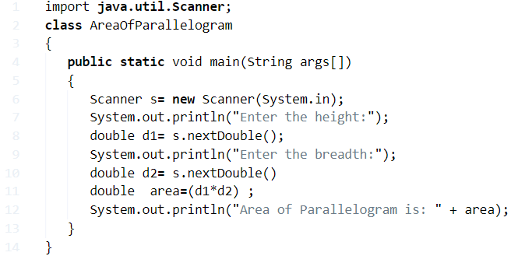

**Output:**

Enter the height:

5

Enter the breadth:

5

Area of parallelogram is:25.0

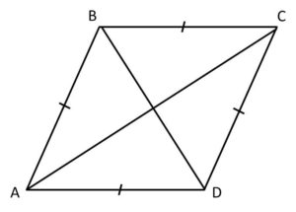**Program – 6 Program To Calculate Area Of Rhombus**

**Def:** A rhombus is a flat shaped, which have equal in length of all sides and opposite sides are equal and the angles too.

**Formula:** Diagonal(D1)*Diagonal(D2)/2

**Method -1**

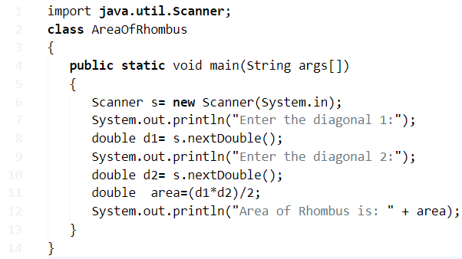

**Output:**

Enter the diagonal 1:

15

Enter the diagonal 2:

18

Area of rhombus is :

135.0

**Method – 2**

As we are directly dumping the variables into the program, such that there is no need to give the input variables on the cmd screen

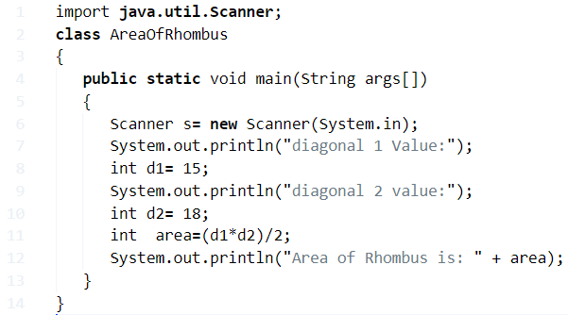

**Program – 7 Java Program To Find Area Of Equilateral Triangle**

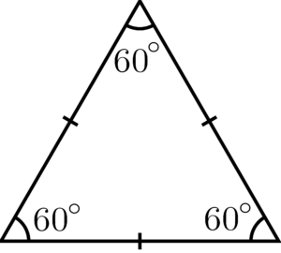**What is an equilateral triangle?**

In geometry, an equilateral triangle is a triangle in which all three sides are equal. In the familiar Euclidean geometry, equilateral triangles are also equiangular; that is, all three internal angles are also congruent to each other and are each 60°.

**Formula:** √3/4 x S to the power of 2 (or) Sˆ2, where S is the side of a triangle.

**Method - 1:**

**Output :**

Enter the side of the Triangle:

5

Area of Triangle is:10.82

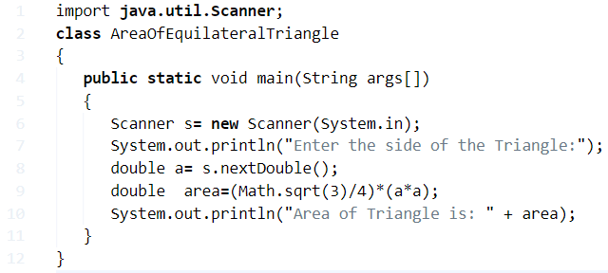

**Method – 2 Online compiler and execution tool**

Here, the code is slightly modified, just taking input in other form using command line arguments. input will send to the main function to store that values we created a string array in the main function(String args[]).

Ex:  step for execution on cmd:

javac MyClass.java     —————-> compiling

java MyClass  10 20 30 ————–> executing and sending arguments to the main function.

args={“10″,”20″,”30”}:

arg[0]=>”10″

arg[1]=>”20″

arg[2]=>”30″

all values are in string form we want in number form to get that we have a method called parseXXX(); it takes input as string convert into a number.

this concept was used in below program look at once analyse it.

Enter your own values, to know the area of an equilateral triangle. You can also use the int.

**Program – 8 Java Program to Calculate Perimeter Of Circle**

* 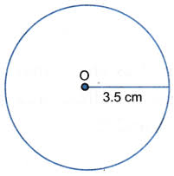As it is clearly known, a circle is the [collection of infinite points which form a locus equidistant from](https://javatutoring.com/remove-an-element-from-collection-using-iterator-object/) a single point. The locus is known as the [circumference of the circle.](https://javatutoring.com/c-program-circumference-of-circle/)
* The single point within the circle is known as the centre of the circle. The [distance between](https://javatutoring.com/distance-between-two-points-java-program/) the centre of the [circle](https://javatutoring.com/calculate-area-of-circle-java-program/) and the [circumference](https://javatutoring.com/c-program-circumference-of-circle/) is regarded as the radius of the circle.
* As you can see, this is a circle with a radius of 3.5cm. Also, the line which passes through the centre of a circle and connects the circumference on both sides of the circle is said to be the diameter of the circle.
* The ratio between to the [Circumference of a circle](https://javatutoring.com/c-program-circumference-of-circle/) and the Diameter is always equal to Pi (22/7).
* Hence, the Circumference of the above circle is as follows:
* Circumference = Pi * D = 2 * r * Pi

= 2 * 3.5 * Pi

= 22cm.

Thus, the multitude of means to calculate the circumference of a circle in Java programming is as follows:

## Method – 1 Using Scanner Class

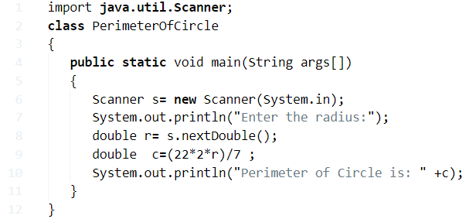

**Output:**

|  |  |
| --- | --- |
| 1  2 | Enter the radius:7  Perimeter of Circle is: 44.0 |

### Method – 2 Using Command Line Arguments

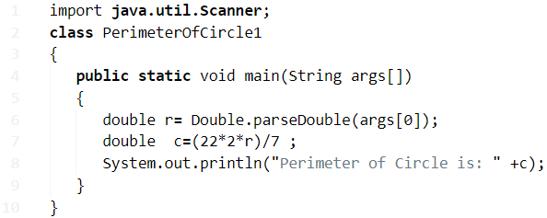

**Output:**

|  |  |
| --- | --- |
| 1  2  3 | javac PerimeterOfCircle1.java  java PerimeterOfCircle1 7  Perimeter of Circle is: 44.0 |

#### Method – 3 Using Static Function

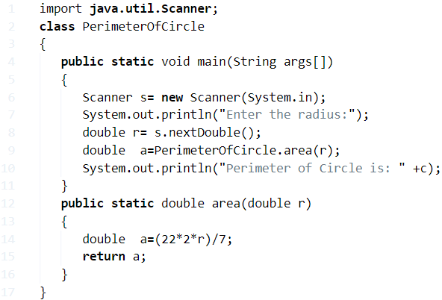

Output

|  |  |
| --- | --- |
| 1  2 | Enter the radius:7  Perimeter of Circle is: 44.0 |

**Program – 9 Java Program Perimeter Of Equilateral Triangle**

* 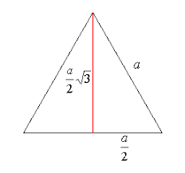An equilateral triangle, as we all know, is a triangle with its entire sides equal. Owing to the angle-side relationship, all the angles of an equilateral triangle are equal to 60 degrees.
* As you can see, this is an equilateral triangle with a side length of “a” units.
* **Perimeter of an equilateral triangle = a + a + a = 3a**
* The altitude of an equilateral triangle bisects the opposite side in equal halves.
* Thus, by applying Pythagoras Theorem, we can calculate the height to be [(sqrt3)/2]*a
* So, the area of the triangle is:

Area = 1/2 * [(sqrt3)/2]*a * a = [(sqrt 3)/4]*a^2

Hence, the several ways to calculate the perimeter of an equilateral triangle in Java Programming are as follows:

## Method – 1 Using Scanner Class

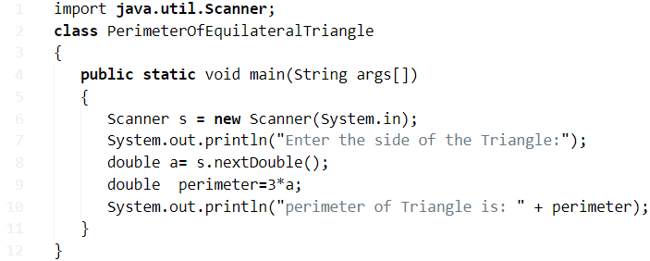

**Output:**

|  |  |
| --- | --- |
| 1  2 | Enter the side of the Triangle:6  perimeter of Triangle is: 18.0 |

### Method – 2 Using Command Line Arguments

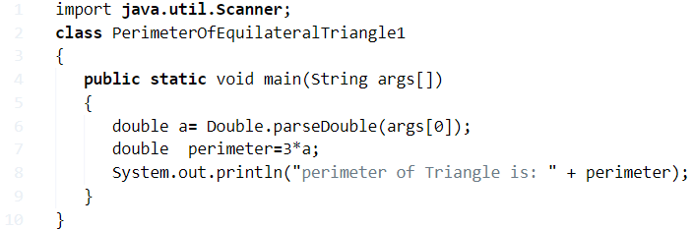

**Output:**

|  |  |
| --- | --- |
| 1  2  3 | javac PerimeterOfEquilateralTriangle1.java  java PerimeterOfEquilateralTriangle1 6  perimeter of Triangle is: 18.0 |

#### Method – 3 Using Static Function

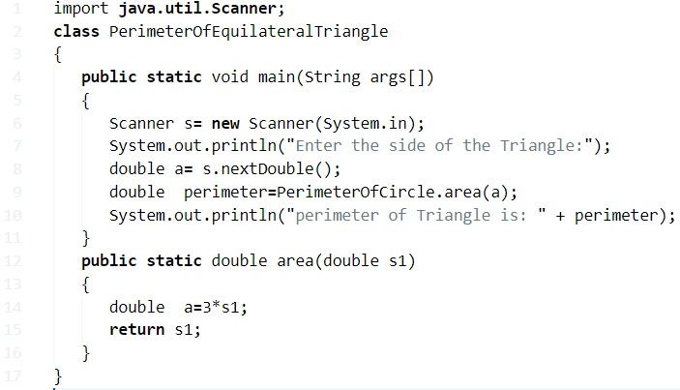

**Output:**

|  |  |
| --- | --- |
| 1  2 | Enter the side of the Triangle:6  perimeter of Triangle is: 18.0 |

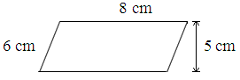**Program – 10 Java Program Calculate Perimeter Of Parallelogram**

* A parallelogram, as we all know, is a two-dimensional quadrilateral figure used in the world of geometry.
* A parallelogram, as the name itself suggests, has its opposite sides equal and parallel. The opposite angles are also equal in nature.
* A special case where all the angles subtended by a parallelogram are 90 degrees is regarded as a rectangle.
* As you can see, this is a Parallelogram with the longer side of 8cm and the shorter side of 6cm. Since the opposite sides of a parallelogram are equal, the perimeter can be calculated with this formula: P = 2(a + b)
* Hence, the perimeter of this parallelogram P = 2(8 + 6) = 28cm.
* Thus, the various methods to calculate the perimeter of a parallelogram in Java Programming is as follows:

## Method – 1 Using Scanner Class

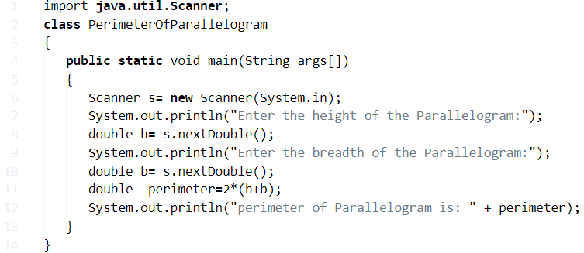

**Output:**

|  |  |
| --- | --- |
| 1  2  3 | Enter the height of the Parallelogram:3  Enter the breadth of the Parallelogram:4  perimeter of Parallelogram is: 14.0 |

### Method – 2 Using Command Line Arguments

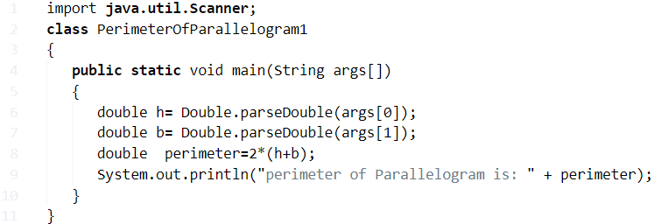

**Output:**

|  |  |
| --- | --- |
| 1  2  3 | javac PerimeterOfParallelogram1.java  java PerimeterOfParallelogram1 3 4  perimeter of Parallelogram is: 14.0 |

#### Method – 3 Using Static Function

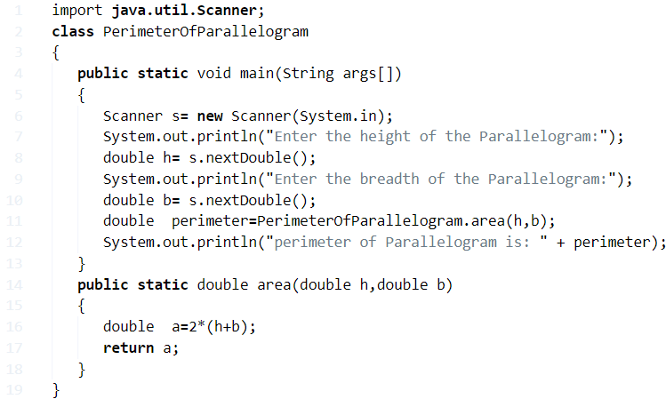

**Output:**

|  |  |
| --- | --- |
| 1  2  3 | Enter the height of the Parallelogram:3  Enter the breadth of the Parallelogram:4  perimeter of Parallelogram is: 14.0 |

**Program – 11 Java Program To Find Perimeter Of Rectangle**

* 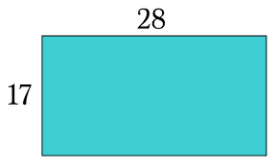As we all know, a rectangle is a two-dimensional quadrilateral figure in the field of geometry. The opposite sides of a rectangle are equal and parallel in nature.
* All of the angles in a rectangle are 90 degrees.
* As you can see, this is a rectangle with a length of 28 units and a breadth of 17 units.
* Thus, the perimeter of a rectangle **P = 2(l + b)**
* So, the perimeter of the given rectangle is as follows:

P = 2(28 + 17) = 90 units.

Hence, the methods used to calculate the perimeter of a rectangle in Java programming are as follows:

## Method – 1 Using Scanner Class

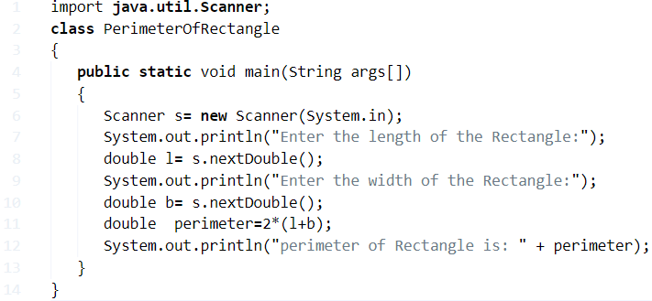

**Output:**

|  |  |
| --- | --- |
| 1  2  3 | Enter the length of the Rectangle:3  Enter the width of the Rectangle:4  perimeter of Rectangle is: 14.0 |

### Method – 2 Using Command Line Arguments

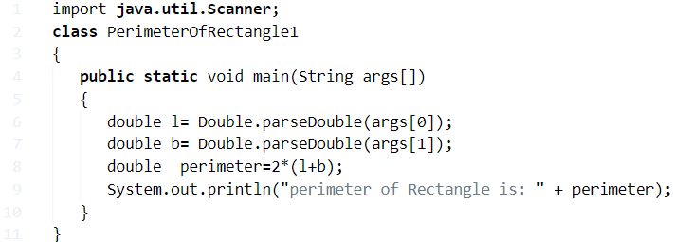

**Output:**

|  |  |
| --- | --- |
| 1  2  3 | javac PerimeterOfRectangle1.java  java PerimeterOfRectangle1 3 4  perimeter of Rectangle is: 14.0 |

#### Method – 3 Using Static Function

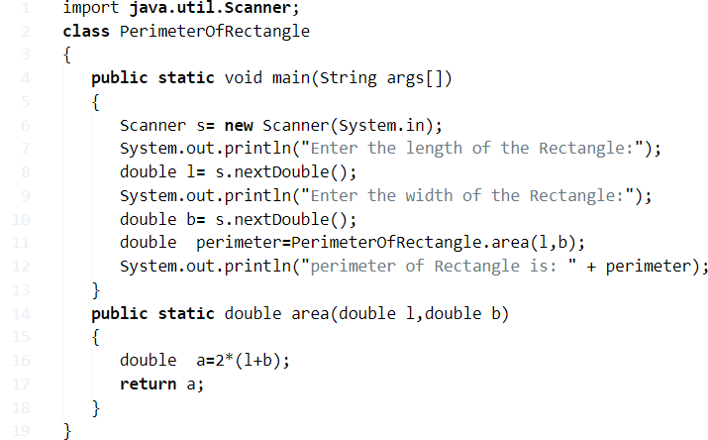

**Output:**

|  |  |
| --- | --- |
| 1  2  3 | Enter the length of the Rectangle:3  Enter the width of the Rectangle:4  perimeter of Rectangle is: 14.0 |

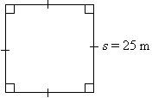**Program – 12 Java Program Calculate Perimeter Of Square**

* As we all know, a square is a two-dimensional quadrilateral figure. It is significantly used in our daily lives.
* The sides of a square are all equal in nature, along with the opposite sides being parallel to each other. The angles of a square are all equal to 90 degrees.
* As you can see, this is square of a side length of 25m. Thus, the perimeter of a square can be calculated as **P = a + a + a + a = 4a**
* So, the perimeter of this square is as follows:

P = 4a = 4 * 25 = 100m.

Thus, the multiple methods used to calculate the perimeter of a square in Java programming are as follows:

## Method – 1 Using Scanner Class

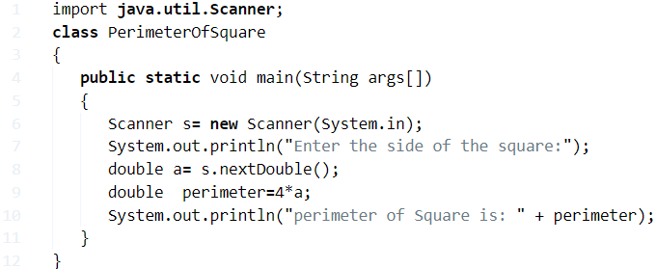

|  |  |
| --- | --- |
|  |  |

**Output:**

|  |  |
| --- | --- |
| 1  2 | Enter the side of the square:4  perimeter of Square is: 16.0 |

### Method – 2 Using Command Line Arguments

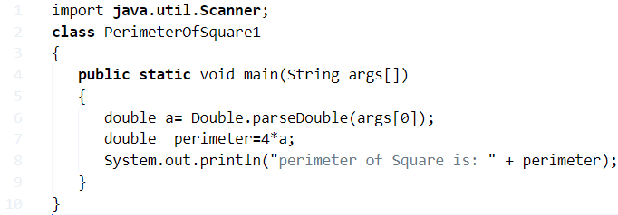

**Output:**

|  |  |
| --- | --- |
| 1  2  3 | javac PerimeterOfSquare1.java  java PerimeterOfSquare1 4  perimeter of Square is: 16.0 |

#### Method – 3 Using Static Function

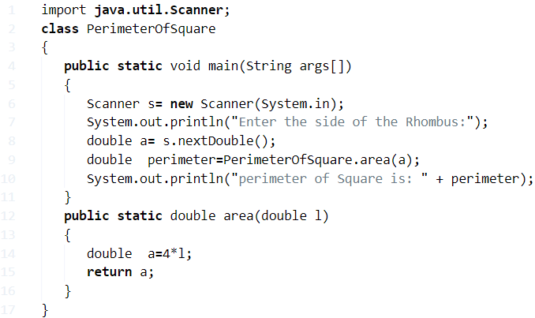

**Output:**

|  |  |
| --- | --- |
| 1  2 | Enter the side of the square:4  perimeter of Square is: 16.0 |

**Program – 13 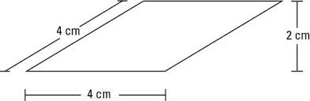Java Program To Calculate Perimeter Of Rhombus**

* As we all know, a rhombus is a two-dimensional quadrilateral figure. It is intensively used in the field of geometry.
* The sides of a rhombus are all equal in nature. The opposite sides of a rhombus are parallel to each other. The opposite angles of a rhombus are equal to each other.
* The rhombus is basically a parallelogram whose adjacent sides are equal to each other.
* As you can see, this is a rhombus with a side length of 4cm and a height of 2cm.
* So, the perimeter of a rhombus **P = a + a + a + a = 4a**
* Hence, the perimeter of this rhombus **P = 4a = 4*4 = 16cm.**
* Thus, the multiple methods used to calculate the perimeter of a rhombus in Java programming is

## Method – 1 Using Scanner Class

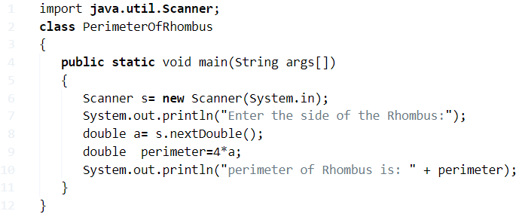

**Output:**

|  |  |
| --- | --- |
| 1  2 | Enter the side of the Rhombus:4  perimeter of Rhombus is: 16.0 |

### Method – 2 Using Command Line Arguments

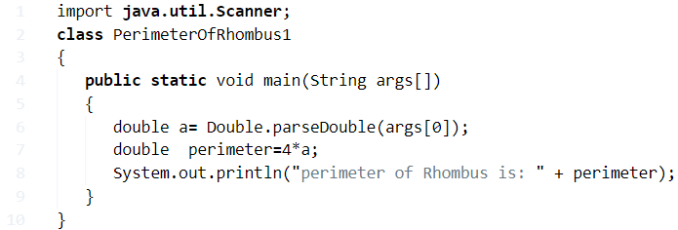

**Output:**

|  |  |
| --- | --- |
| 1  2  3 | javac PerimeterOfRhombus1.java  java PerimeterOfRhombus1 4  perimeter of Rhombus is: 16.0 |

#### Method – 3 Using Static Function

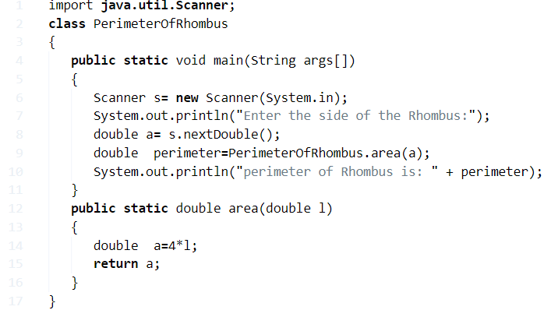

**Output:**

|  |  |
| --- | --- |
| 1  2 | Enter the side of the Rhombus:4  perimeter of Rhombus is: 16.0 |

**Program – 14 Java Program to calculate Volume of Cone**

**What is a cone?**

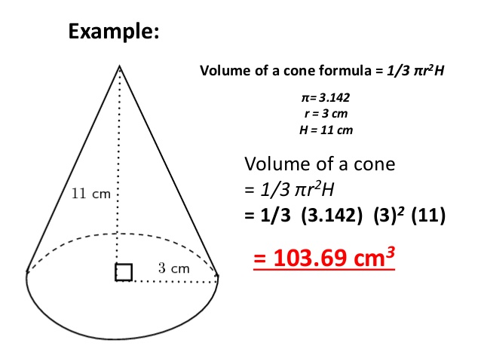A cone is a three-dimensional geometric shape that tapers smoothly from a flat base to a point called the apex or vertex.

**Formula:**

Volume: $π*r^{2}*\left(h/3\right)$

Surface area: $π*r^{2}$

No. of faces: 1

Shapes with similar faces: Cylinder

Base shape: Circle

**Method - 1: To determine the volume of a cone by using the formula**

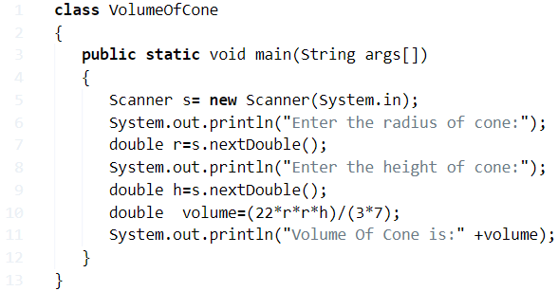

**Output:**

|  |  |
| --- | --- |
| 1  2  3  4  5 | Enter the radius of cone:  5  Enter the height of cone:  10  Volume Of Cone is: 261.80 |

**Method - 2 Using**[**command line arguments**](http://www.javaprogramshub.com/command-line-arguments-java-with-examples/)**with online execution tool**

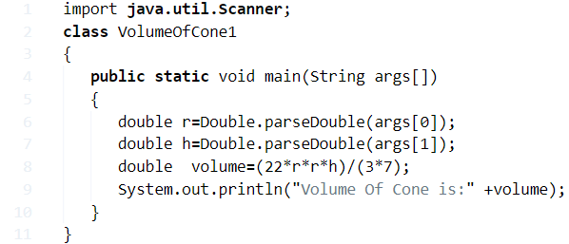

**Online Execution And Compile Tool for the above java program:**

* The difference between the standard java program and command line arguments are nothing but a small change in syntax. Where is in command line arguments using “[Parse](http://www.javaprogramshub.com/command-line-arguments-java-with-examples/)” are giving the input values before the program executes.
* Whereas in example 1, we are providing the data values according to the **program execution** method. If you need to know more information about the parse method;
* Here we share the [**complete guide about parse**](http://www.javaprogramshub.com/command-line-arguments-java-with-examples/)checks it out. Still, if you require knowing any more details about the **calculation of a volume of cone Java program**, then you can comment here at the end of the post we are glad to help you out.

**Method - 3:** **Using invoked return method** ( If you are a newbie to learn the java program then we kindly suggest you check out the above two examples only, for advanced users see the below program )

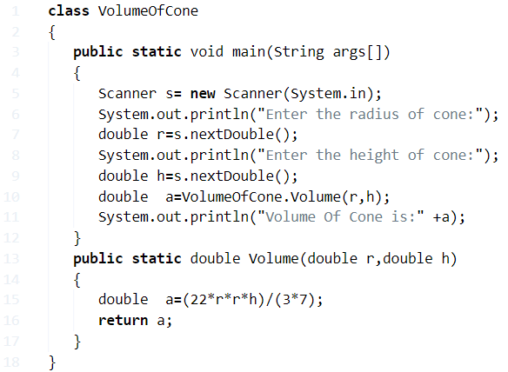

**Program – 15 Java Program To Calculate Volume Of Prism**

**What is a prism?**

**Geometry:** A solid geometric figure whose two ends are similar, equal, parallel rectilinear figures, and whose sides are parallelograms.

**Optics:** A glass or other transparent object in the form of a prism, especially one that is triangular with refracting surfaces at an acute angle with each other and that seperates white light into a spectrum of colours.

**Formula:** 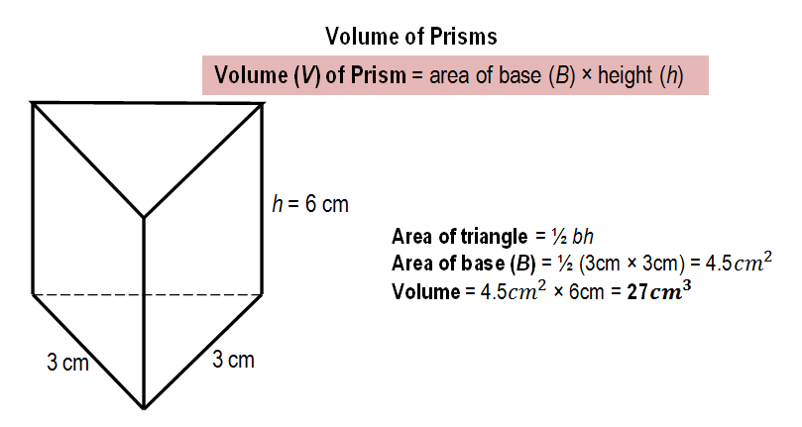The volume of a prism = Area of base * Height

**Note: Before calculating the volume of prism, you must calculate the Area of base**

Here is the **example program # 1** with online compiler and execution tool. Make sure to check out the rest of the examples in different formats to know how the code actually works. If you were at starting level to learn the java then do subscribe to our blog. Our dedicated team will share the best of the information related to coding from **a basic level to core level.**

**Method - 1**

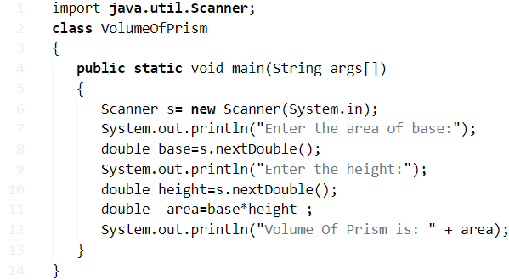

**Output :**

|  |  |
| --- | --- |
| 1  2  3  4  5 | Enter the area of base:  4.5  Enter the height:  6  Volume Of Prism is: 27.0 |

**Here is the online execution & Compiler tool for the above example program -1**

You may get an idea. How the above code works in order to calculate the volume of a prism. Below is the complete explanation of that java code. Check only, if you were new to programming. If you know the basics of java programming or coding then skip this step and follow out to the next example that we are written as **Example method 2.**

**Here is the step by step explanation:**

|  |  |
| --- | --- |
| 1 | import java.util.Scanner; |

– Scan the input variables and provide the necessary files from inbuilt JDK package. Used in the new scanner method or syntax.

|  |  |
| --- | --- |
| 1 | class VolumeOfPrism |

– The class is a blueprint, where objects are created within a class.

|  |  |
| --- | --- |
| 1 | public static void main(String args[]) |

– It’s a method, where your string input variables converted to arguments like as double, int, float, whatever you were written in the code.

|  |  |
| --- | --- |
| 1 | Scanner s= new Scanner(System.in); |

– The scanner is a method that retrieves the data from the java.util.scanner and uses to read the input variables from your device(system.in).

|  |  |
| --- | --- |
| 1 | System.out.println("Enter the area of base:"); |

– Returns the output value on the screen, whatever you have been written in the brackets.

|  |  |
| --- | --- |
| 1 | double base=s.nextDouble(); |

– Double is a method, which can take the variables into decimal points either normal integers. Where ‘ base ‘ names to that memory, where s is a scanner function to let you know that it is an integer. Nextdouble(); represents to store the given value and cursor will move on to the second line until the program completes its execution.

|  |  |
| --- | --- |
| 1 | double  area=base*height ; |

– The formula to find out the volume of a prism in java.

|  |  |
| --- | --- |
| 1 | System.out.println("volume of prism is: " + area); |

  – The output value will be displayed over here.

So, you got an idea how the above java program to **calculate the volume of a prism**. Did you check out the online compiler tool? Anyways, here is another example method to calculate **the volume of a prism in java**. Consider the following Java code as an example method # 2.

The little difference, when compares with the above code is nothing but just a small change in syntax. Here a new method called ‘ parse ‘. Maybe the below program cannot execute on your cmd file. Check out the program.

**Method - 2**

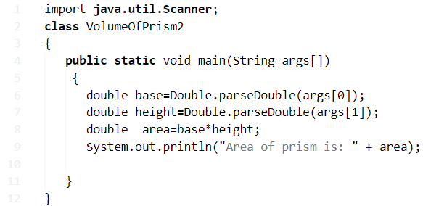

**Here is the online execution tool for the above program in order to calculate the volume of prism :**

The above program may not work on your command line. Since the example **program #1 is universally applicable** to all and can execute anywhere on JDK. **Below is the complete explanation of the above code, parse :**

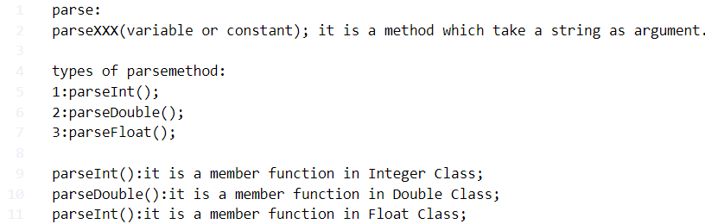

|  |  |
| --- | --- |
|  |  |

You may get an idea what is parsing and how the parse method works in the above java program to calculate the volume of a prism.

Here is another example program. Check it out, the following program can also universally applicable.

**Method – 3**

example #3 java program to find the volume of prism

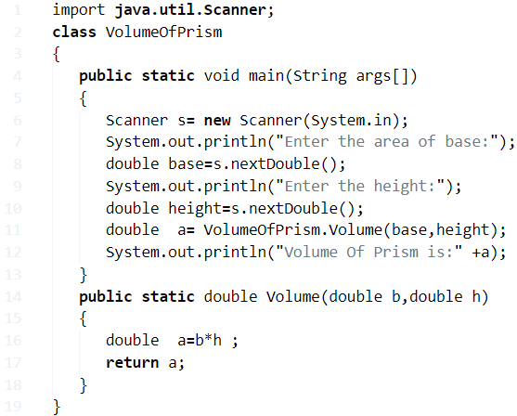

**Star pattern printing**

## 1. Java program to print the following pattern on the console

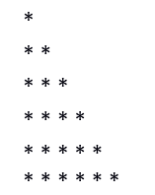

To accomplish this task, we need to create two loops and the 2nd loop is to be executed according to the first loop. The first loop is responsible for printing the line breaks whereas the second loop is responsible for printing the stars (*).

### Algorithm:

* **STEP 1:** START
* **STEP 2:** DEFINE i,j
* **STEP 3:** SET n=7
* **STEP 4:** PRINT "Right Angle Triangle"
* **STEP 5:** SET i=1.REPEAT STEP 6 to 8 UNTIL i<n< li=""></n<>
* **STEP 6:** SET j = 1 .REPEAT STEP 7 UNTIL j<=i
* **STEP 7:** PRINT * and SET j=j+1
* **STEP 8:** PRINT new line and SET i=i+1
* **STEP 9:** END

### Program:

1. **class** pattern
3. **public** **static** **void** main(String[] args)
4. {
5. **int** i,j, n=7;
6. System.out.println("Right angle triangle");
7. **for**(i=1;i<n;i++)
8. {
9. **for**(j=1;j<=i;j++)
10. {
11. System.out.print(" *");
12. }
13. System.out.println("");
14. }
15. }

**Output:**



## 2. Java program to print the following pattern on the console



### Algorithm:

* **STEP 1:** START
* **STEP 2:** DEFINE i, j
* **STEP 3:** SET n=6
* **STEP 4:** SET i=n. REPEAT STEP 5 to STEP 7 UNTIL i>0.
* **STEP 5:** SET j=0. REPEAT STEP 6 UNTIL j<i.< li=""></i.<>
* **STEP 6:** PRINT * and SET j=j+1
* **STEP 7:** PRINT "" and SET i=i-1.
* **STEP 8:** END

### Program:

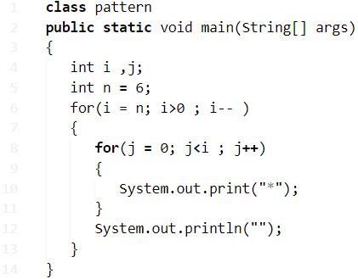

**Output:**



## 3. Java program to print the following pattern on the console



### Algorithm:

* **STEP 1:** START/li>
* **STEP 2:** SET size=0./li>
* **STEP 3:** DEFINE c./li>
* **STEP 4:** PRINT new line./li>
* **STEP 5:** SET size=5/li>
* **STEP 6:** DEFINE i, j, k./li>
* **STEP 7:** SET i = 0. REPEAT STEP 8 to STEP 14 UNTIL i< (size+1) /li>
* **STEP 8:** SET j=size. REPEAT STEP 9 UNTIL j>i./li>
* **STEP 9:** PRINT "" and SET j=j-1/li>
* **STEP 10:** SET k=0. REPEAT STEP 11 and 12 UNTIL k<(2*i-1)/li>
* **STEP 11:** PRINT * /li>
* **STEP 12:** SET k=k+1/li>
* **STEP 13:** PRINT new line./li>
* **STEP 14:** SET i= i+1./li>
* **STEP 15:** END

### Program:

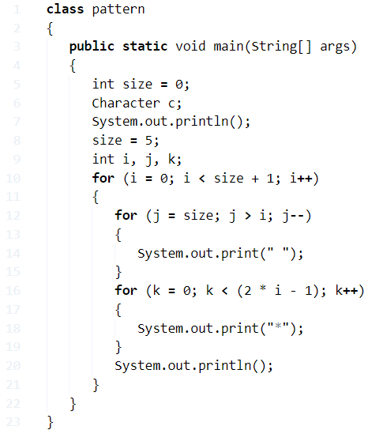

**Output:**



**4. Java Program To Print Diamond Star Pattern**

1. Using For Loop – Diamond Star / Asterisk Pattern Code

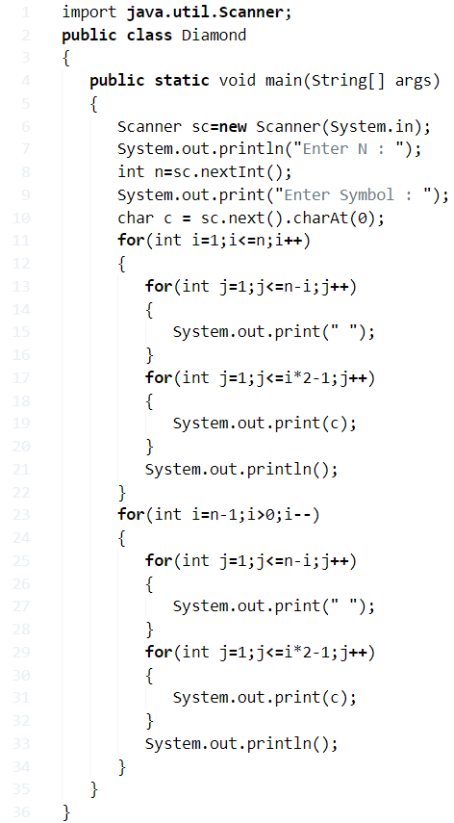

**The explanation for the above code:**

**1)** For loop is useful when the set of statements need to execute N no. at times.

**2)** First outer for loop displays half of the diamond pattern, 2nd outer for loop displays the remaining half of the pattern.

**3)** First outer for loop executes the code until the condition false if the condition at for loop true it checks the 1st inner loop condition if true its display space, if false it comes to 2nd inner loop and checks the condition,  if true it display charter “*” / Asterisk

|  |  |
| --- | --- |
| 1  2  3  4  5 | *     ***    *****  *******  ********* |

**3)** cursor comes to next line, 2nd outer for loop will execute the code until the condition false. In 2nd outer for loop if the condition true then it checks condition at 1st inner loop if condition true then it displays space otherwise it goes to 2nd inner loop and checks the condition if true then it displays the charter”*”.

**4)** The second outer for loop will display this pattern.

|  |  |
| --- | --- |
| 1  2  3  4 | *******    *****     ***      * |

**Output:**

|  |  |
| --- | --- |
| 1  2  3  4  5  6  7  8  9  10  11  12 | Enter N :  10  Enter Symbol : *      *     ***    *****  *******  *********  *******    *****     ***      * |

### 2. Using While Loop

**1)** while loop is entry checking loop,i.e it checks the code at while, if it is true it executes the code.

**2)** The 1st outer while loop executes the code until the condition i<=n false. if the condition true it checks the 1st inner while loop if condition true then it displays space, otherwise, goes to the next inner loop and display charter “*”.

**3)** 2nd outer while loop executes the code until the condition I>0.

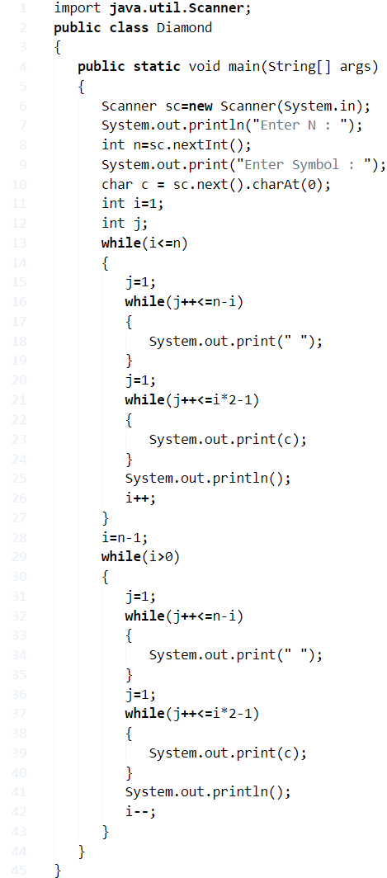

**Output:**

|  |  |
| --- | --- |
| 1  2  3  4  5  6  7  8  9  10  11  12  13  14  15  16  17  18  19  20  21  22  23  24  25  26 | Enter N :  12  Enter Symbol : .              .             ...            .....           .......          .........         ...........        .............       ...............      .................     ...................    .....................  .......................    .....................     ...................      .................       ...............        .............         ...........          .........           .......            .....             ...              . |

#### 3. Diamond Star Pattern Program – Using Do While Loop

1. The do-while loop is exit checking loop,i.e it executes the code once then checks the condition.

**2)** 1st outer do-while loop executes the statements until the condition ++i<=n is false,the first inner loop will display space until the condition ++j<=n-i+1 is false, 2nd inner loop will display “*” until the condition++j<=i*2-1 is false. The 1st outer do-while loop will display half of the diamond pattern.

**3)** The 2nd outer do-while loop will execute the statements until the condition –i>0 if false. The 1st inner loop will display space until the condition ++j<=n-i+1 is false,The 2nd inner loop will display charter “*” until the condition ++j<=i*2-1 is false.The 2nd outer do-while loop will display the remaining half of the pattern of the diamond.

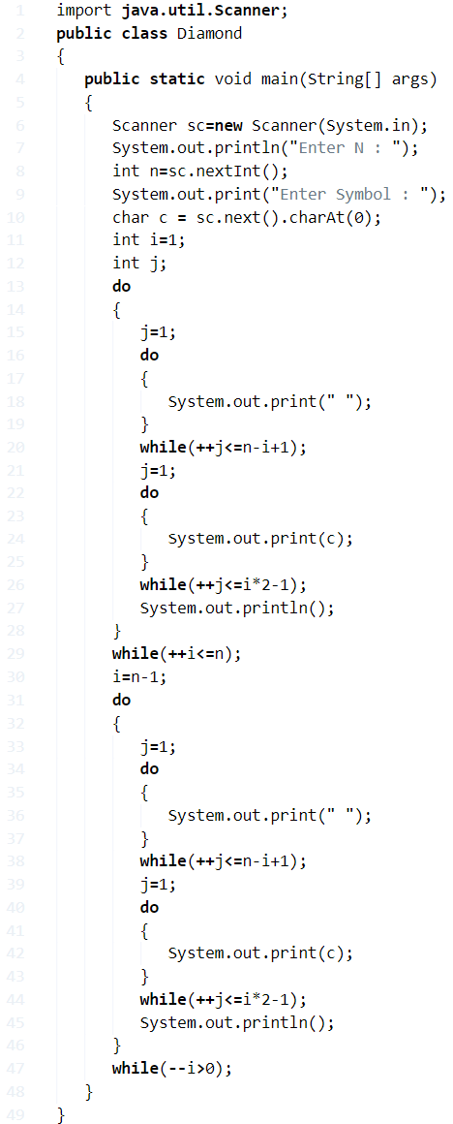

**Output:**

Output:

Java

|  |  |
| --- | --- |
| 1  2  3  4  5  6  7  8  9  10  11  12  13  14  15  16 | Enter N :  7  Enter Symbol : *         *        ***       *****      *******     *********    ***********  *************    ***********     *********      *******       *****        ***         * |

**Java Program To Print Hollow Mirrored Rhombus | 4 Ways**

**1. Using For Loop**

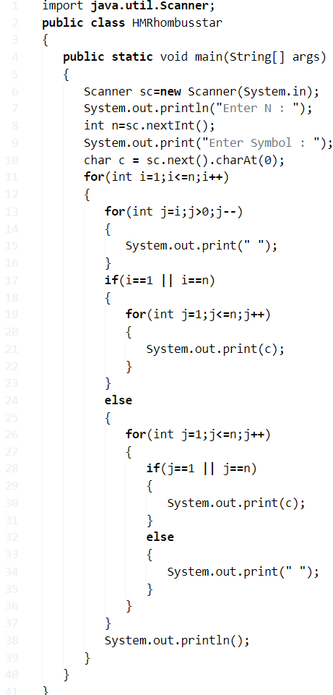

**1)** Read the n value using scanner object sc, and store thatvalue in the variable n.

**2)** Run the outer for loop with the structure for(int i=1;i<=n;i++)

**3)** The 1st-row iterates with the structure for(int j=i;j>0;j–) and prints spaces if j>0.

**4)** If  if(i==1 || i==n) is

* **a)**true, then for loop with the structure for(int j=1;j<=n;j++) and prints charters from j=1 to n.
* **b)** false,the loop with the structure for(int j=1;j<=n;j++) and prints charters at j=1 or j=n,prints spaces at if j!=1 and j!=n .

**5)** Cursor comes to next line and the outer loop starts the execution again, repeats until the condition at outer for loop is false.

In this example n=5, for i=1 the condition i<=n is true, 1st inner loop prints one space for j=i, then comes to if condition, if condition is true for i=1, so the inner loop prints charters from j=1 to j=5, After 1st iteration at 1st row one space and 5 charters will be printed.

Next cursor comes to next line and i value increased by 1.for i=2, the 1st inner loop prints 2 spaces for j=2,1.

Here if the condition fails for i=2 so comes to else part then inner loop prints charters at j=1 and j=5,  and prints spaces for j=2,3,4. after 2 iterations this pattern will be printed.

|  |  |
| --- | --- |
| 1  2 | *****    *   * |

After all iterations the total pattern will be printed as follows:

**Output:**

|  |  |
| --- | --- |
| 1  2  3  4  5  6  7  8 | Enter N :  5  Enter Symbol : *  *****    *   *     *   *      *   *       ***** |

**2. Hollow Mirrored Rhombus Star Pattern – Using While Loop**

**1)** while loop is entry checking loop, it checks the code then executes the code.

**2)** Check the Condit, on at while (i<=n) for given value of i, if this condition is true then j initialized to 1, condition while and 1st inner loop print condition while(–j>0) is false.

**3)** If   if(i==1 || i==n) condition is a) true , j=1, and inner while loop prints charter until the condition  while(j <=n)  is false. b)false, come to else part then  while loop prints charter at j=1 or j=n,until while(j<=n) condition is false, prints space at j!=1 and j!=n .

**4)** Cursor comes to next line, i value increased by 1, and outer while loop executes the code again, repeats until i<=n condition is false.

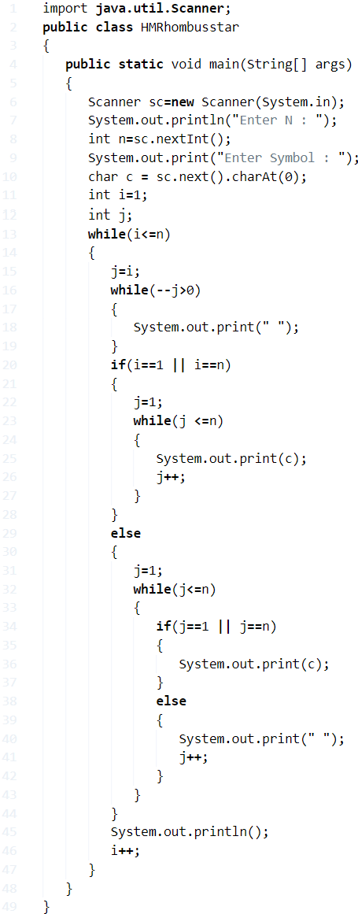

**Output:**

|  |  |
| --- | --- |
| 1  2  3  4  5  6  7  8  9  10  11  12  13 | Enter N :  10  Enter Symbol : *  **********  *        *    *        *     *        *      *        *       *        *        *        *         *        *          *        *           ********** |

**3. Hollow Mirrored Rhombus Star Pattern -Do-while**

**1)** The do-while loop is exit checking loop, it executes the code onetime then checks the code.

**2)** For given i,j do loop starts the execution, the inner do loop prints the one space then checks the condition while (–j>0),  if it is true then it prints space until the condition while(–j>0) is false.

**3)** Checks the if condition

* a)true inner do loop prints one charter then checks the condition  while(++j<=n), it prints until the condition while(++j<=n) is false.
* b) false, comes to else part and for j=1 the inner loop prints one charter then checks the condition while (++j<=n),it is false so prints space, repeats until the condition ++j<=n is false.

**4)** Cursor comes to next line and i value increased by 1, then checks the condition at outer do-while while(i<=n), if it is true, the do loop again stars the execution, repeats until the condition at outer do-while is false.

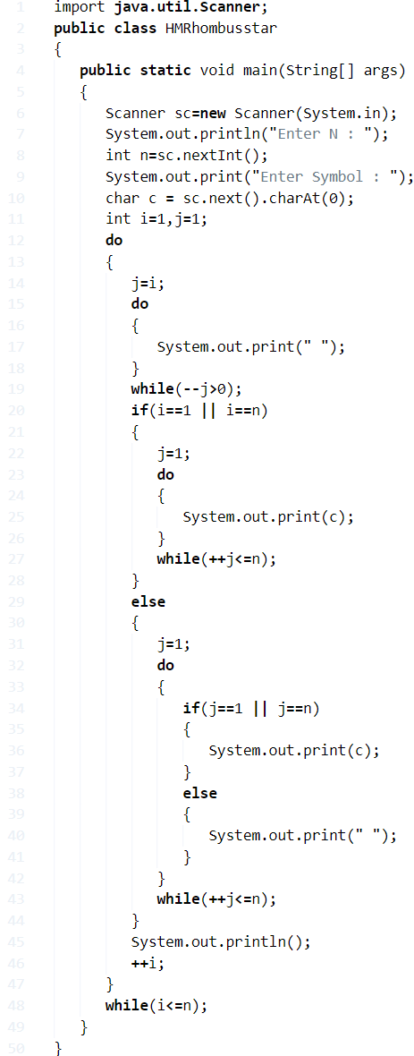

**Output:**

output:

Java

|  |  |
| --- | --- |
| 1  2  3  4  5  6  7  8  9  10 | Enter N :  7  Enter Symbol : *  *******    *     *     *     *      *     *       *     *        *     *         ******* |

**Java Program To Print Mirrored Rhombus Star Pattern**

1. Using For Loop

**1)** Read the n value using scanner class, store it in the variable n.

**2)** Run the outer for loop with the structure for(int i=1;i<=n;i++) to iterate through rows

**3)** The 1st inner loop prints space from j=n-i to j<n, 2nd inner loop prints charter from j=1 to j=n.

In this example n=6, for i=1, 1st inner loop prints one space for j=5. For j=6 condition fails then comes to next for loop. 2nd loop prints charters from j=1 to j=6 at 1st row. next n=2 ,1st loop prints spaces for j=4,5. 2nd loop prints charters from j=1 to 6 at 2nd row.after  2 iterations this pattern will be printed.

|  |  |
| --- | --- |
| 1  2 | ******    ****** |

After all iterations, the given pattern will be printed.

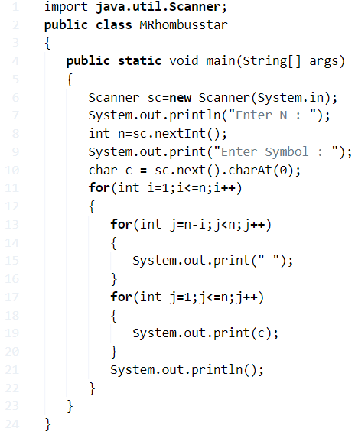

Output:

|  |  |
| --- | --- |
| 1  2  3  4  5  6  7  8  9 | Enter N :  6  Enter Symbol : *  ******    ******     ******      ******       ******        ****** |

**Method - 2 Using While Loop**

**1)** While loop is entry checking loop, it checks the condition then only executes the code.

**2)** Checks the condition at while, while(i<=n), if it is true then j initialized to 1 and 1st inner loop prints space until the condition  while(–j>0) is false

**3)** j initialized to 1,2nd inner loop prints charter until the condition  while(j++<=n) is false.

**4)** Next cursor comes to next line and i value increased by 1,  and again starts the execution of outer while loop until  (i<=n) the condition is false.

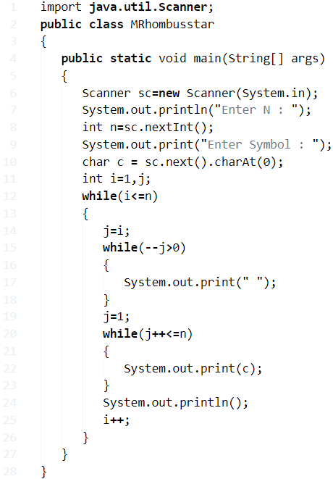

Output:

|  |  |
| --- | --- |
| 1  2  3  4  5  6  7  8  9  10  11  12  13  14  15 | Enter N :  12  Enter Symbol : *  ************  ************    ************     ************      ************       ************        ************         ************          ************           ************            ************             ************ |

**Method - 2 Using Do-While Loop**

**1)** The do-while loop is exit checking loop, it executes the code one time then it checks the condition.

**2)** For i,j values 1st inner do loop prints one space then checks the code while(–j>0), if this code is true then it prints the space until the condition is false.

**3)** For j=1, 2nd inner loop prints one charter then checks the condition while(++j<=n), if this condition true it prints charter until the condition is false.

**4)** Cursor comes to next line and i value increased by 1, then checks the condition at outer do-while loop (i<=n), if this condition is true then the outer do-while loop start the execution again, repeats until the condition i<=n is false.

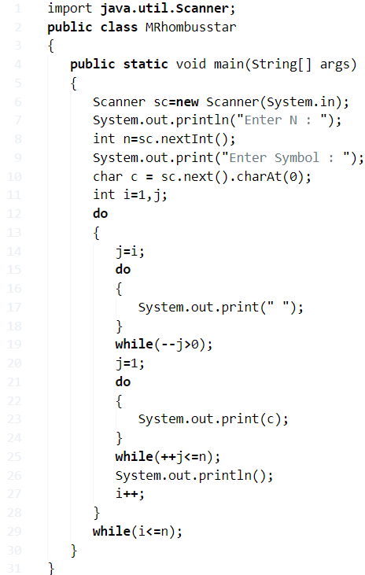

Output:

output:

|  |  |
| --- | --- |
| 1  2  3  4  5  6  7  8 | Enter N :  5  Enter Symbol : 5  55555    55555     55555      55555       55555 |

## 6. Java program to print the following pattern on the console

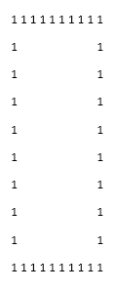

### Algorithm:

* **STEP 1:** START
* **STEP 2:** SET i =1.REPEAT STEP 3 to 7UNTIL i<=10.
* **STEP 3:** SET j=1.REPEAT STEP 4 and 5UNTIL j<=10.
* **STEP 4:** if(i==0 or i==10 or j==0 or j==10) then PRINT 1 else PRINT ""
* **STEP 5:** SET j=j+1
* **STEP 6:** PRINT new line.
* **STEP 7:** SET i=i+1
* **STEP 8:** END

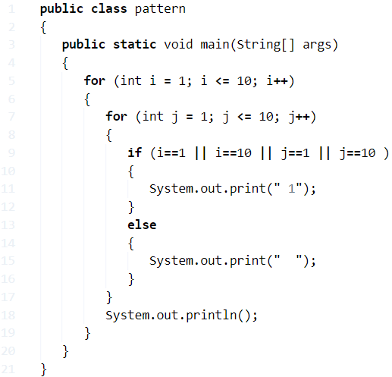

**Output:**



## Java program to print the following pattern on the console

1 2 3 4 5  
1 2 3 4  
1 2 3  
1 2  
1

### Algorithm:

* **STEP 1:** START
* **STEP 2:** DEFINE i, j.
* **STEP 3:** SET n=5.
* **STEP 4:** SET i=n. REPEAT STEP 5 to STEP 7 UNTIL i>0.
* **STEP 5:** SET j=1. REPEAT STEP 6 UNTIL j<=i.
* **STEP 6:** PRINT j and SET j=j+1.
* **STEP 7:** PRINT "" and SET i=i-1.
* **STEP 8:** END

### Program:

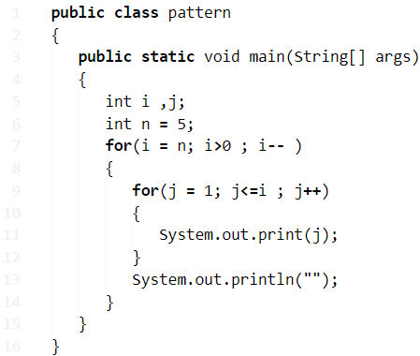

**Output:**

1 2 3 4 5

1 2 3 4

1 2 3

1 2

1

## Java program to print the following pattern on the console

In this program, we are creating a right-angled triangle of numbers in increasing order. We are creating two loops, and 2nd loop is executing according to the first loop, inside 2nd loop printing the number row-wise i loop times.

1  
2 3  
4 5 6  
7 8 9 10

### Algorithm:

* **STEP 1:** START
* **STEP 2:** SET n=1.
* **STEP 3:** SET i=0.REPEAT STEP 4 to STEP 8 UNTIL i<6.
* **STEP 4:** SET j=1.REPEAT STEP 5 and 6 STEP UNTIL j<i.< li=""></i.<>
* **STEP 5:** PRINT n
* **STEP 6:** SET n=n+1, j=j+1.
* **STEP 7:** PRINT new line.
* **STEP 8:** SET i=i+1.
* **STEP 9:** END

### Program:

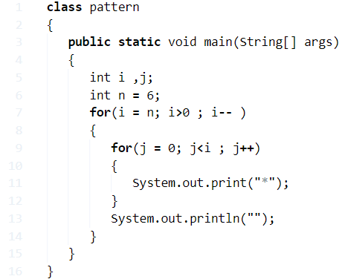

**Output:**

1

2 3

4 5 6

7 8 9 10

## Java program to print the following pattern on the console

1  
1 2  
1 2 3  
1 2 3 4  
1 2 3 4 5

### Algorithm:

* **STEP 1:** START
* **STEP 2:** SET n=5.
* **STEP 3:** SET i=0. REPEAT STEP 4 to STEP 8 UNTIL i<=n.
* **STEP 4:** SET j=0.REPEAT STEP 5 to STEP 6 UNTIL j<i.< li=""></i.<>
* **STEP 5:** PRINT j+1
* **STEP 6:** SET j=j+1
* **STEP 7:** PRINT new line.
* **STEP 8:** SET i=i+1.
* **STEP 9:** END

### Program:

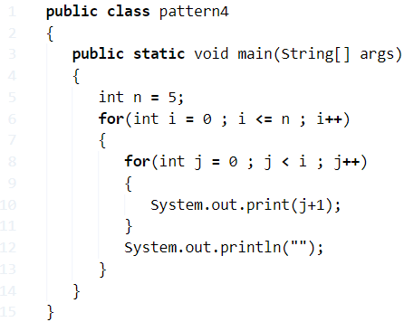

**Output:**

1

1 2

1 2 3

1 2 3 4

1 2 3 4 5

## Java program to print the following pattern on the console

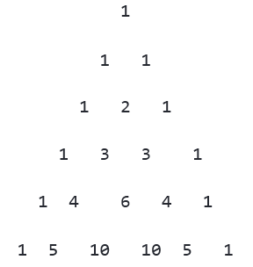

### Algorithm:

* **STEP 1:** START
* **STEP 2:** SET coe=1, rows= 6.
* **STEP 3:** SET i=0. REPEAT STEP 4 to STEP 11 UNTIL i<rows.< li=""></rows.<>
* **STEP 4:** SET space = 1. REPEAT STEP 5 and STEP 6 UNTIL space<(rows ?i)
* **STEP 5:** PRINT ""
* **STEP 6:** ++space
* **STEP 7:** SET j=0. REPEAT STEP 8 to STEP 9 UNTIL j<=i .
* **STEP 8:** IF(j==0||i==0)  
                  SET coe=1  
                  ELSE  
                  SET coe=coe*(i-j+1) /j  
                  PRINT coe
* **STEP 9:** SET j = j+1
* **STEP 10:** PRINT new line.
* **STEP 11:** SET i=i+1
* **STEP 12:** END

### Program:

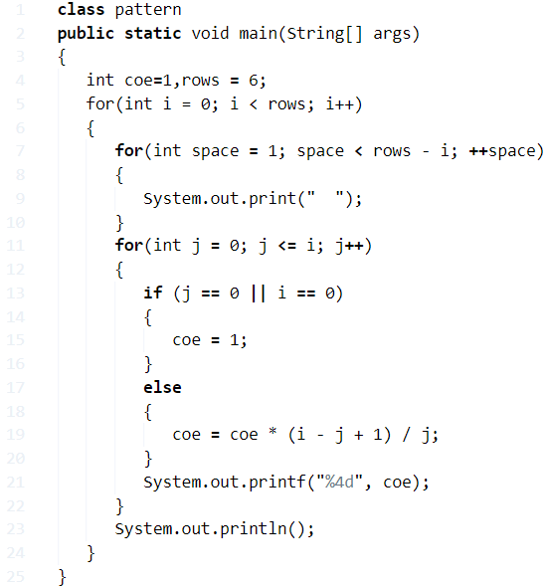

**Output:**



## Java program to print the following pattern

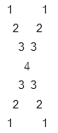

### Algorithm:

* **STEP 1:** START
* **STEP 2:** SET lines=8
* **STEP 3:** DEFINE i, j
* **STEP 4:** SET i=1.REPEAT STEP 5 to 14 UNTIL i<lines< li=""></lines<>
* **STEP 5:** SET j=1
* **STEP 6:** REPEAT STEP 7 and 8 UNTIL j <=(lines/2)
* **STEP 7:** IF j is equals to i PRINT j  
                ELSE IF i is greater than 4 and j equals (lines-i) PRINT j  
                ELSE PRINT " "
* **STEP 8:** j = j + 1
* **STEP 9:** j = j - 2
* **STEP 10:** REPEAT STEP 11 and 12 UNTIL j > 0
* **STEP 11:** IF j is equals to i PRINT j  
                ELSE IF i is greater than 4 and j equals (lines-i) then PRINT j  
                ELSE PRINT " "
* **STEP 12:** j = j - 1
* **STEP 13:** PRINT a new line
* **STEP 14:** i = i + 1
* **STEP 15:** END

### Program:

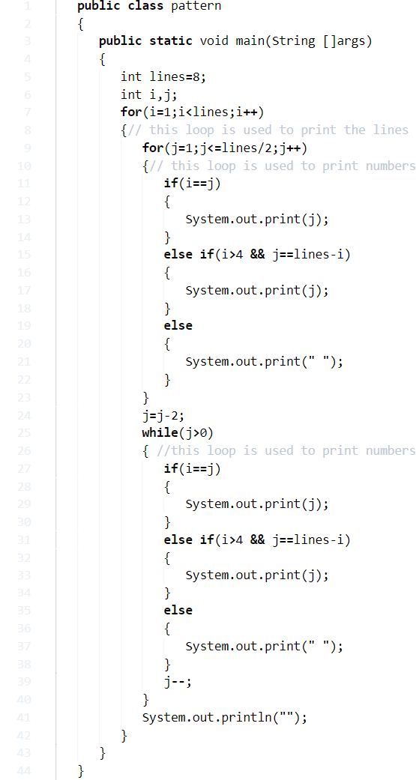

**Output:**



## Java program to print the following pattern on the console

A  
B B  
C C C  
D D D D  
E E E E E

To accomplish this task, we need to use two loops, the first loop is responsible for printing the line breaks whereas the second loop is responsible for printing the alphabet.

### Algorithm:

* **STEP 1:** START
* **STEP 2:** SET n=4.
* **STEP 3:** SET i=0.
* **STEP 4:** REPEAT STEP 5 to STEP 7 UNTIL i<=n
* **STEP 5:** SET j = 0. REPEAT STEP 6 UNTIL j<=i.
* **STEP 6:** PRINT char(65+i) and SET j=j+1.
* **STEP 7:** PRINT new line and SET i=i+1.
* **STEP 8:** END

### Program:

1. **class** pattern
2. {
3. **public** **static** **void** main(String[] args)
4. {
5. **int** n = 4;
6. **for**(**int** i = 0 ; i <= n ; i++)
7. {
8. **for**(**int** j = 0 ; j <= i ; j++)
9. {
10. System.out.print(" "+(**char**)(65 + i));
11. }
12. System.out.println("");
13. }
14. }
15. }

**Output:**

A

B B

C C C

D D D D

E E E E E

## Java program to print the following pattern

5432*  
543*1  
54*21  
5*321  
*4321

### Algorithm:

**STEP 1:** START

**STEP 2:** DEFINE i, j.

**STEP 3:** SET lines=5

**STEP 4:** SET i=1. REPEAT STEP 5 to STEP 10 UNTIL i <= lines

**STEP 5:** SET j=lines

**STEP 6:** REPEAT STEP 7 and 8 UNTIL j >= 1

**STEP 7:** IF j!=i then PRINT j  
                else PRINT *

**STEP 8:** j=j-1

**STEP 9:** PRINT new line.

**STEP 10:** i=i+1

**STEP 11:** END

### Program:

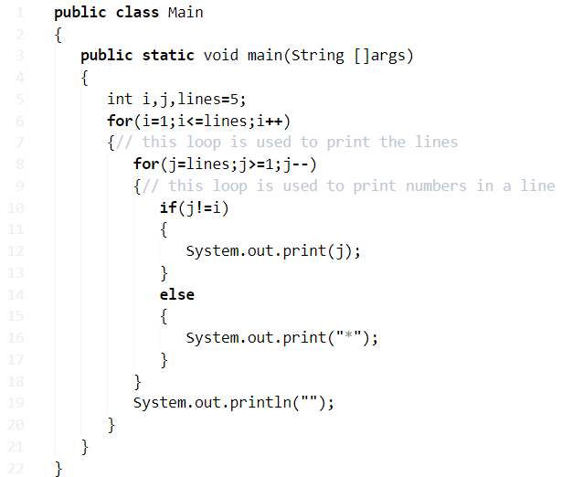

**Output:**

5432*

543*1

54*21

5*321

*4321

## Java program to print the following pattern

*000*000*  
0*00*00*0  
00*0*0*00  
000***000

### Algorithm:

* **STEP 1:** START
* **STEP 2:** SET lines=4
* **STEP 3:** Define i, j
* **STEP 4:** SET i =1
* **STEP 5:** REPEAT STEP 6 to 15 UNTIL i <= lines
* **STEP 6:** SET j=1
* **STEP 7:** REPET STEP 8 and 9 UNTIL j <= lines
* **STEP 8:** IF i is equal to j PRINT * ELSE PRINT 0
* **STEP 9:** SET j = j + 1
* **STEP 10:** DECREMENT j by 1 and PRINT *
* **STEP 11:** REPEAT STEP 12 and 13 UNTIL j >=1
* **STEP 12:** IF i is equals to j PRINT * ELSE PRINT 0
* **STEP 13:** SET j = j - 1
* **STEP 14:** PRINT a new line
* **STEP 15:** SET i = i + 1
* **STEP 16:** END

### Program:

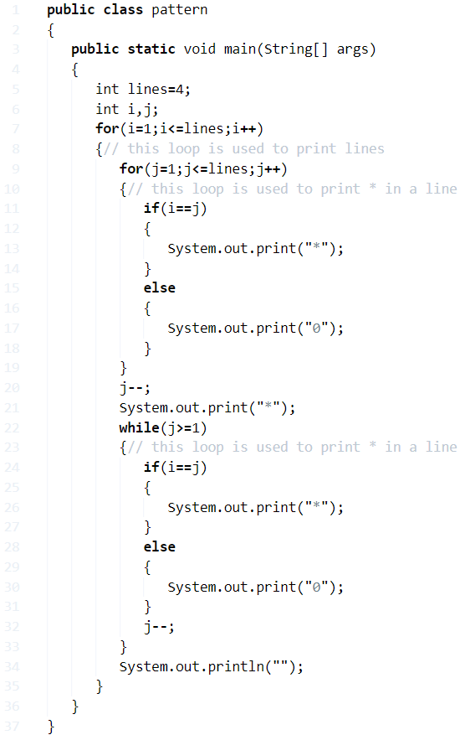

**Output:**

*000*000*

0*00*00*0

00*0*0*00

000***000

## Java program to print the following pattern on the console

12344321  
123**321  
12****21  
1******1

### Algorithm:

* **STEP 1:** START
* **STEP 2:** SET lines=4
* **STEP 3:** DEFINE i, j.
* **STEP 4:** SET space=0
* **STEP 5:** SET i=0
* **STEP 6:** REPEAT STEP 7 TO 20 UNTIL i<lines< li=""></lines<>
* **STEP 7:** SET j=1
* **STEP 8:** REPEAT STEP 9 UNTIL j <= space.
* **STEP 9:** PRINT " " and SET J=J+1
* **STEP 10:** SET j=1
* **STEP 11:** REPEAT STEP 12 and 13 UNTIL j<=lines
* **STEP 12:** IF j <=(lines-i). PRINT j ELSE PRINT *
* **STEP 13:** SET j=j+1
* **STEP 14:** DECREMENT j by 1
* **STEP 15:** REPEAT STEP 16 and 17 UNTIL j>0
* **STEP 16:** IF j>( lines-i ) then PRINT * ELSE PRINT j
* **STEP 17:** SET j=j-1
* **STEP 18:** IF (lines-i) >9 INCREMENT space by 1
* **STEP 19:** PRINT new line
* **STEP 20:** SET i=i+1
* **STEP 21:** END

### Program:

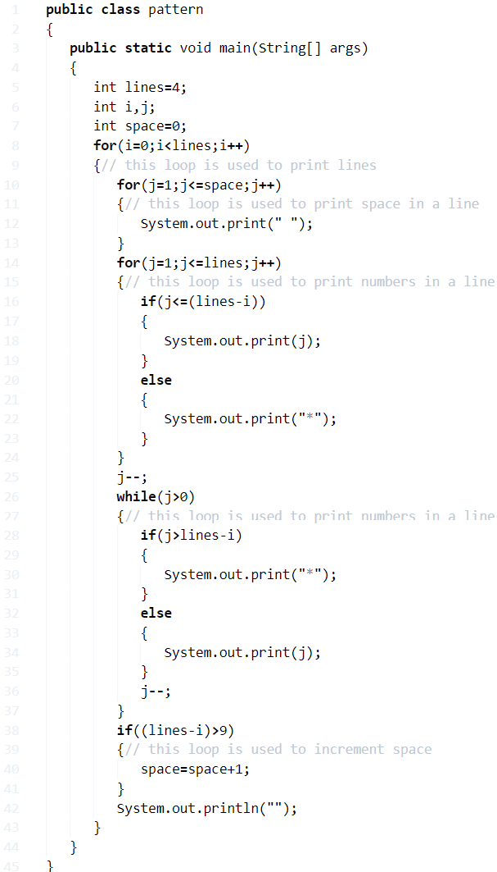

**Output:**

12344321

123**321

12****21

1******1

**Star Pattern “8:**

## Using For Loop

**1)** First, checks the condition at for loop, if it is true, then it comes to”if “condition.

If the “if” condition is true then run the first inner for loop, otherwise, run the 2nd inner for loop.

**2)** In the first inner loop iterates from j=1 to j=n, checks the “if “condition, if it is true it will display “space'” otherwise it comes to else part and display the “*” symbol.

**3)** If the first “if” condition is false then 2nd inner for loop will be executed, in the 2nd for loop iterates from j=1 to j=n, check the “if” condition if it true it displays the “*” symbol otherwise it displays “space”.

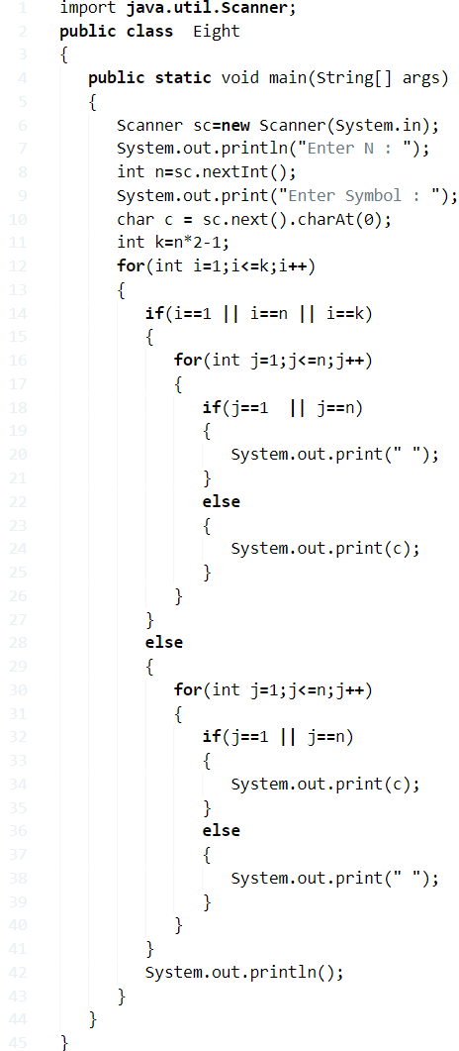

**Output:**

|  |  |
| --- | --- |
| 1  2  3  4  5  6  7  8  9  10  11  12 | Enter N :  5  Enter Symbol : *  ***  *   *  *   *  *   *  ***  *   *  *   *  *   *  *** |

### Using While Loop

**1)** First, the condition at while will be checked, if the condition is true it checks the **“if”** condition if it true it executes the first inner while loop otherwise it comes to the else part i.e 2nd inner while loop.

**2)**In the 1st inner while loop, if the condition at while is true then checks the “if ” condition, if the condition is true then it displays “space” otherwise it displays “*”, it will continue until the inner while loop condition is false.

**3)** 2nd inner while loop executes only the if condition at outer while loop is false, in 2nd inner while loop first checks the condition at while will be checked after that checks the “if” condition, if condition true then displays “*” otherwise displays “space”.

**4)** The total code in the outer while loop will execute until the condition at while is false.

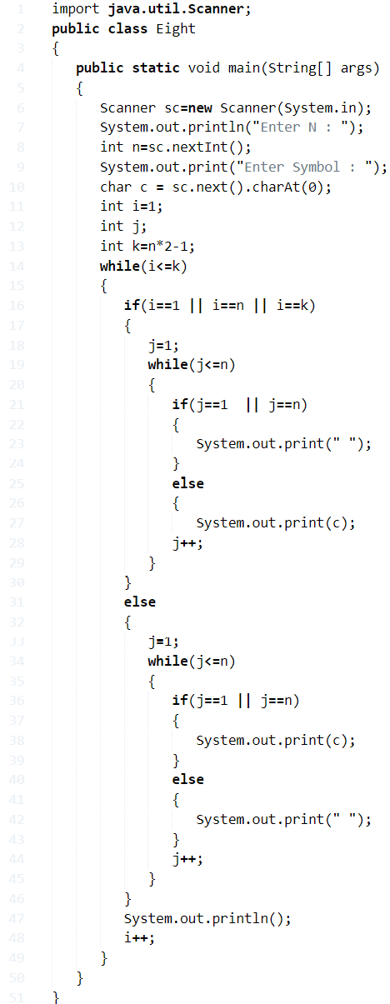

**Output:**

|  |  |
| --- | --- |
| 1  2  3  4  5  6  7  8  9  10  11  12 | Enter N :  5  Enter Symbol : .  ...  .   .  .   .  .   .  ...  .   .  .   .  .   .  ... |

#### Using Do-While Loop

**1)** If the condition at the “if” is true in an outer [do-while loop it executes the 1st inner do-while loop](https://javatutoring.com/do-while-java-examples/), otherwise it comes to else part i.e. 2nd inner do-while loop.

**2)** In 1st inner do-while loop if the “if” condition is true it will display space otherwise it will display “*”, 2nd inner do-while loop if the “if” condition is true then it will display “*” otherwise it will display space.

**3)** The total code in the outer do-while loop will be executed until the while condition is false i.e while(i<=k).

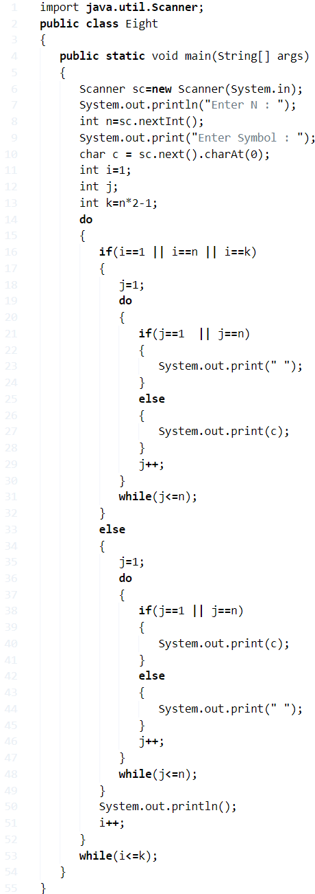

**Output:**

Output

|  |  |
| --- | --- |
| 1  2  3  4  5  6  7  8  9  10  11  12  13  14  15  16  17  18  19  20  21  22 | Enter N :  10  Enter Symbol : *  ********  *        *  *        *  *        *  *        *  *        *  *        *  *        *  *        *  ********  *        *  *        *  *        *  *        *  *        *  *        *  *        *  *        *  ******** |

**X Star Pattern Java Program**

## Using For Loop

**1)** In the inner for loop iterates from j=1 to k and prints charter if  j=i or j=k-i+1  displays “*”,else it displays space.

**2)** This code will execute until the inner for loop condition is false, then it comes to the outer for loop, the for loop will execute until the condition i<=k is false.

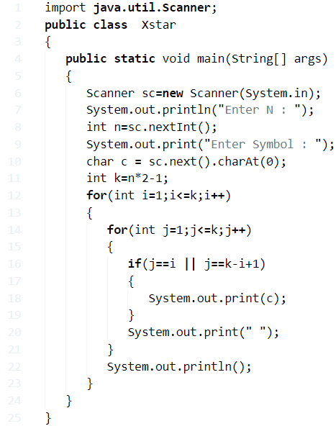

**Output:**

|  |  |
| --- | --- |
| 1  2  3  4  5  6  7  8  9  10  11  12  13  14  15  16  17  18  19  20  21  22 | Enter N :  10  Enter Symbol : .  .                  .  .                .    .              .     .            .      .          .       .        .        .      .         .    .          .  .           .          .  .         .    .        .      .       .        .      .          .     .            .    .              .  .                .  .                  . |

### Using While Loop

**1)** While loop checks the condition first then executes the code.

**2)** First checks the condition at while loop i.e i<=k, if it is true, then it comes to the inner while loop.

**3)** In inner while loop first checks the condition j<=k, then it executes the code in the loop until the condition is false, then cursor come out of the inner loop and goes to the outer loop, this will continue until the condition i<=k is false.

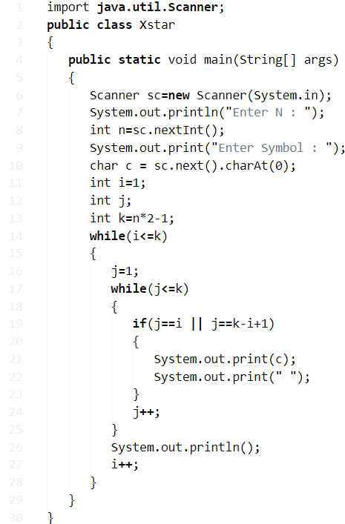

**Output:**

|  |  |
| --- | --- |
| 1  2  3  4  5  6  7  8  9  10  11  12 | Enter N :  5  Enter Symbol : ^  ^        ^  ^      ^    ^    ^     ^  ^      ^     ^  ^    ^    ^  ^      ^  ^        ^ |

#### Using Do-While Loop

1) First, the code will be executed i.e. inner do-while loop, the code in the inner loop executes until the condition j<=k is false. It prints charter for j=i ,j=k-i+1.Other than these j values prints space.

2) If the condition false then cursor comes to outer do-while loop. The outer do loop execution will stop if the condition i<=k is false

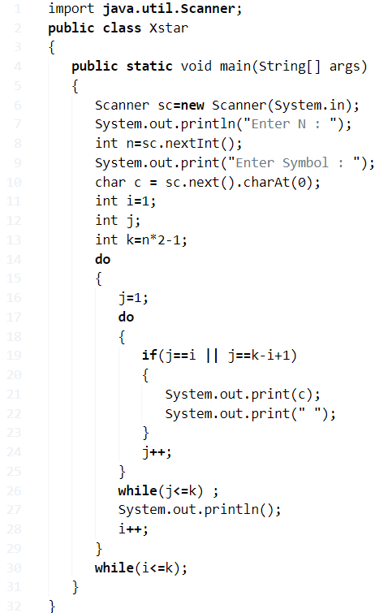

**Output:**

Output

Java

|  |  |
| --- | --- |
| 1  2  3  4  5  6  7  8  9  10  11  12 | Enter N :  5  Enter Symbol : *  *        *  *      *    *    *     *  *      *     *  *    *    *  *      *  *        * |

**Mirrored Half Diamond Star Pattern Programs**

## Using For Loop

**1)** For loop, execute the group of statements n number of times.

**2)** The 1st outer for loop iterates until the condition i<=n is false, the first inner loop display space until the condition j<=n-i is false,

**3)** 2nd inner loop will display the character until the condition j<i is false. The 1st outer loop will display this pattern after all iterations.

|  |  |
| --- | --- |
| 1  2  3  4  5 | *     **    ***  ****  ***** |

**4)** The 2nd outer loop iterates until the condition i>0 is false, the first inner loop will display space until j<=n-i is false. The 2nd inner loop will display character until the condition j<=i is false. The 2nd outer loop will display this pattern.

|  |  |  |  |
| --- | --- | --- | --- |
| 1  2  3  4 | ****    ***     **      * | | |
|  | |  |

**Output:**

|  |  |
| --- | --- |
| 1  2  3  4  5  6  7  8  9  10  11  12 | Enter N :  5  Enter Symbol : *      *     **    ***  ****  *****  ****    ***     **      * |

### Using While Loop

**1)** 1st outer while loop will execute the code until the condition i<=n is false. The 1st inner loop will display the space until the condition j++<=n-i  is false, the 2nd inner loop will display the character until the condition j++<=i is false. The 1st outer loop will display the first half of the pattern of mirrored half diamond star pattern.

After first outer loop execution, the cursor comes to next line and executes the 2nd outer while loop.

**2)** 2nd outer loop will execute the statements until the condition i>0 is false, the 1st inner loop displays the space until the condition j++<=n-i is false, the 2nd inner loop will display character until the condition j++<=i is false. The 2nd outer loop will display the remaining half of the pattern of a mirrored half diamond.

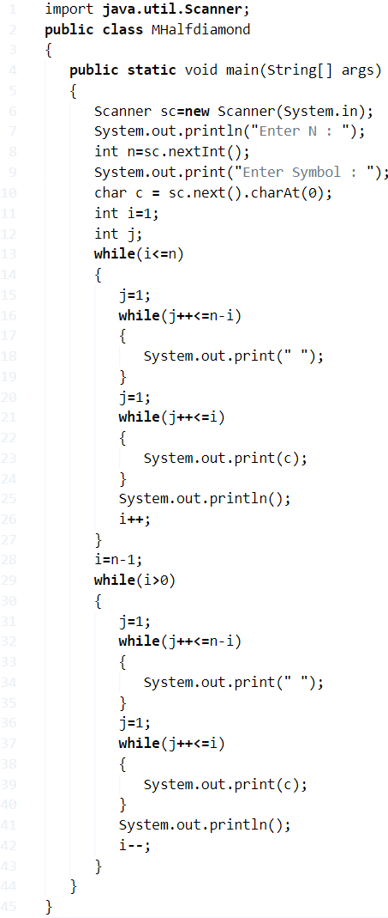

**Output:**

|  |  |
| --- | --- |
| 1  2  3  4  5  6  7  8  9  10  11  12  13  14  15  16  17  18  19  20  21  22 | Enter N :  10  Enter Symbol : -           -          --         ---        ----       -----      ------     -------    --------  ---------  ----------  ---------    --------     -------      ------       -----        ----         ---          --           - |

#### Using Do-While Loop

**1)** The do-while loop executes the code one time then checks the condition at while.

**2)** The 1st outer do-while loop executes the code until the condition is false ++i<=n is false, 1st inner loop will display the space until the condition ++j<=n-i+1 is false, 2nd inner loop will display character until the condition ++j<=i is false. This outer loop displays half of the pattern of a mirrored half diamond pattern.

**3)** The 2nd outer do-while loop executes the code until the condition–i>0 is false, 1st inner loop will display space until the condition ++j<=n-i+1, 2nd inner loop will display character until the condition ++j<=i is false. This outer loop displays the remaining half of the pattern of a mirrored half diamond pattern.

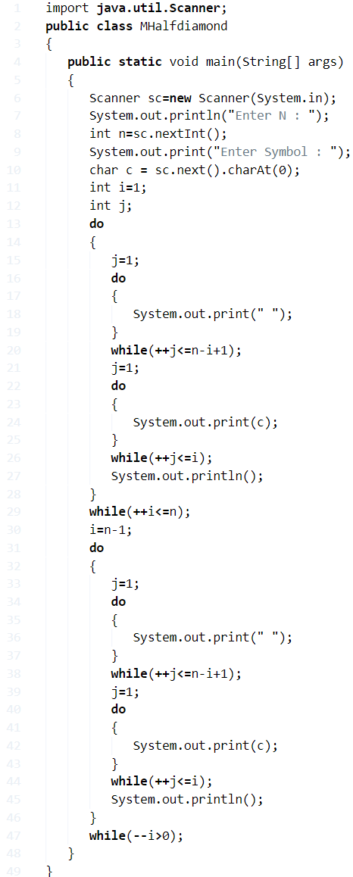

**Output:**

Output

|  |  |
| --- | --- |
| 1  2  3  4  5  6  7  8  9  10  11  12 | Enter N :  5  Enter Symbol : ,       ,      ,,     ,,,    ,,,,  ,,,,,    ,,,,     ,,,      ,,       , |

**Java Hollow Inverted Pyramid Star Pattern**

## Using For Loop

**1)** Read the entered value and store in the variable n.

**2)** Run the outer loop with the structure for(int i=n;i>0;i–) for n times.

**3)**Run the 1st inner loop with the structure for(int j=1;j<=n-i;j++)

prints space for i>0 and j<=n-i

**4)**If the first inner loop condition is false then checks the” if” condition

– condition true 1st loop prints character for ( i==1 or i==n) and j<=i*2-1,

-condition false 2nd  loop prints character for (j==1 || j==i*2-1), prints space for (j!=1&j!=i*2-1) until j<=i*2-1

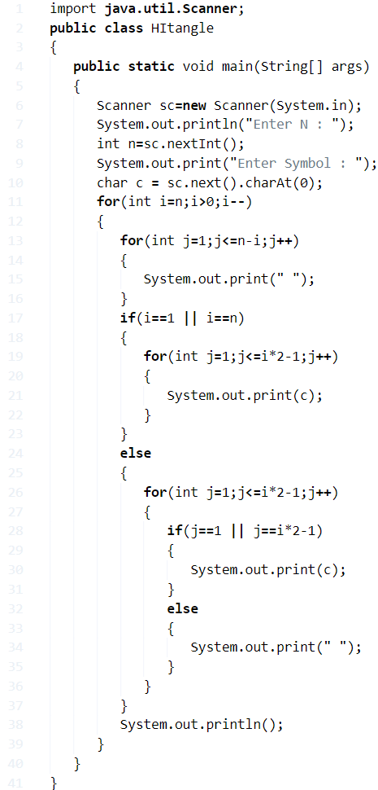

**Output:**

|  |  |
| --- | --- |
| 1  2  3  4  5  6  7  8  9  10  11  12  13 | Enter N :  10  Enter Symbol : *  *******************  *               *    *             *     *           *      *         *       *       *        *     *         *   *          * *           * |

### Using While Loop

**1)** The outer while will iterate n times,if the condition is true at outer loop then inner while loop condition true then prints space. condition false check the condition at “if”.

**2)**

**a)**If condition true first while loop prints character until j++<=i*2-1 is false.

**b)** condition false next while loop prints character for j==1 , j==(i*2)-1), until while(j<=(i*2)-1) condition is false.

**c)** prints space for j!=1 and J!=(i*2)-1, until  while(j<=(i*2)-1) condition is false.

**Output:**

|  |  |
| --- | --- |
| 1  2  3  4  5  6  7  8  9  10  11  12  13 | Enter N :  10  Enter Symbol : +  +++++++++++++++++++  +               +    +             +     +           +      +         +       +       +        +     +         +   +          + +           + |

#### Using Do-While Loop

**1)** Outer do-while loop iterates until i>0 condition if false.

**2)** The inner loop prints space, after that it checks the condition, it prints space until the condition (++j <=n-i+1); is false.

**3)** “if” condition true 1st do-while loop prints character until the condition (++j <=i*2-1) is false.

**4)**“if” condition false 2nd do-while loop prints character if  (j==1 || j==i*2-1) is false, until the condition (++j <=i*2-1) is false.

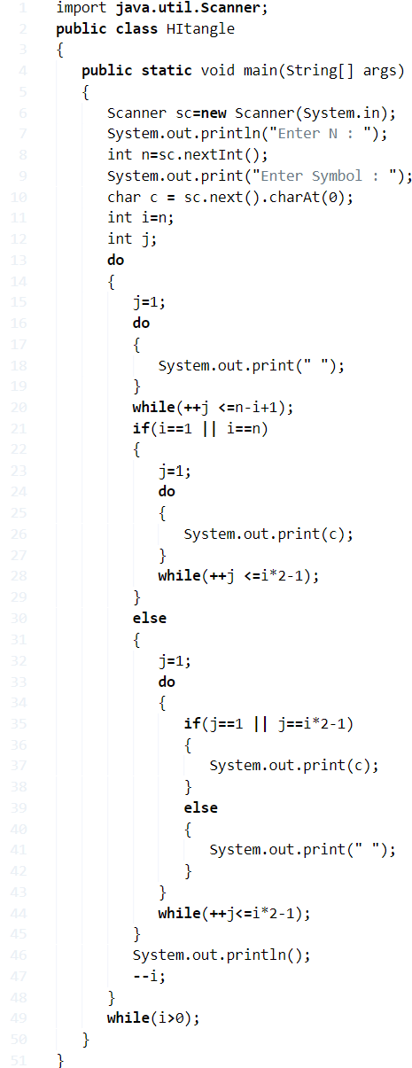

**Output:**

Output

|  |  |
| --- | --- |
| 1  2  3  4  5  6  7  8  9  10 | Enter N :  7  Enter Symbol : *  *************    *         *     *       *      *     *       *   *        * *         * |

**Java Inverted Right Triangle Star Pattern Program**

## Using For Loop

**1 )** Read the entered value n.

**2)** To iterate through rows run the outer loop from n to 1 with the structure for(int i=n;i>0;i–).

**3)** To iterate through columns run the inner loop with the structure for(int j=0;j<i;j++).

**4)** Inner loop prints the character for   j<i

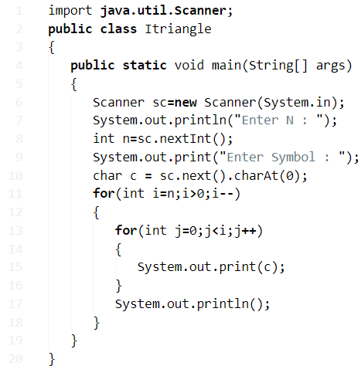

**Output:**

|  |  |
| --- | --- |
| 1  2  3  4  5  6  7  8 | Enter N :  5  Enter Symbol : *  *****  ****  ***  **  * |

### Using While Loop

**1)** It checks the condition i>0, then executes the code.

**2)** The inner while loop will displays character until the condition j++<i false.

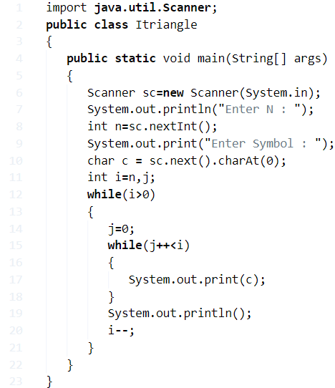

**3)** The outer loop executes the total code until condition false.

**Output:**

|  |  |
| --- | --- |
| 1  2  3  4  5  6  7  8  9  10 | Enter N :  7  Enter Symbol : .  .......  ......  .....  ....  ...  ..  . |

#### ****Using Do-While Loop****

**1)** The inner do-while loop prints the character and then the condition –j<i, is true then again prints the character until the condition is false.

**2)**The outer do-while loop executes the code until the condition –i>0.

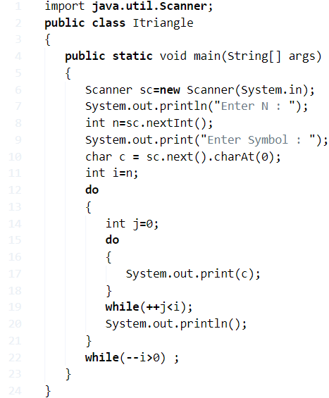

**Output:**

Output

|  |  |
| --- | --- |
| 1  2  3  4  5  6  7  8  9  10  11  12  13 | Enter N :  10  Enter Symbol : *  **********  *********  ********  *******  ******  *****  ****  ***  **  * |